Year 2 Topic Support Pack – Week 9
Topic Task 1 – History
Look at this photo of Grace O’Malley, the Pirate Queen, meeting Queen Elizabeth I. Firstly, can you think about why are their clothes different? How would you describe their clothes?

____________________________________________________________________________________________________________________________________________________________________________________________________________________________________________
Think back to the story of Grace O’Malley’s life. Her main enemy was Lord Bingham, Queen Elizabeth’s governor who had been sent to take control of her land and even imprisoned her! Grace wrote to Queen Elizabeth and this is a picture of them meeting for the very first time. How do you think Grace might have been feeling towards Queen Elizabeth? What do you think they might have said to each other? Complete the speech bubbles to show what you think they might have said to one another.

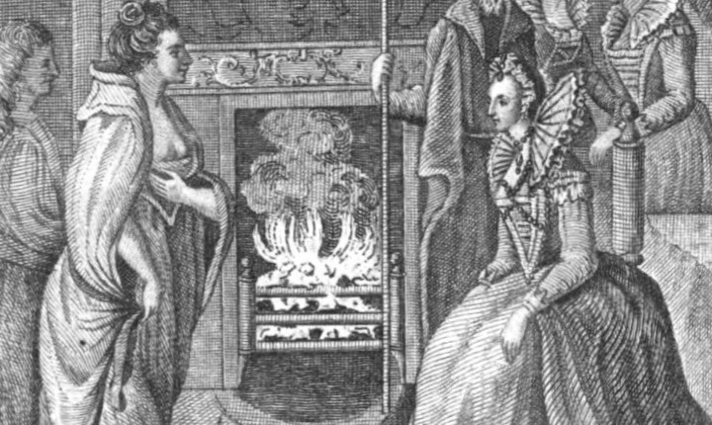

Topic Task 3 - French

Now you have mastered numbers 1-20, can you say the days of the week in French? Watch the YouTube clip to help you learn how to say the days of the week. https://www.youtube.com/watch?v=l2ZFzUTsA7A
Then see if you can work out which days these are below:
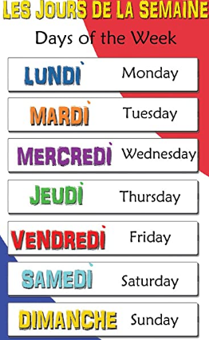

samedi = _______ mercredi = ______

lundi = _______ jeudi = _______

dimanche = _______ mardi = ______

vendredi = _______

