Week 12 English Support Pack
In this pack, you will find all of the instructions, resources, and questions that you will need to complete your English lessons for this week. We are carrying on with our Summer text driver, Cogheart. This week, we will be looking at Chapter 3. Chapter 3 is read by Miss Thomas and will have the pages of the book shown in the video recording.
Lesson 1 – Guided Reading
Listen to the video recording of Chapter 3 and answer the questions below:
Literal Questions:
Which new character is introduced in this chapter?

What might stop Robert from going up in an airship?

What does Robert see out of his window?

What did Robert find scary about the men?

Why doesn’t Robert point exactly at his shop?

What is the name of Robert’s da?

Why is Robert not a very good apprentice?

Inference Questions:
What do you think wakes Robert up?

How can you tell Robert loves airships?

Why doesn’t Robert believe the fox would be reading the sign?

How did Robert identify that the fox was a mechanimal?

Why do you think Robert gives the men the wrong directions?

Why did Malkin not move?
Predict:
What do you think Robert will do after he finds the mechanimal sat on the mattress in the old wooden shed?

Vocabulary:
Find the definitions of the words below. You can use the online dictionary.
https://www.dictionary.com/browse/online-dictionary

- What does ‘vowed’?

- What does ‘viscous’ mean?

- What does ‘emanted’ mean?

- What does ‘scarce’ mean?

- What does ‘Horologist’ mean?

- What does ‘facade’ mean?

Lesson 2 – Guided Reading/SPAG
This lesson we are going to identify literacy features that are embedded in the text on pages 35 and 36, at the start of Chapter 3. You may also listen to the video recording alongside the text. After that, we are going to use the description on pages 46 and 47 to draw what the old wooden shed looks like inside.
A reminded of different literacy features that you might find in the text:
Expanded noun phrases, alliteration, fronted prepositional phrases, ISPACE, similes, personification, onomatopoeia, modal verbs…

Highlight and label with a key the literacy features in the text below:

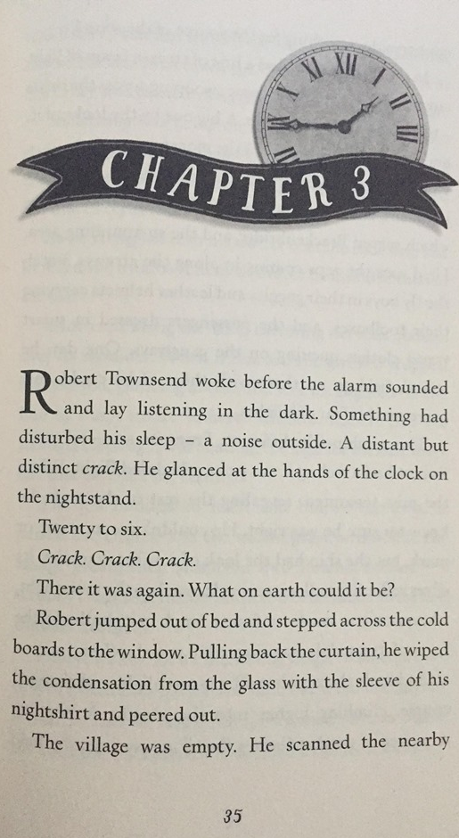

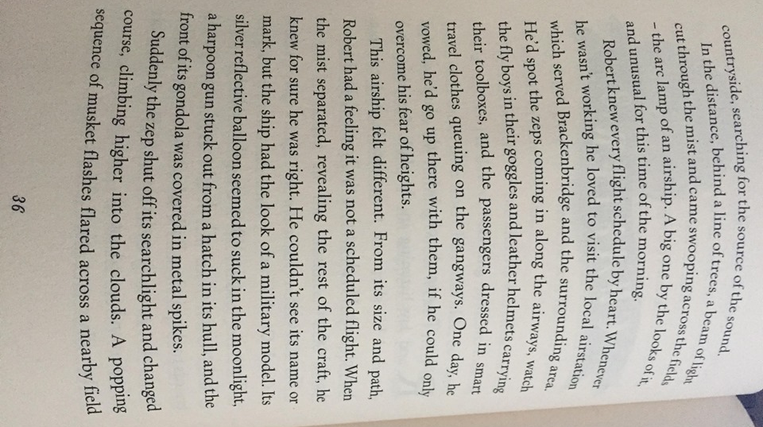

Underline the description of the old wooden shed that Robert enters and use this to draw a detailed drawing.
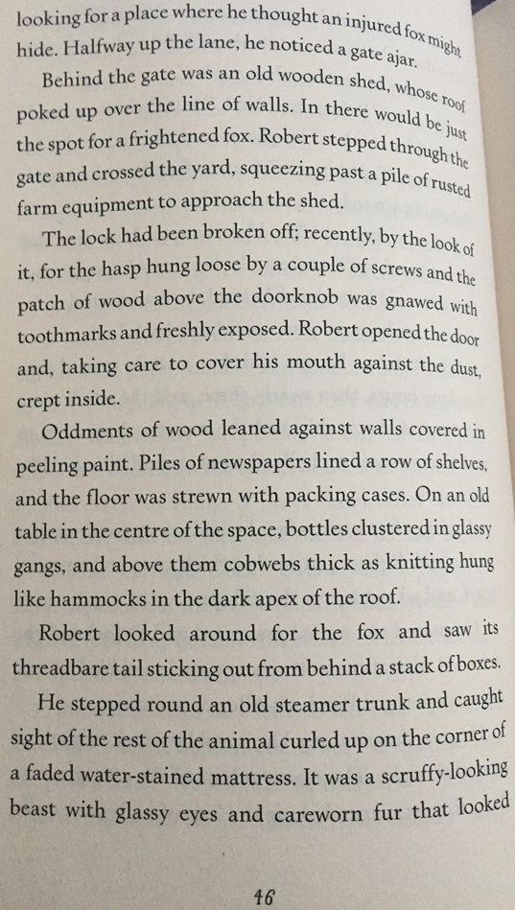

Neatly label your drawing with direct words and phrases from the text. It would be great to see your drawings coloured. Think about what colours you will use and why…

Lesson 3 – Writing
This lesson we are going to write a diary entry on the day that Robert finds the mechanimal. Read from page 42 which is the start of this day.
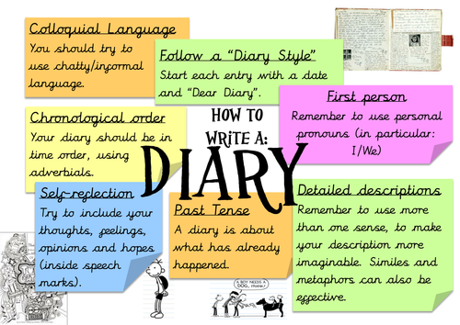
Think about what a diary entry consists of:

This is a great opportunity for you to include your literacy features such as expanded noun phrases, alliteration, fronted prepositional phrases, ISPACE, similes, personification, onomatopoeia, modal verbs…

You can also vary your types (simple, compound and complex) to vary your pace. Try to write 2 – 3 detailed paragraphs.
Challenge: Can you use a semi-colon to join two linking ideas? E.g. I crept inside the shed; cobwebs danced on the ceiling.

Date:
Dear Diary,
Extension Task
For your extension task draw role on the wall of Robert and find words to describe what he might look like on the outside and what he is like on the inside.
