Year 1 Maths Support Pack - Week 9
In this pack, you will find instructions on how to complete your Maths lessons for this week. We are learning about Place Value, number bonds and fact families this week and you will need to watch some short videos to help you. Follow the links on your home learning menu, or on our class page on the website, to watch the videos. You can then complete the worksheets by printing them, or viewing them on the screen and writing the answers on your own paper.
Week 9 Lesson 1: Representing numbers within 50
Watch the short videos, then complete the tasks below. 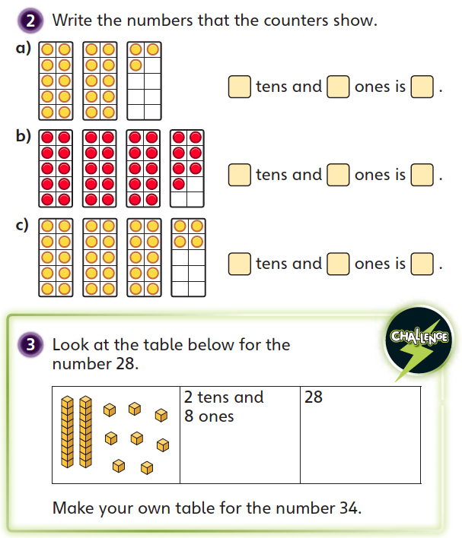
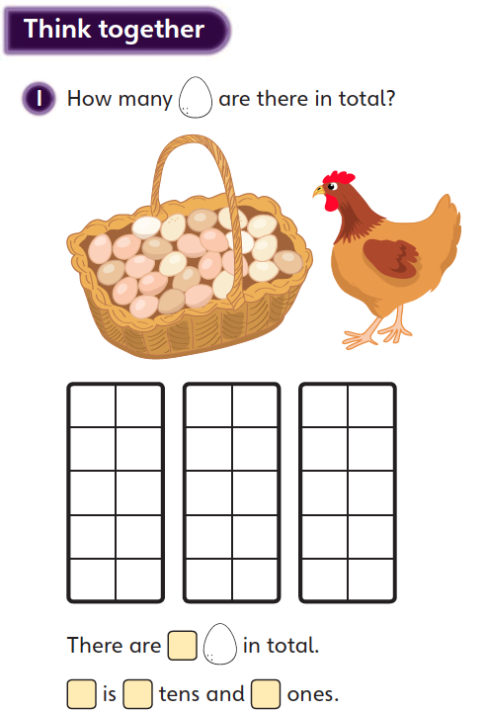
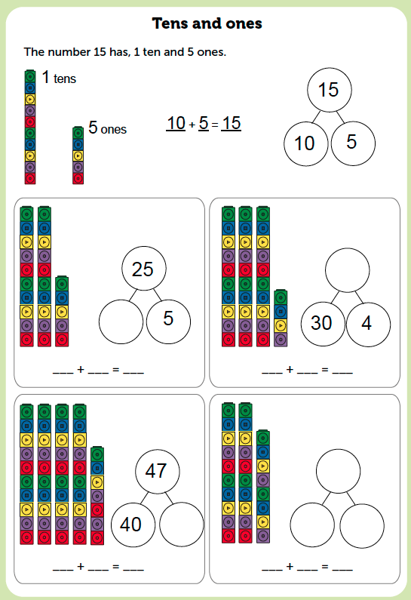
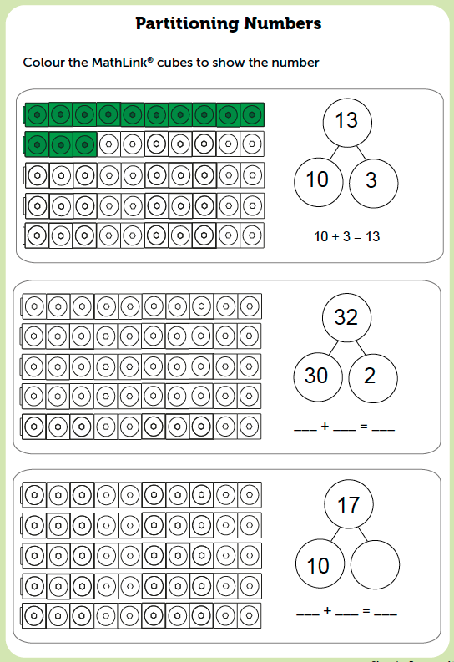
Lesson 2: Counting with tens and ones

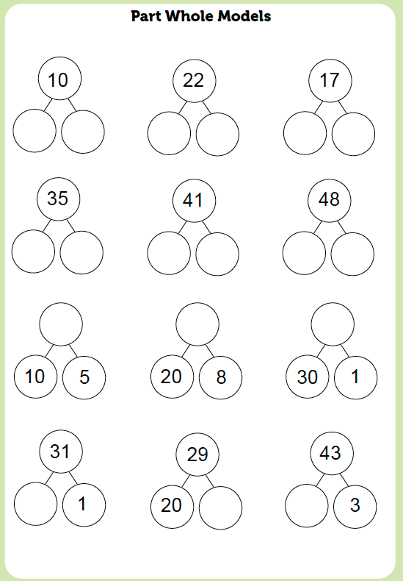

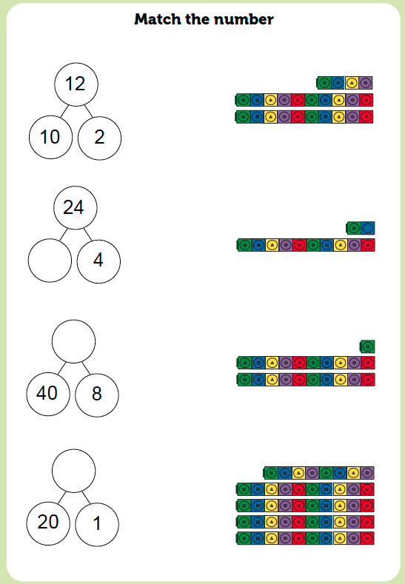

Lesson 3: Comparing numbers of objects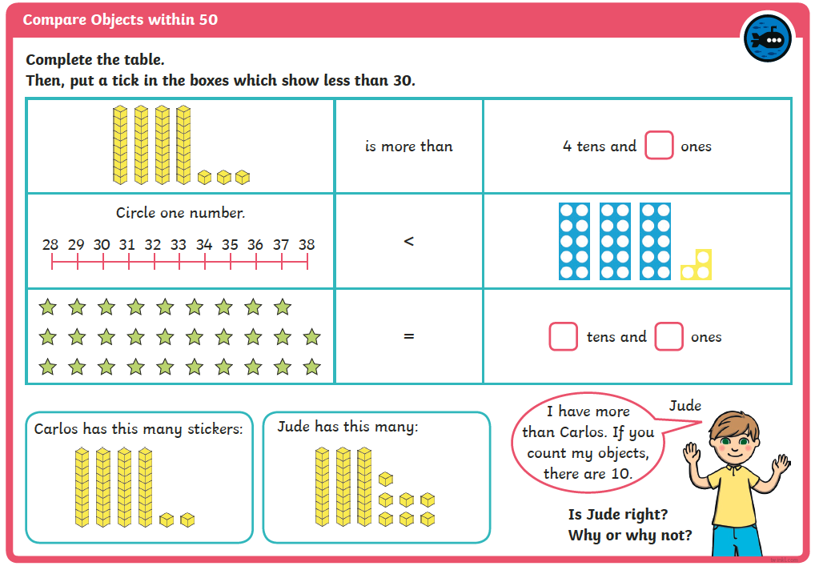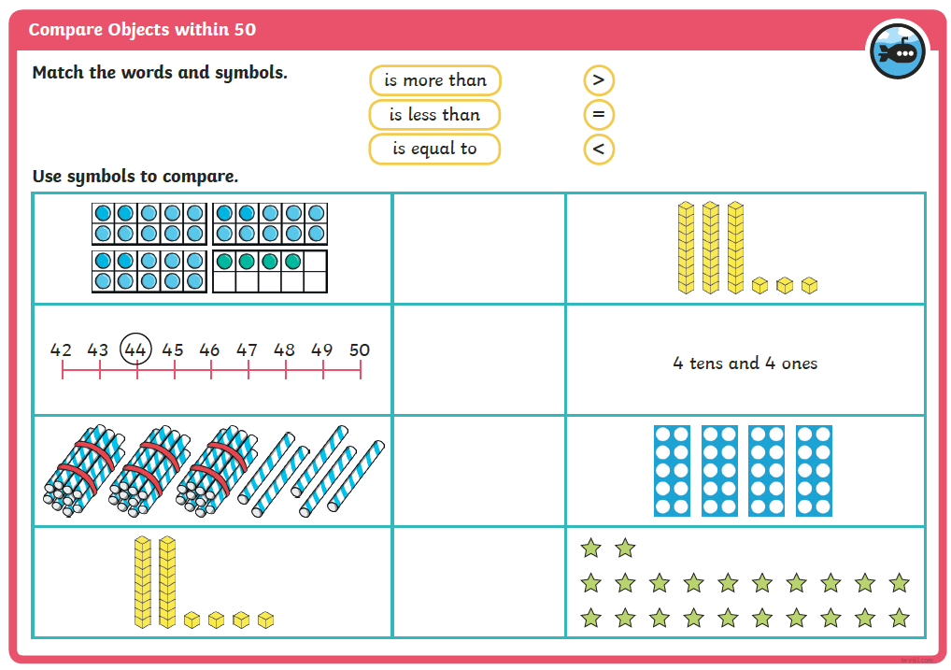
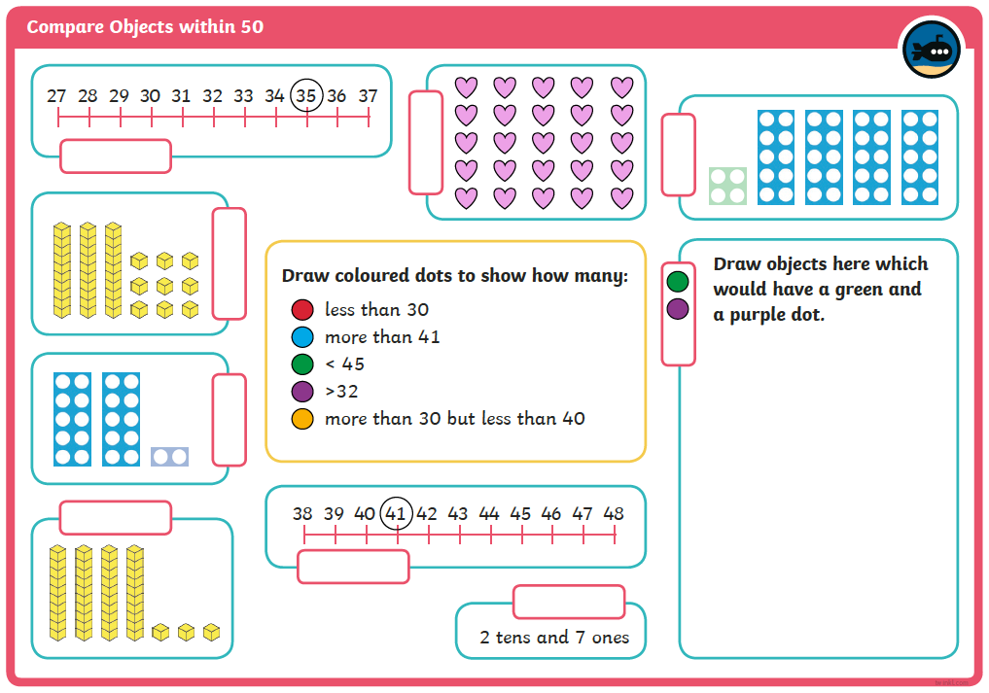

Challenges
