Year 2 Topic Support Pack – Week 11
Topic Task 1 – Geography
Read through the PowerPoint presentation to remind yourself what a physical and human geographical feature is. Then have a go at completing the activities.
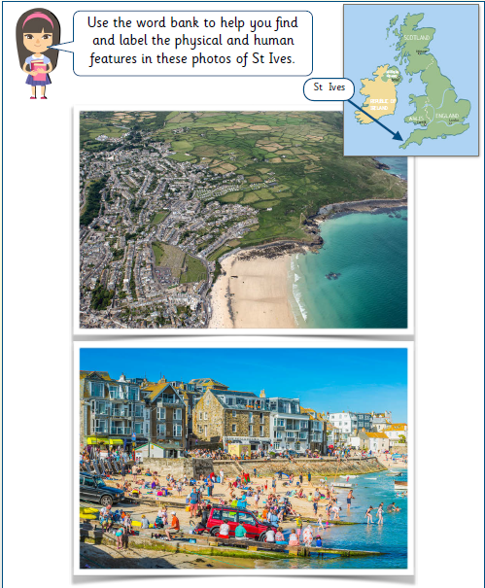

Can you now write a description of this seaside location?
____________________________________________________________________________________________________________________________________________________________________________________________________________________________________________
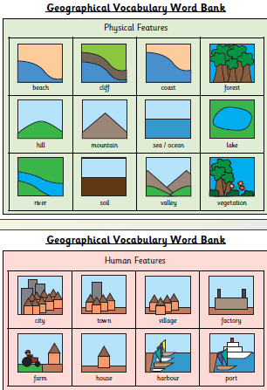

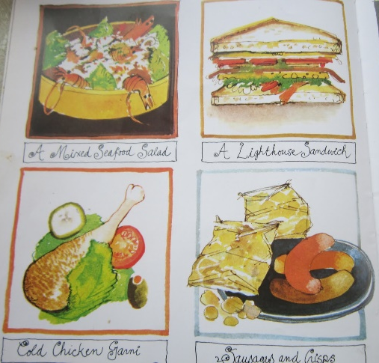
Topic Task 2 – Design & Technology
In The Lighthouse Keeper’s Lunch, Mrs Grinling makes Mr Grinling a delicious lunch every day for him to enjoy in the lighthouse. This includes a special lighthouse sandwich. Can you guess what ingredients are in Mr Grinling’s lighthouse sandwich?
Your task for this lesson is to design your own lighthouse sandwich. It can have in it whatever you would like. Draw and label your sandwich design in the box below:

Now can you use your best spreading, cutting and slicing skills to make your lighthouse sandwich?
Topic Task 3 – Science

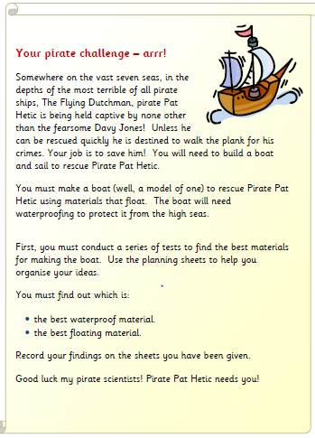

What are you trying to find out?
______________________________________________________________________________________________________________________
Which materials are you going to test?
______________________________________________________________________________________________________________________

What are you going to measure?
______________________________________________________________________________________________________________________
What are you keeping the same?
______________________________________________________________________________________________________________________
What are you going to change?
______________________________________________________________________________________________________________________
What equipment do you need?
______________________________________________________________________________________________________________________
I predict that…
____________________________________________________________________________________________________________________________________________________________________________________________________________________________________________

