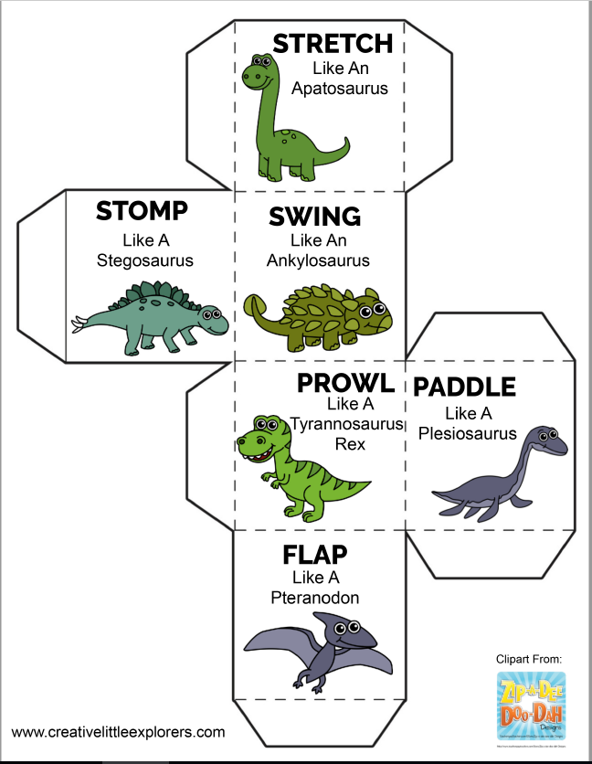

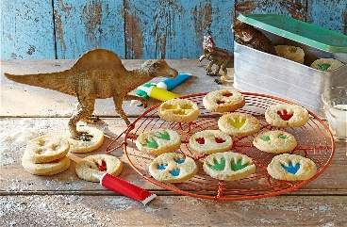
Dinosaur Biscuit Recipe
- 325g (11oz) plain flour, sifted, plus extra for dusting
- 200g cold salted butter, cut into cubes
- 125g golden caster sugar
- 1 vanilla pod, seeds scraped out
- 2 large free-range egg yolks
- 1-2 tbsp whole milk
- few plastic toy dinosaurs with different-sized feet
- red, yellow, green and orange flavoured writing icing pens
- 1 free-range egg, beaten

- Put the flour and butter in a food processor and blitz until it resembles fine breadcrumbs. Or rub together into a bowl and with your fingertips until it resembles fine breadcrumbs. Kids will love doing this.
- Add the sugar, vanilla, egg yolks and milk. Blitz again until it just comes together. If you’re not using a food processor, mix the sugar, vanilla and egg yolks with a knife, trying not to overwork the dough, until the mixture comes together in a smooth dough.
- Tip out onto a lightly floured surface and roll into a cylinder. Wrap tightly with cling film and chill for 1 hour.
- Preheat the oven to gas 6, 200°C, fan 180°C. Using a sharp knife, cut the dough into 1/2 cm discs and arrange on 2 lined baking sheets. Dip the dinosaur feet into plain flour, then press into the top of each biscuit to make several foot prints on each one. Kids will really love doing this.
- Brush with the beaten egg and bake in the preheated oven for 15-18 minutes, or until just golden.
- Remove from the oven and transfer to a wire rack to cool. While the biscuits are still warm, press the dinosaur feet into the indents to make them more distinct and leave to cool.
- Fill in the imprints with different-coloured writing icing and set aside until set. Kids will love decorating the biscuits with icing.
Tip: To make chocolate-flavoured biscuits substitute 25g of the plain flour from the biscuit mix with 25g of cocoa powder.

