Year 2 Home Learning Menu – Week 15
This week is the last full week of the school year! You have worked so hard at home that it is time to enjoy some different activities before your summer holidays officially begin! Here are some fun activities for you to complete at home this week. Enjoy!

Rainbow Treasure Hunt  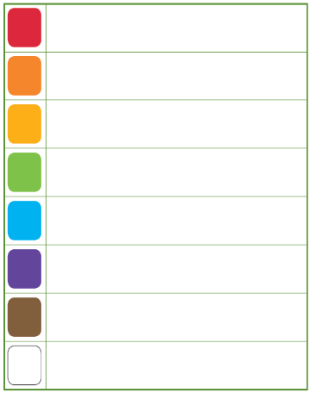 | 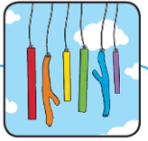  Rainbow Wind Chimes | Making Bubbles
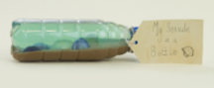  Seaside in a Bottle | 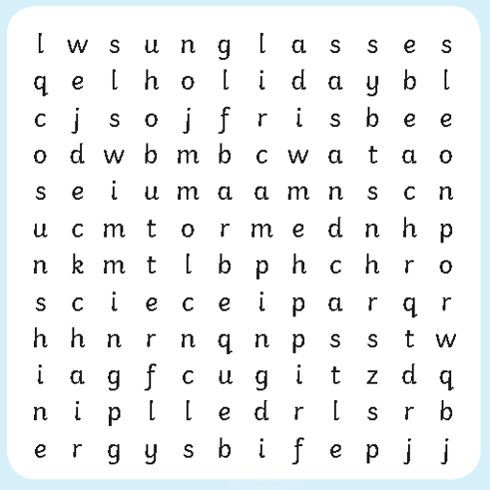  Summer Wordsearch | Summer Spot the Difference
Maths Mystery Game  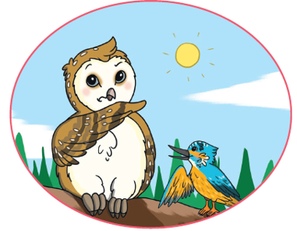 | 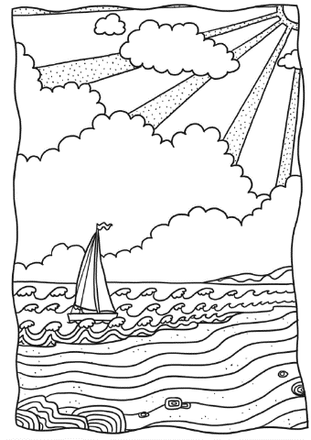  Summer Colouring | Sunshine Dot Painting

