Year 2 Maths Support Pack – Week 7
In this pack, you will find instructions on how to complete your Maths lessons for this week. We are learning about money this week and you will need to watch some short videos to help you. Follow the links on your home learning menu to watch the videos. You can then complete the worksheets by printing them, or viewing them on the screen and writing the answers on your own paper.
Lesson 1 – Recognising coins and counting and comparing amounts
First watch the video to remember the coins we have in the UK and their values. Then follow the second link to BBC Bitesize to learn how to count and compare amounts, refreshing your understanding of the greater than and less than symbols. Then complete the tasks below to check your understanding.

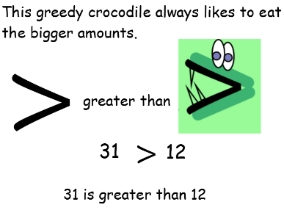
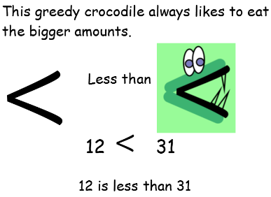
Remember!

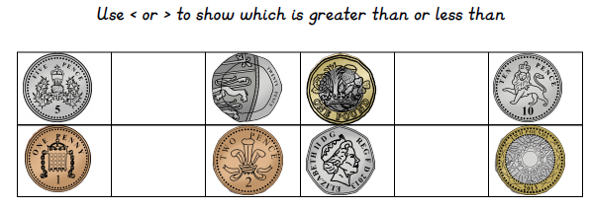
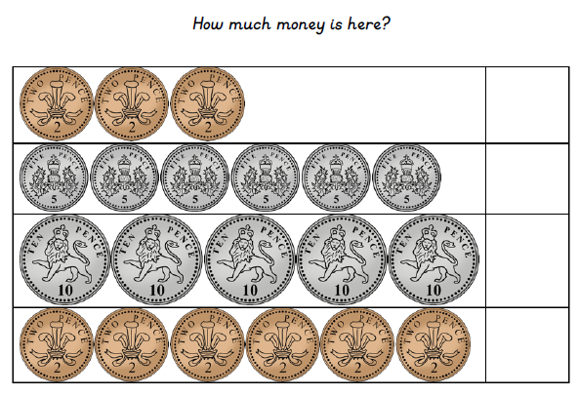
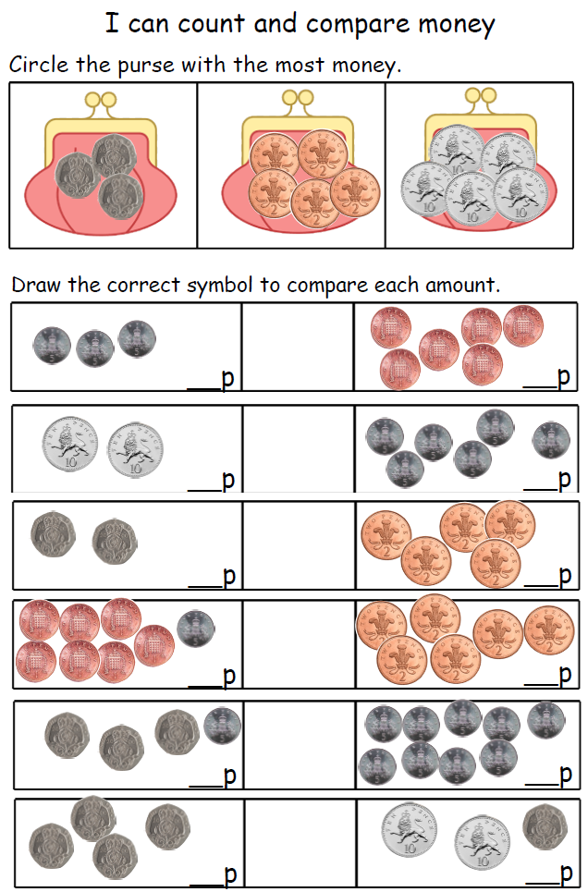
Extension – Now can you follow this link to learn about the different notes we have in the UK. Pause the video at the different points to see if you can answer the questions.
https://www.youtube.com/watch?v=5DDI_RlZB0c

Lesson 2 – Finding different combinations of coins to make the same amount
First watch the video to see how we can make 40p using three different combinations of coins. Then have a go at the activity below to think of different ways you can make the given amounts.
Remember! Use your counting in 2s, 5s and 10s to help you.
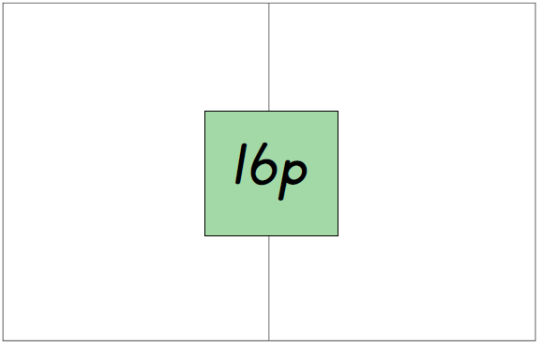

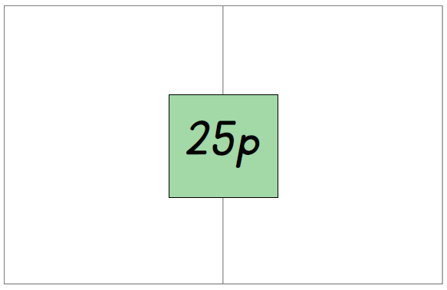
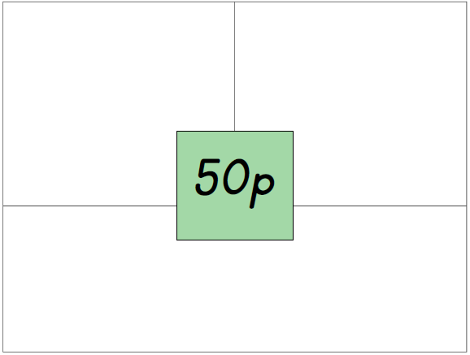

Chilli Challenge!
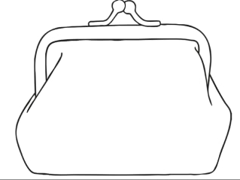
I have 26p in my purse. I only have three coins. What coins are in my purse?

Extra Hot Chilli Challenge!
What if I now had four coins. How could I make 26p?

Lesson 3 – Real-life experience of using money
Let’s Imagine! Can you set up a pretend shop in your home? Maybe it is a supermarket or a toy shop? Can you make price tags for each of the items in your shop maybe they are 5p, 17p, 39p, £1.50 or £4.67? Can you then use real coins or use the coins provided below to pretend to buy the different items in your shop?
Remember to take photos of you buying and selling and send to us!
