Literacy: Lesson 1
Watch Miss Ramsier reading the story ‘Aliens Love Underpants’ By Claire Freedman. Then complete the below activity, drawing the cheeky alien or the astronaut in the correct place.
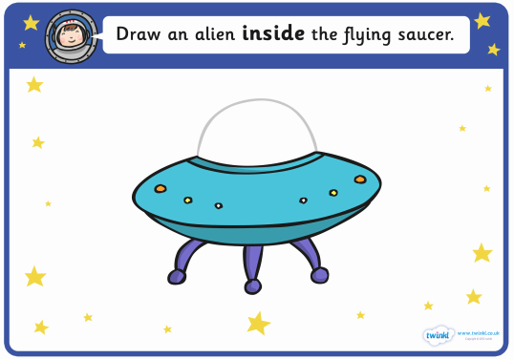

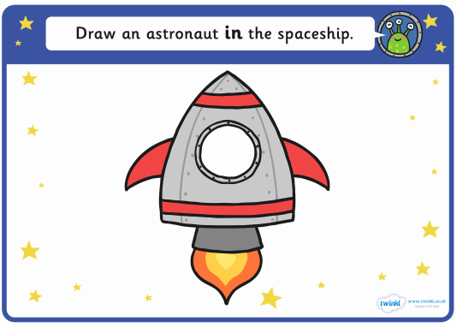
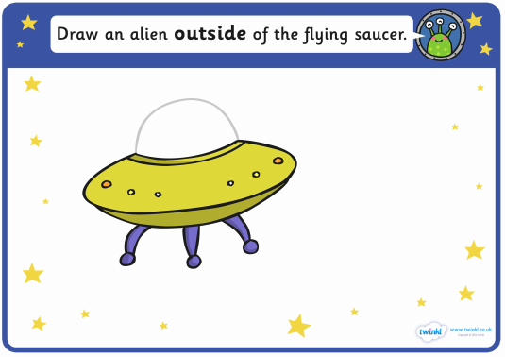

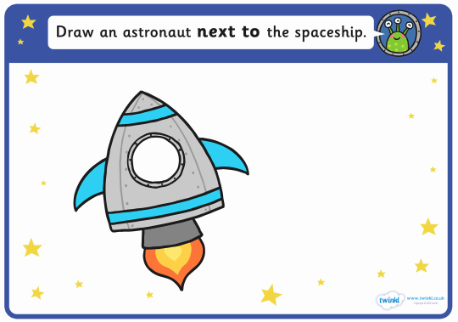

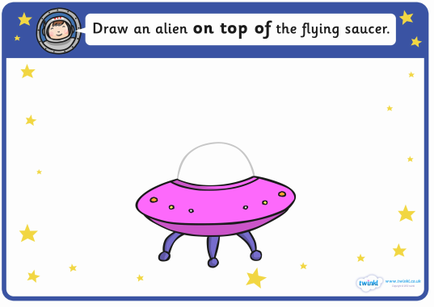

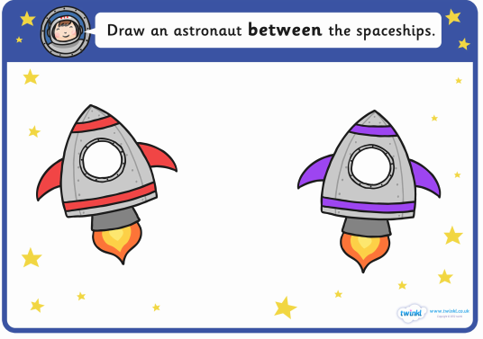

Literacy Lesson 2:
Oh no! Miss Ramsier and Mrs Stroe were asked to keep an eye on the cheeky aliens and we lost them all! Can you look closely at the picture and write a sentence, letting us know where the alien in each picture is. Do not forget to use positional language, for example: On top of, next to, underneath.
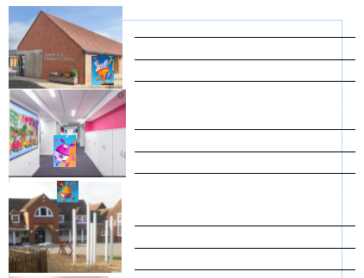
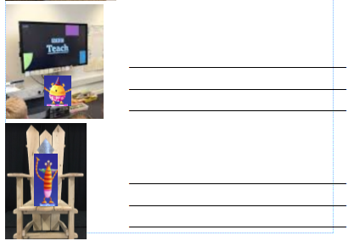
Literacy Lesson 3:
Watch Miss Ramsier reading the story ‘Aliens Love Underpants’ again. Can you write a list of all the things that the aliens love to do with the underwear?

