Year R Home Learning Menu – Week 6
Try to complete as many of the activities on this menu as you can during the week. If you would like more, log on to Teach Your Monster to Read, Oxford Owls or use some of the websites provided in the original pack. Please remember to take photos of any of the activities and upload onto EyLog so we can see what you have been doing!
Data Handling  Can you choose a category (favourite colour, favourite animal) and make a tally chart to collect data using tally marks. You could ring your friends or family to ask them  .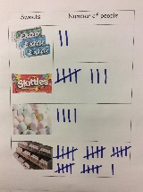  For more of a challenge answer some of these questions;  Which was the most popular?  Which was the least popular? | Phonics  Can you draw some letter sounds, special friends or tricky red words on your bathroom tiles using felt tips, bath crayons or a whiteboard pen (ask a grown up first). Then when a grown up calls one out you can squirt water on it to wash it away.  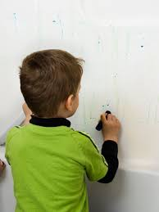  You could also give this a go. Write some words using chalk, or just with water and a paint brush.  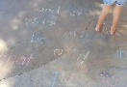 | Spring  On your daily walk take a picture of something beautiful. Then when you get home can you draw what you saw and took the photo of? We would love to see your photo with your drawing.  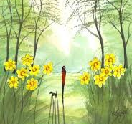  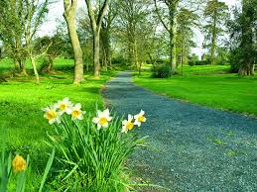  For more of a challenge you could write about your walk. Try using words like first, then and next. Can you use the red word saw?
Floating and Sinking  Can you build a boat using items from your recycling that you think will float? Then test it out in the bath or the sink.  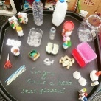  For a further challenge can you finish the following sentences;  I made my boat out of…….  When I tested my boat it…….  Next time I would ……. | Garden Potion  Can you make your own garden potion. Do you have a jar, plastic tub or mixing bowl you could use? You might use flowers, petals, leaves, grass or anything you might find on your daily walk.  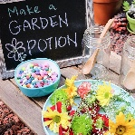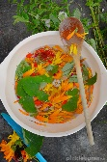  For a further challenge you might want to; Write a list or recipe of what you put into your potion.  Answer these questions: What could you smell? What colours were there? | Trolls: A Cosmic Kids Yoga Adventure  Become stronger, calmer and stronger by joining in with this active screen time.  https://www.youtube.com/watch?v=U9Q6FKF12Qs

