Year 2 Topic Support Pack – Week 10
Topic Task 1 – History
Can you carry out some research to find out more about lighthouses? Complete this research sheet or create your own poster about lighthouses to show what you have found out.
How does a lighthouse work?
_______________________________________________________________________________________________________________________________________________________________________________
What is a lighthouse?
______________________________________________________________________________________________________________________________________________________

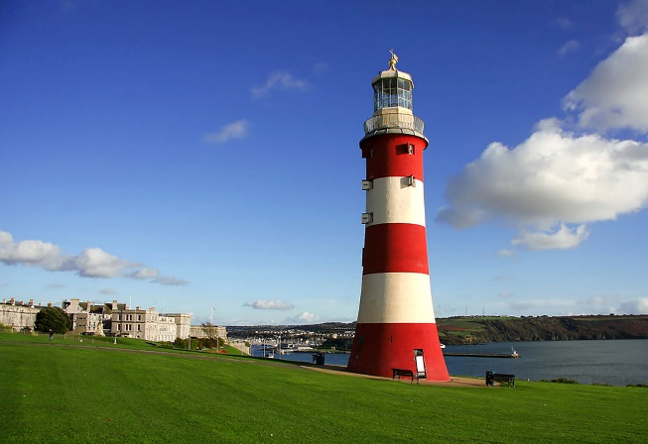
What do lighthouse keepers do?
______________________________________________________________________________________________________________________________________________________
Where are lighthouses found?
________________________________________________________________________________________________________________________________________________________________
Topic Task 2 – Art
Andy Goldsworthy creates artwork using natural resources from the environment. Can you create your own artwork in the same style as Andy Goldsworthy?
Take a photo of your artwork to send on the VLE.
Here are some of Andy Goldsworthy’s creations to help inspire you!
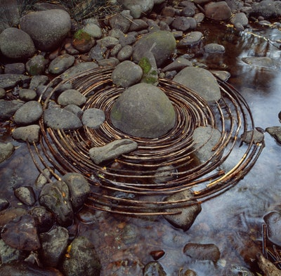
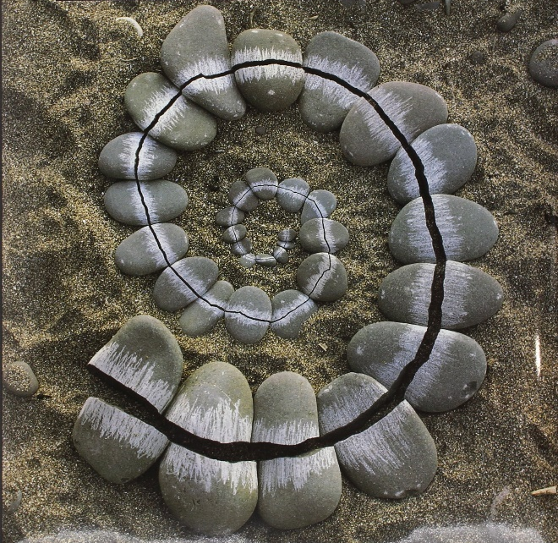
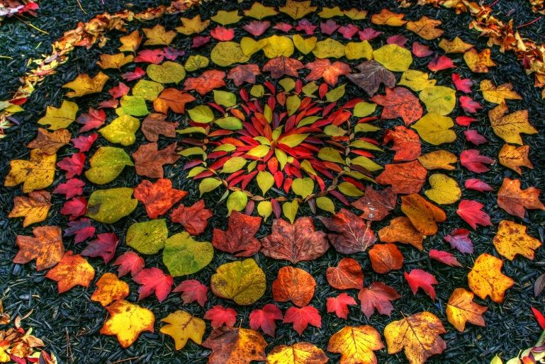
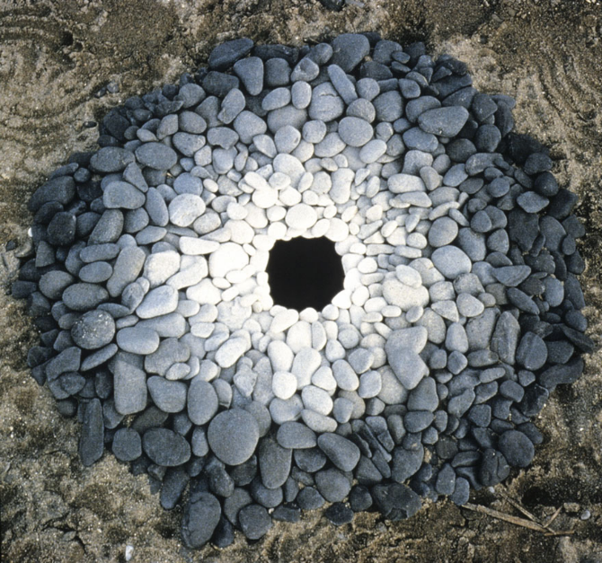
Topic Task 3 - French
https://www.youtube.com/watch?v=rAzYpgvmtII
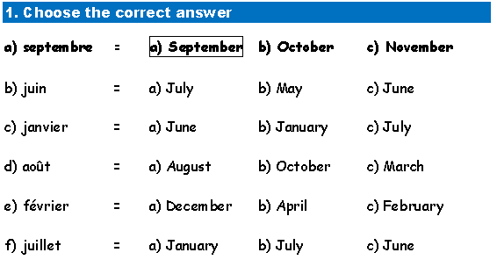
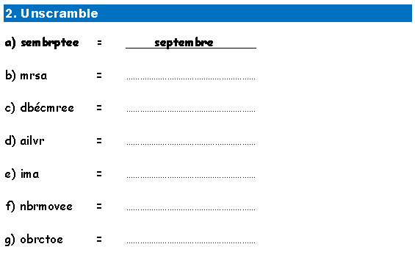
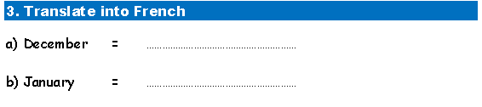
Watch the clip to learn the months of the year and how to pronounce them. Practice saying the months of the year. then have a go at this sheet.

