Year 2 Home Learning Menu – Week 14
Have a go at as many of the activities as you can. There are 3 Maths and 3 English lessons for you to complete which you will find more details of in the Maths and English Support Packs. You will need to work through the lessons in order. There are also 3 topic based activities for you to complete which link to the learning you would have completed at school.

Maths task 1  To measure millilitres  Watch the video to recap capacity and volume and how to read millilitres on a scale. Then complete the tasks to show your understanding of measuring in millilitres.  https://classroom.thenational.academy/lessons/to-use-millilitres | Maths task 2  To measure mass in grams  Watch the video by following this link for a short introduction to mass.  https://www.youtube.com/watch?time_continue=339&v=9dwdO_ISPL8&feature=emb_logo  Then follow the link below to find out in more detail how to measure mass in grams. Read through the learning summary (ask an adult to help) and then complete the activities to show your understanding.  https://www.bbc.co.uk/bitesize/articles/zcdrsk7 | Maths task 3  To measure mass in kilograms  Now you can measure mass in grams, have a try at measuring in in kilograms!  Follow the link below and read through the learning summary (ask an adult to help) and then complete the activities to show your understanding.  https://www.bbc.co.uk/bitesize/articles/z3qk3j6
English task 1  Take a look at the picture of the tiny dragon! Where do you think it has come from? What do you think it is? Have a go at answering the questions using your best imaginative ideas! | English task 2  No-one knows much about the tiny dragon. In order for people to find out more about him, you are going to create an information report. In this lesson you need to plan the ideas that you are going to include in your report. Complete the planning template with your ideas. | English task 3  Now that you have planned your report, you need to write all about the tiny dragon. Look at the example to remind yourself of how to write an information report. Then use your plan to help you write your own about the dragon.
Topic task 1 – Art  Watch the video and follow the instructions to learn how to draw your own pirate!  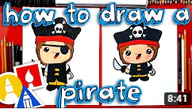  https://www.youtube.com/watch?v=mvYF2qEiNMI | Topic task 2 - DT  As a final piece to finish our seaside topic can you create your own shoebox seaside scene to show everything that you have learnt? There are examples in the topic pack.  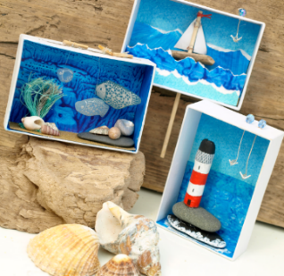 | Topic task 3 - History  Look through the slides to find out more about seaside holidays from the past. Can you tell the difference between seaside holidays from 100 years ago, 50 years ago and now?  Cut out and sort the selection of images into those from the different time periods. How can you tell which is which?
Extension tasks:
- Maths – Log on to your MyMaths and complete the measurement activities.
- English – Can you write another report, this time on one of the strange looking creatures in your pack?
- Topic – Talk to the grown-ups in your life about seaside holidays they went on when they were younger. What did they do? Where did they go? What did they like?

