Year 2 English Support Pack – Week 8
Lesson 1 – Contractions
https://www.bbc.co.uk/bitesize/topics/zvwwxnb/articles/zcyv4qt
Watch the BBC clip to remind yourself of what a contraction is.
A contraction is when you combine two words to make one shorter word, using an apostrophe to replace missing letters.
Now read through these sentences from The Pirates Next Door. Can you underline any contractions? Once you have found them, can you write above each one what the original two words are? The first one has been done for you.
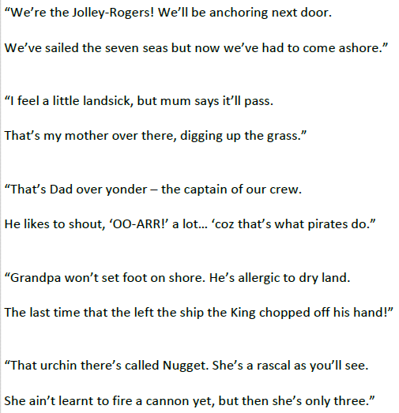
We are
Lesson 2 – Rhyming words
The Pirates Next Door is a story that includes rhyming words. These are different words that end in the same sound so they sound very similar.

Follow this link and complete the quiz to test your knowledge on rhyming words.
https://www.educationquizzes.com/ks1/english/rhyming-words-1/
Now try this one:
https://www.educationquizzes.com/ks1/english/rhyming-words-2/
If you are unable to follow the links to complete the quiz online, they are included in this pack for you.

Next, sort the words on the next sheet into groups by putting together all the words that rhyme. Remember to look and listen for the sound at the end of the word but these sounds may be spelt differently. Copy the words into the boxes in their groups.

Chair Cheap Deep
Sheep War Claw
Floor Wear Heap
Hair See There
Tree Score Flea
Compare Silly Happy

Quiz 1
1. Which word rhymes with hat?  pit  sat  chin  red | 2. Which word rhymes with shark?  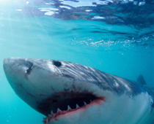  shin  fish  bark  happy
3. Which word doesn't belong in this group?  shine  fine  lane  line | 4. Which word doesn't belong in this group?  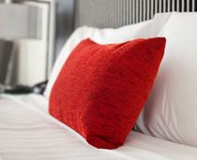  red  head  bed  show
5. Which word doesn't belong in this group?  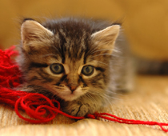  string  rat  flat  cat | 6. Which word doesn't belong in this group?  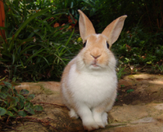  hop  happy  stop  shop
7. Which word rhymes with chair?  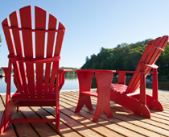  pear  head  stone  rubber | 8. Which word doesn't belong in this group?  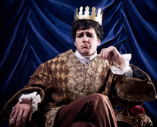  king  flight  fling  wing
9. Which word rhymes with shin?  thin  hat  slime  lolly | 10. Which word rhymes with snail?  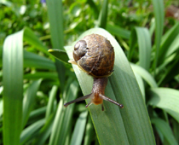  whale  fit  fat  shine

Quiz 2
1. Which word does not rhyme with 'hill'?  pill  fail  drill  still | 2. Which word doesn't rhyme with the word 'clock'?  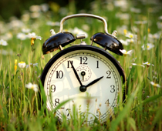  sock  shock  stone  lock
3. Finish this poem: I'm horse riding...  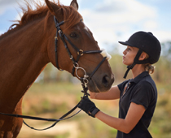  Whilst he goes and plays football.  Whilst he goes swimming.  Whilst he goes dancing.  Whilst he goes gliding. | 4. Finish this poem: We will ride on the train...  Then go on a bus.  Then go on a coach.  Then walk.  Then go on a plane.
5. Finish this poem: As I walk around...  I don't want to hear a sound.  I want to look at the pictures.  I don't want to hear any music.  I don't want to hear your feet moving. | 6. Finish this poem: I have two lovely blue suits...  Now I need to buy some matching shoes.  Now I need to buy some matching socks.  Now I need to buy some matching boots.  Now I need to buy a tie.
7. Which word rhymes with the word 'world'?  shower  now  curled  stole | 8. Which word doesn't rhyme with the word 'mouse'?  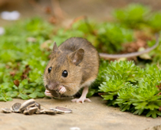  cat  house  grouse  louse
9. Finish this poem: Put your coat on or you'll freeze...  Now do what I've asked.  Now do what I've asked, please.  Do it now.  I love snow! | 10. Finish this poem: Before you jump, always check...  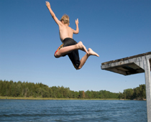  If you don't, you could hurt yourself!  If you don't, you could injure your back!  If you don't, you could break your neck!  If you don't, you could break your finger!

Lesson 3 – Pirate Poetry
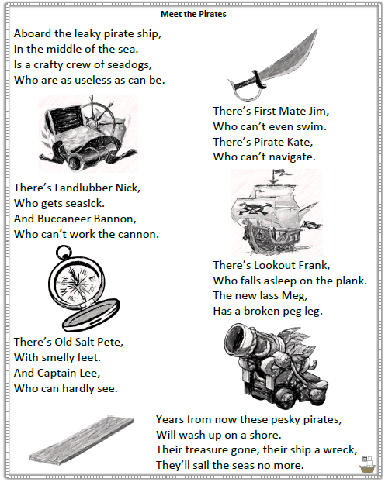
Read through the poem ‘Meet the Pirates’. Can you circle all the rhyming words? What do you notice about where these words are in the poem?
Now have a go at answering these questions about the poem.

1. Can you match these items to the pirates? One has been done for you.
Plank – Lookout Frank
Compass - _______________
Cannon - ________________
Peg leg - ________________

2. What makes Buccaneer Bannon so useless?
____________________________________________

3. What word gives us a clue that the pirate ship is sinking? ________________

4. What problems could occur because of Frank?
________________________________________________________________________________________

5. Can you identify pirate words from the poem?
____________________________________________________________________________________________________________________________________

Extension task –
If you want an extra challenge, why not have a go at writing your own pirate poem. Can you try and include contractions and make your poem rhyme?

_________________________________________________________________________________________________________________________________________________________________________________________________________________________________________________________________________________________________________________________________________________________________________________________________________________________________________________________________________________________________________________________________________________________________________________

