Maths Support Pack – Week 13
This pack includes your 3 maths lessons for the week. The pack includes:
- Maths starters to keep your brains working fast!
- 3 maths lessons
- Worksheets
- Extension Task
This pack is to help you, so read through as carefully as possible so that you know what to do for your maths this week. In week 13, we are going to be testing our knowledge with word problems. Try your best with everything. Happy Learning Year 5! 😊

Lesson 1 – Addition and Subtraction Word Problems
Starter –
Complete the maths challenge: 14 -2 X2 -5 -10 X3 X5 X2 =
Challenge Question: 35 -2 X2 -5 -10 X6 X3 X4 =
Input –
If you feel you need a refresher on how to pick out key information from word problems, watch the video of Miss Riley explaining how we would do this. You can watch this on the VLE or on the website.
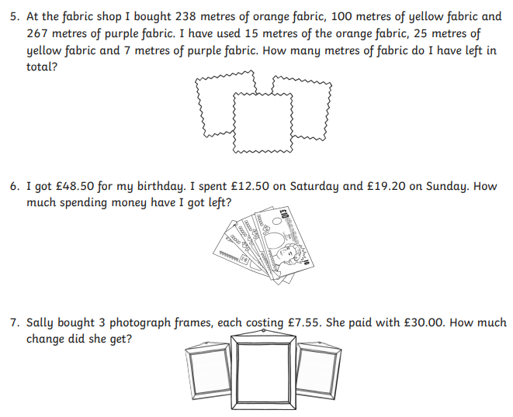
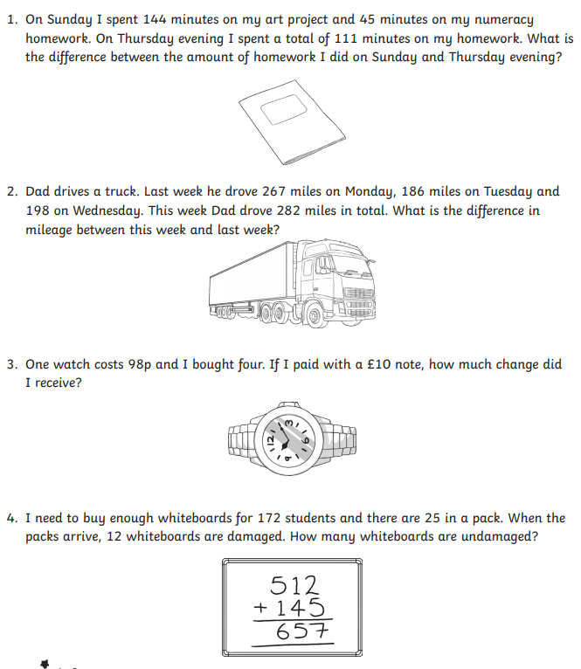
Activity:

Lesson 2 – Multiplication and Division Word Problems
Starter –
- Players on a football team + people in your house – what year group you will be next year=

- Number of ninja turtles there are x how many adults work in your current classroom

Input –

If you feel you need a refresher on how to pick out key information from word problems, watch the video of Miss Riley explaining how we would do this. You can watch this on the VLE or on the website.
Activity:
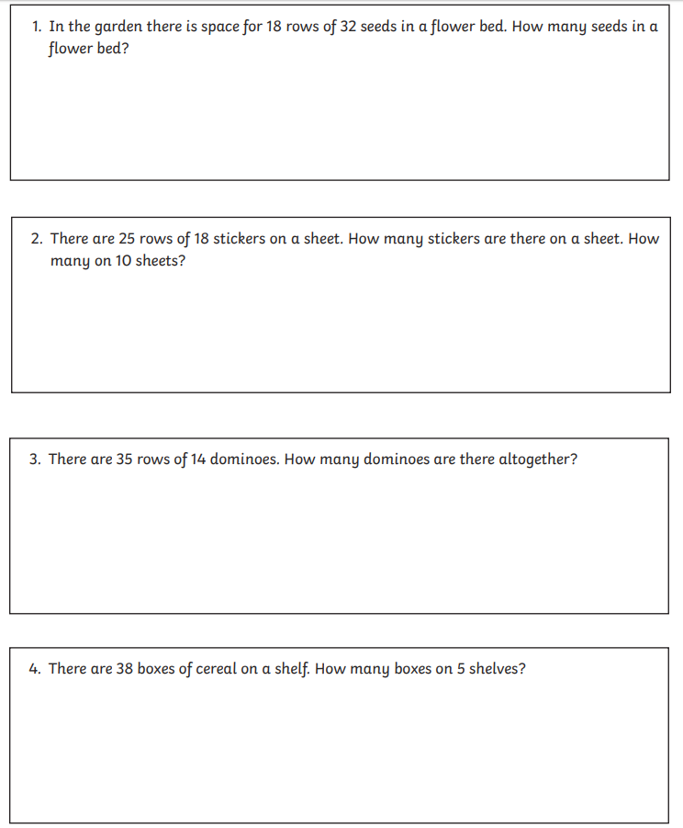
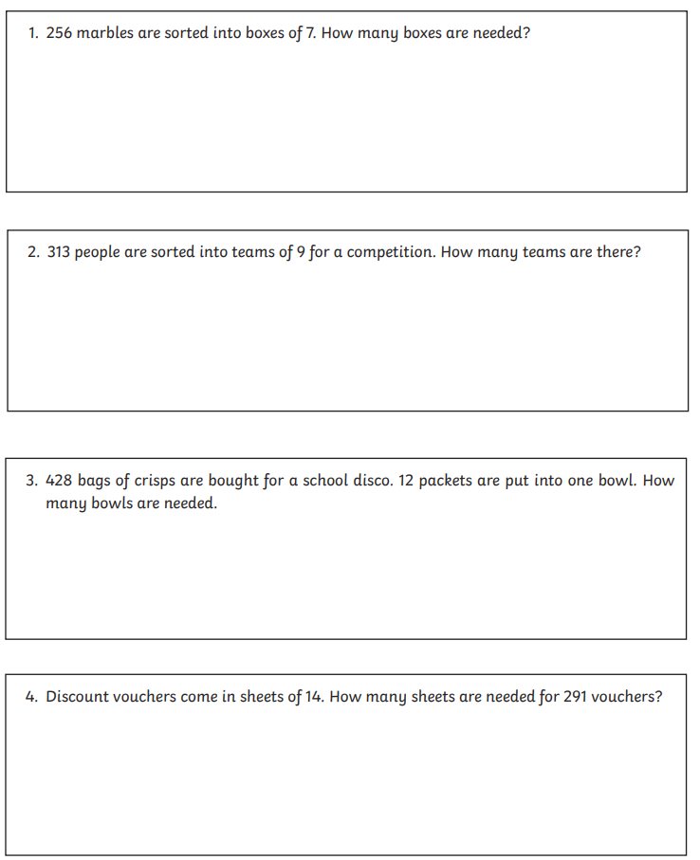
A B

Lesson 3 – Data Handling Word Problems
Starter –
https://www.topmarks.co.uk/maths-games/daily10

Input –
If you feel you need a refresher on how to pick out key information from word problems, watch the video of Miss Riley explaining how we would do this. You can watch this on the VLE or on the website.

Activity:
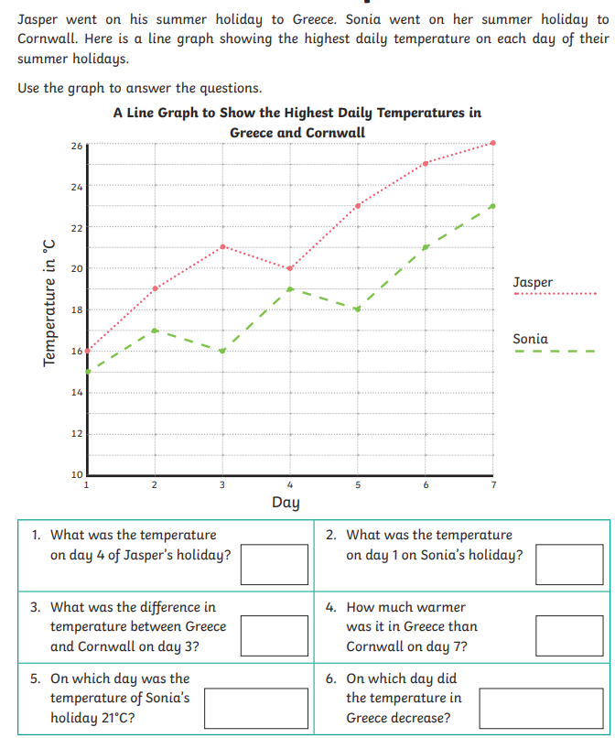

Well done for completing you Maths Pack! An extension is below for you to have a go at

Extension –

Make up your own word problems for any of these areas of maths. You can test someone in your house to see if they can answer them.

