Year 2 Maths Support Pack – Week 12
In this pack, you will find instructions on how to complete your Maths lessons for this week. We are learning about division this week and you will need to watch some short videos to help you. Follow the links on your home learning menu to watch the videos. You can then complete the worksheets by printing them, or viewing them on the screen and writing the answers on your own paper.

Lesson 1 – Sharing and the ÷ symbol
First watch the two Times Table Rockstars videos to remind yourself about sharing equally and how this relates to the ÷ symbol. Then have a go at answering the questions below to check your understanding.
When a quantity is shared equally between people, what you're calculating is how much each person gets (how big each share is).
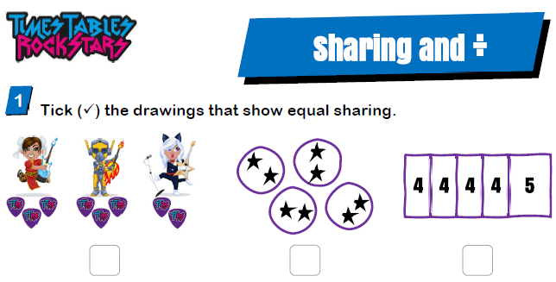

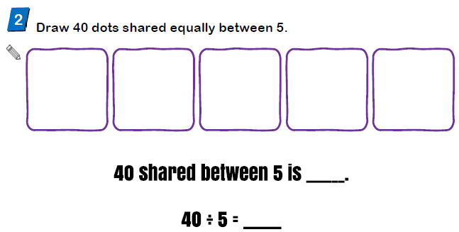

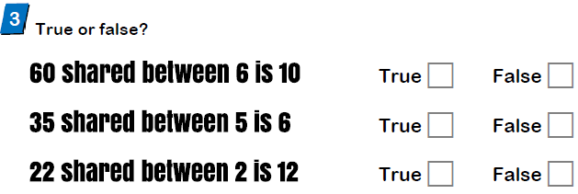

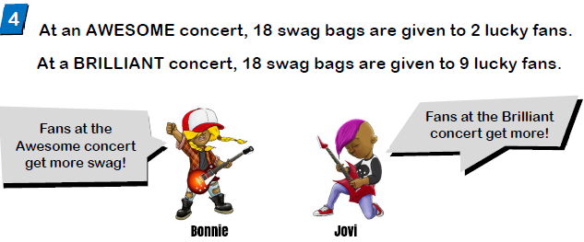

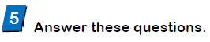

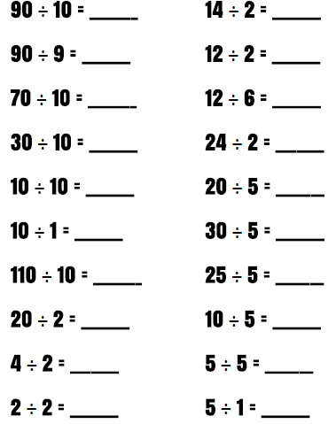

Lesson 2 – Grouping and the ÷ symbol
Today's lesson moves on from yesterday’s division as sharing to understanding division as grouping. When a quantity is put into equal groups, what you’re calculating is ‘how many groups’’. Watch the first video which shows how to put objects into equal groups and focuses on the language of 'into groups of'. Then watch the second video to look at the connection between 'into groups of' and the ÷ symbol.
There's also a reminder that division questions can be thought of as 'how many groups of … make …?' (for example how many groups of 10 make 80?).
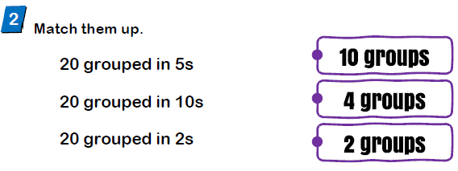
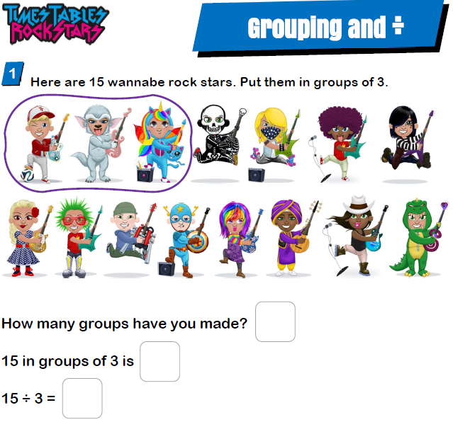
Now have a go at answering the questions below to check your understanding.
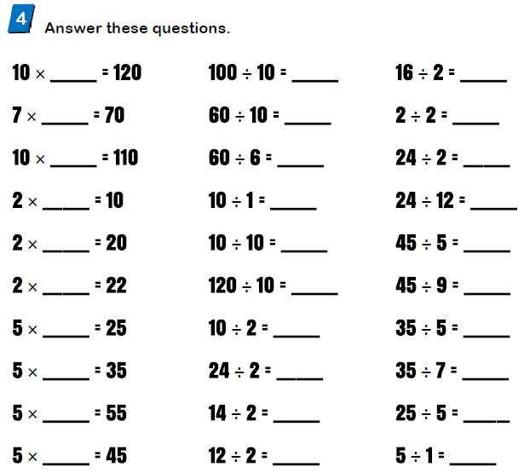
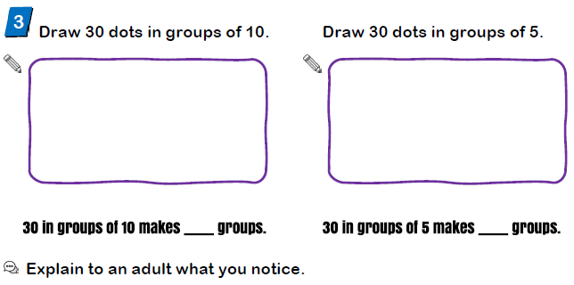
Lesson 3 – Odd and Even numbers
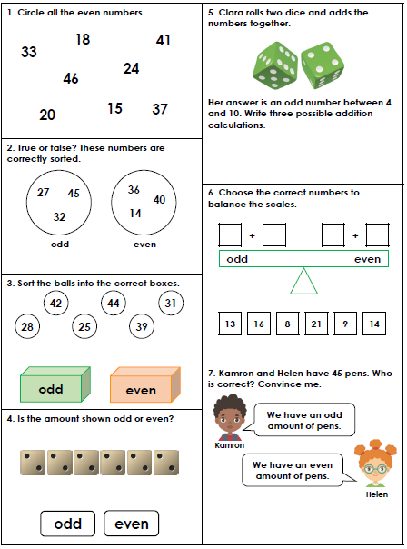
In today's lesson you will learn all about odd and even numbers with Katie. Watch the video and try and answer the questions. Have a go at this worksheet to show your understanding of odd and even numbers. You could use your own objects from around the home to help find whether an amount is odd or even.

