Year 4 Home Learning 4.5.20 – 8.5.20
Topic Support Pack

Lesson 1 – History

The information below is there to help you summarise who the Anglo- Saxons were and why they came Britain. This will be key in future history lessons.

Taken from: https://www.natgeokids.com/uk/discover/history/general-history/anglo-saxons/

Anglo-Saxon facts: Who were they?
The Anglo-Saxons were a group of farmer-warriors who lived in Britain over a thousand years ago.
Made up of three tribes who came over from Europe, they were called the Angle, Saxon, and Jute tribes. The two largest were the Angle and Saxon, which is how we’ve come to know them as the Anglo-Saxons today.
They were fierce people, who fought many battles during their rule of Britain – often fighting each other! Each tribe was ruled by its own strong warrior who settled their people in different parts of the country.

When did the Anglo-Saxons invade Britain?
The Anglo-Saxons first tried invading in the 4th century, but the Roman army were quick to send them home again! Years later – around 450AD – the Ancient Romans left Britain, the Anglo-Saxons seized their chance and this time they were successful!
They left their homes in Germany, the Netherlands and Denmark and sailed over to Britain on wooden boats. Many of them were farmers before they came to Britain and it’s thought they were on the look-out for new land as floodwaters back home had made it almost impossible to farm.

CHALLENGE: Without using google, draw what you think an Anglo-Saxon person would have looked like. You can use the information provided to help you. Annotate your drawing explaining why you think they might look like this.

Lesson 2 – Computing
To support you later on in your learning, you need to write a short story on any topic of your choice. Eventually, we will be including sound effects with this, and you should think about what sound effects that you could use.
Here is a link to a story being read with sound effects.
https://youtu.be/lF-EHOTLRyU

Lesson 3 – Science
Using the sheet provided, look at the different electrical items around your home. Write down which ones are operated by the mains or batteries. There may be some appliances which are powered by both. It is not essential to use the sheet below but it is there as a guide.

Can you begin to think of any advantages and disadvantages to battery and mains power?

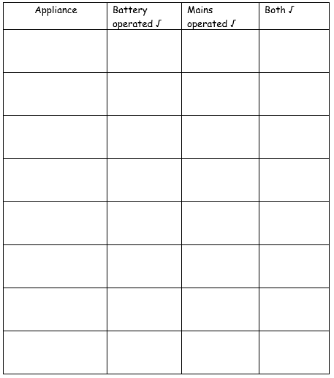

CHALLENGE: Explain how we receive electricity from mains and batteries. Use the information provided and your own research to inform your explanation.

