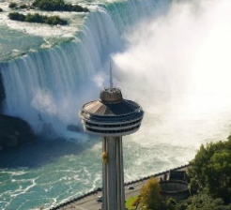
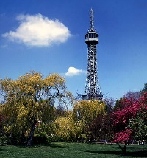
11.5.20-15.5.20
Year 4 Home Learning Tasks

Throughout the week complete the following tasks. If you have any questions, please contact either Miss Bradley or Mr Ward on VLE. Please find attached any helpful resources for the tasks below.
Literacy 1  Using your knowledge and understanding of ‘The Highway Man’ write what the feelings of the characters using the extracts from the poem. | Literacy 2  You need to write a love letter as if you are Bess. You are to imagine the Highway Man is late returning to you and in your worry, you have decided to write a love letter to him. | Literacy 3  Write 6 expanded noun phrases about what you can see in your home and garden. Think carefully about the prepositions you use. Make sure you use a different preposition in each of your 6 expanded noun phrases.
Maths 1  Complete Lesson 1 on Week 2 of the White Rose Home Learning website. You will be focusing on dividing 2 digits by 10. Use the support document to help you. | Maths 2  Complete Lesson 3 on Week 2 of the White Rose Home Learning website. You will be focusing on hundredths as a decimal. Use the support document to help you. | Maths 3  Complete Lesson 5 on Week 2 of the White Rose Home Learning website. You will be focusing on dividing 1 or 2 digits by 100. Use the support document to help you.
Topic 1 – Design and Technology  Following our HMS Victory unit, design and annotate a boat which you can make with recycled materials. Think carefully about how it will float and what materials will be suitable for water. Start collecting your recycled materials, to help you make your boat next week.  . | Topic 2 – Science  Research the different symbols and their meanings, which represent the different components that can be used in an electrical circuit. | Topic 3 – French  Research and list 10 sports or hobbies in French. Use the table provided to record your information.
Challenge 1: Create a reasoning or problem solving question based on the area of Maths you have been looking at this week. Ask a member of your family to solve it. Go through the question with them, explaining the Mathematical knowledge.
Challenge 2: Research and explain how the surface area of an object affects if it sinks or floats.
Challenge 3: Choose one of the sports or hobbies you found in French and write it in the sentence ‘I like…’ or ‘I play…’ in French.

Don’t forget to read at home every night for 10 minutes and practice your times tables. Why not try and watch the BBC iPlayer videos as well.

