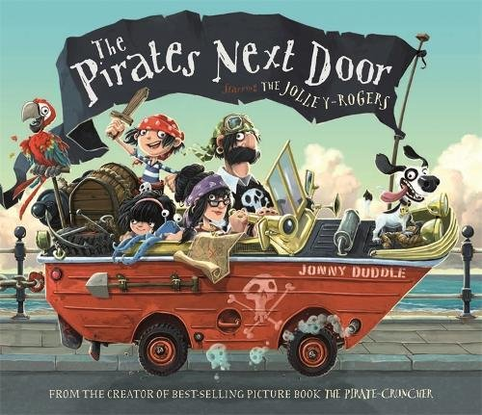

Now have a go at answering these questions about the story. Write down your answers and then ask your grown up to check them. The answers are on a separate page

- What is the name of the town where Matilda lives?
- What was unusual about Jim Lad’s dog?
- What word does Jim Lad use to describe his sister Nugget?
- Why do you think no one else would sit by Jim at school?
- Why have the pirates come to the town?
- Who called the council to see what they could do?
- How did Mr Shaw feel about the pirates? Why?
- What number house did the two Miss Yates live at?
- How many signatures did Mrs Bevan collect on her petition?
- Why were there crosses on every lawn when the pirates left?

