Maths Answer Pack – Week 13
Lesson 1 – Word Problems- Addition and Subtraction
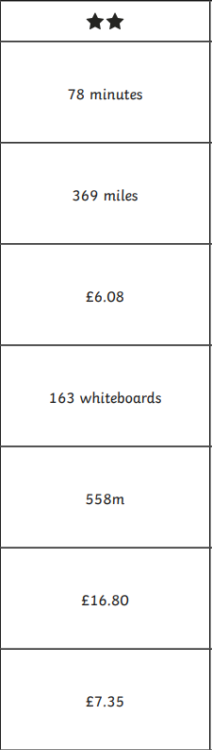

Lesson 2 – Word Problems- Multiplication and Division

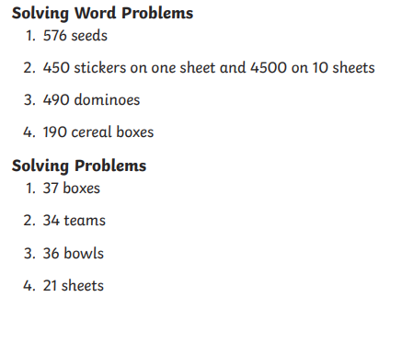
Lesson 3 – Word Problems- Data Handling

