Year 1 Home Learning Menu – Week 15
You have all been amazing during lockdown. Miss Ramsier and Mrs Stroe are SO proud of all the amazing home learning you have completed. You are all SUPERSTARS!!! As a treat we have planned 9 fun activities this week for you to complete. Enjoy!

Activity 1  Under adult supervision, try to make yourself a sandwich. Set up a teddy bears picnic in your home and enjoy your sandwich!  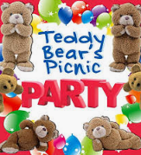 | Activity 2  Design your own Love Monster in your own support pack. Give them a face and a name.  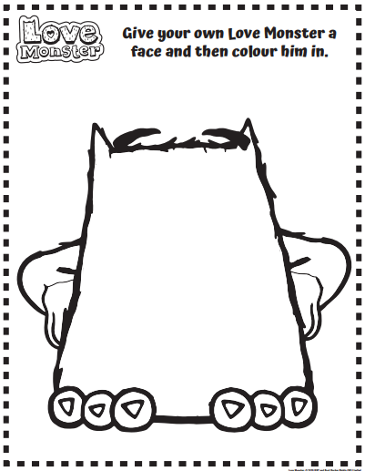 | Activity 3  Complete the nature scavenger hunt in your support pack.  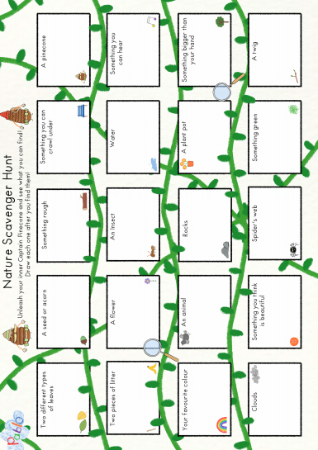
Activity 4  Spend half an hour playing games on the CBeebies website.  www.bbc.co.uk/cbeebies | Activity 5  Make a blanket fort and enjoy reading a book inside it  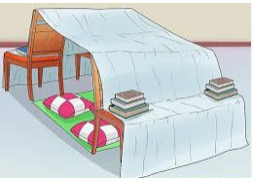 | Activity 6  Do some yoga from Youtube, at school we use ‘cosmic kids yoga’  https://www.youtube.com/c/CosmicKidsYoga
Activity 7  Make a paper plate dream catcher and sleep with it by your bed. Let it catch your dreams for next year!  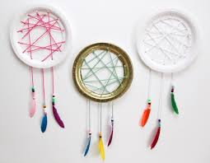  http://smashedpeasandcarrots.com/easy-paper-plate-dream-catcher-tutorial/ | Activity 8  Complete 1 or all of the mindfulness colouring pages in your pack, you might want to do these in your fort! | Activity 9  Finally, if you want to…  Record a goodbye message to us and email it or send it to us via the VLE. We miss you all so much and we would love the chance to wish you good luck for next year!

