On my Farm
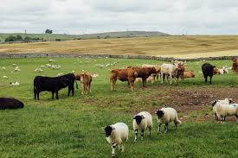

On my farm there is_______________
______________________________________________________________________________________________________________________________________________________
Adding to 10
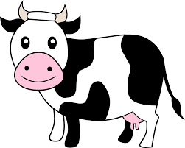

Cooking
Recipe for

Ingredients
Equipment

Instructions

Farmer Duck
Can you write a sentence about each of the pictures from the story?




