Our Seeds Are Growing

Macau Homework Menu – Extended Home Learning March 2020
Choose at least two of the tasks to complete for your home learning.
Be creative and have fun!
Write a letter to Stig of the Dump complaining about the Dump.  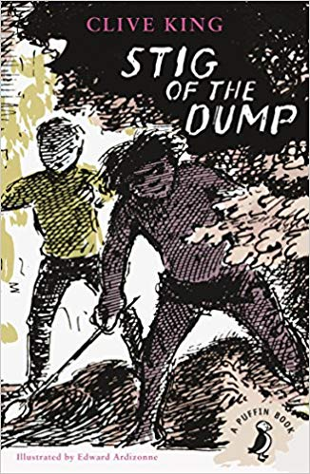 | 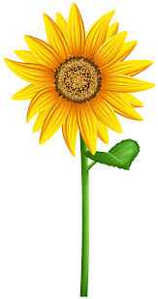  Make a list of items that have seeds in. | 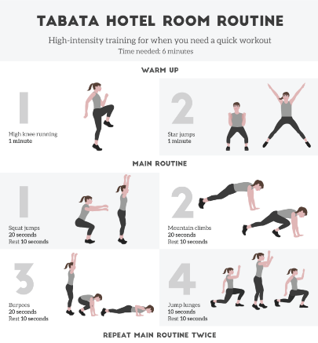  Create your own fitness routine. You can video your routine if you want to!
Draw a cave man drawing that tells a story.  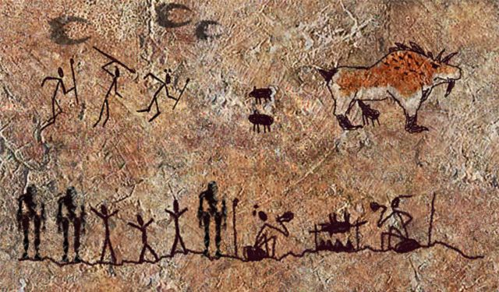 | Draw and label a healthy meal. | 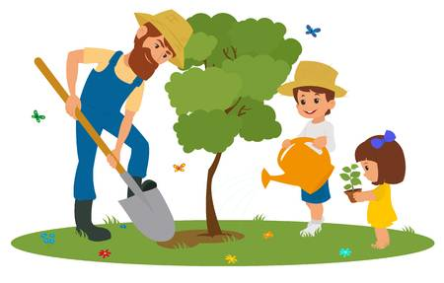  Write two paragraphs on why plants and trees are important to us.
*Don’t forget to try and read at home.* Handwriting still needs to be completed.

