Literacy Lesson 1
Can you add –ed to the end of words to change them?
Just a reminder from last week…
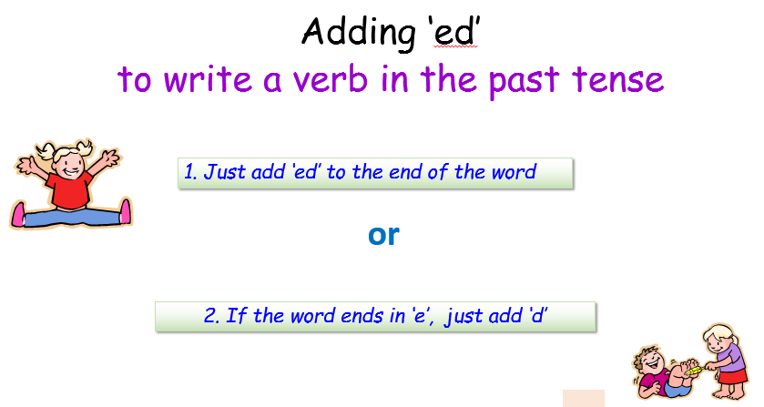
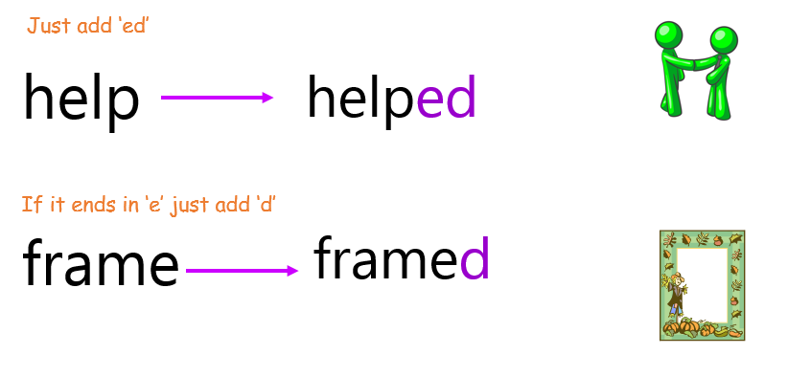

Re-watch this fun YouTube video from last week
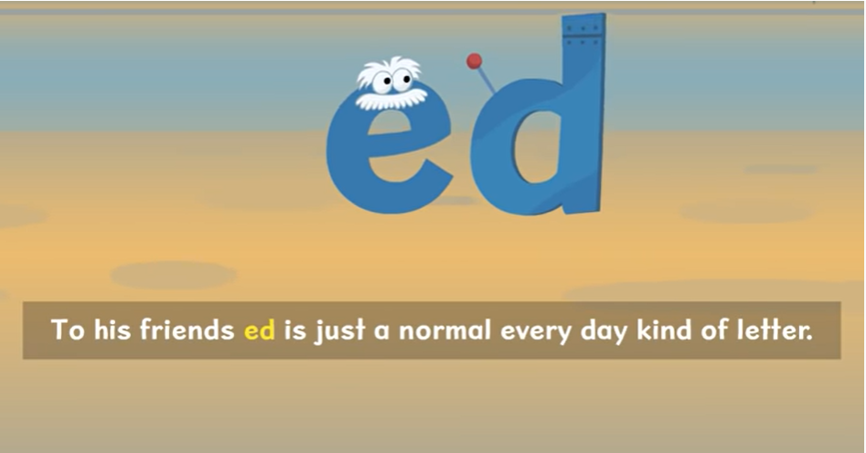

https://www.youtube.com/watch?v=jxl28KQOHy4

Now have a go at changing these words:

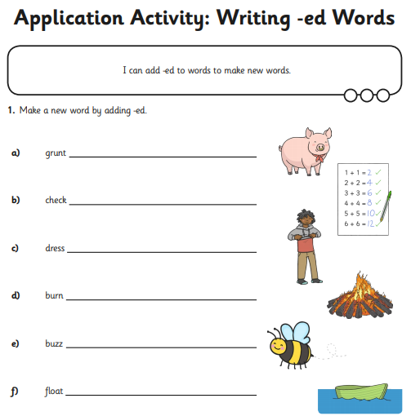

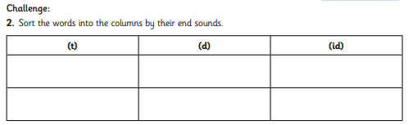
Literacy Lesson 2
Watch the video ‘There’s a T-Rex in Town’ on the following link: https://youtu.be/meGDisgj3js
After watching the video answer the comprehension questions below:
- How many years ago did the T-Rex live?
_________________________________________________________
- Why did a T-Rex wag his tail?
__________________________________________________________________________________________________________________
- How many times faster than a child was a T-Rex?
_________________________________________________________
- How much could a T-Rex eat in one mouthful?
_________________________________________________________
- Would a T-Rex need to wear glasses?
_________________________________________________________
- Why not?
__________________________________________________________________________________________________________________
- How many fingers did a T-Rex have on each hand?
_________________________________________________________
- How have scientists learnt about dinosaurs?
__________________________________________________________________________________________________________________
- What does Tyrannosaurus Rex means?
_________________________________________________________
Where did a T-Rex live?
______________________________________________________________________________________________________________

Literacy Lesson 3
Can you create an information text on a T-Rex
Remember:
An information text is full of facts and knowledge.
Look back at your notes on the T-Rex from the previous session and read the fact card below before you begin.

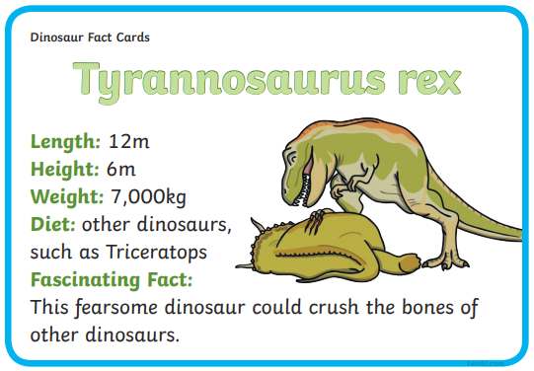

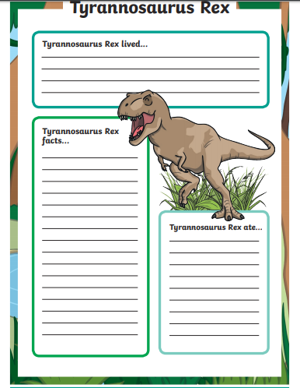
Extension: Read the following information on the Terrific T-Rex and then answer the questions below
