Week 14 – Topic Support Pack
In this pack, you will find all the instructions, resources and questions that you will need to complete your French work this week.
Lesson 1 – Research and find these words in French
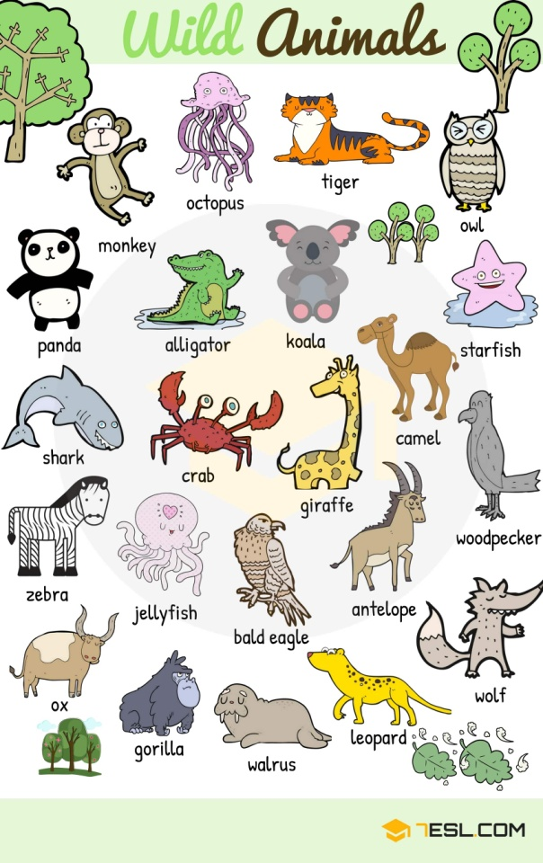
Find the names of 5 different animals:
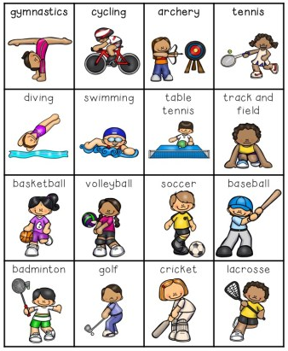
Find the names of 5 different sports:

Lesson 2 – Write a poem in English using some of the English words in Lesson 1
Write a free verse poem using words from lesson 1. You could include animals, sports or days of the week in your poem. Remember your literacy features that you could include (similes, alliteration, ISPACE and prepositions).
As a challenge, can you include rhyming couplets in your poem?
Example:
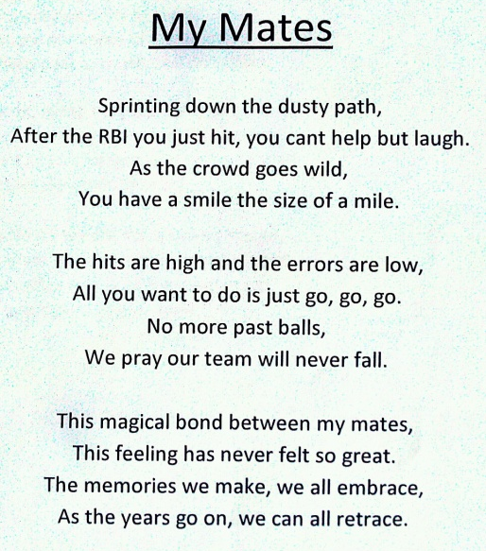

Lesson 3 –Write your poem in French in the style of a calligram (shape poem)
Use Google Translate to translate your poem to French.
https://translate.google.com/
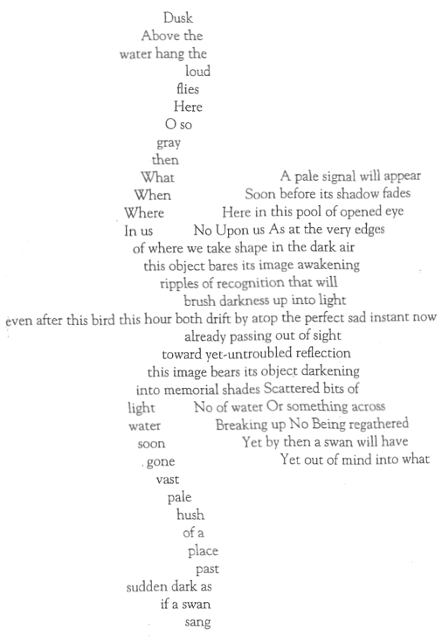
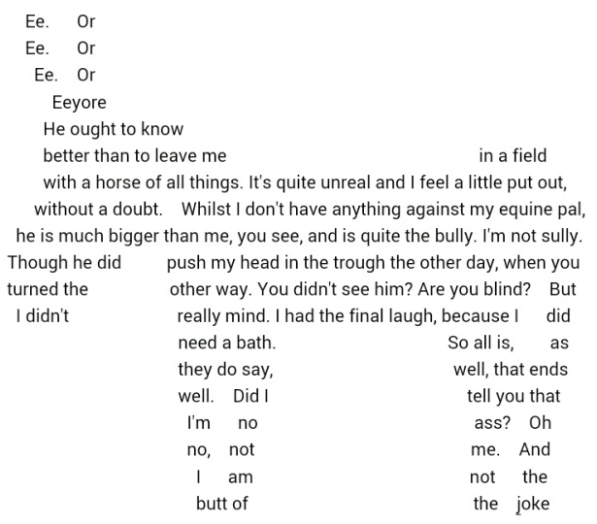
Present your poem in a shape that is related to your poem. The best way to do this is to draw your shape first, making sure it is big enough to fit your poem in. Some examples are given below:
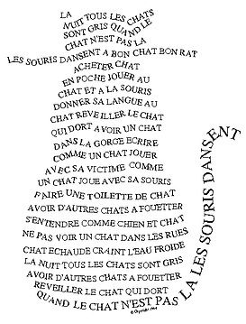

Extension: Perform your poem and send us a video. We would love to see how creative you can be!

