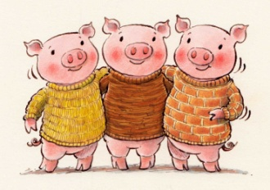
8th February 2019
Dear Parents/Carers,
We would like you to support your child in a special homework project. This term we have been enjoying the story of The Three Little Pigs. In Design and Technology we have been designing houses for the pigs and talking about the materials we would need to make them.
We would like your child to make a house for one of the pigs and bring it to school on Monday 25th February. Please let them be as creative as they wish. You could use an old shoe box, lego or any other materials you happen to have. We are looking forward to seeing the wonderful creations!
With thanks
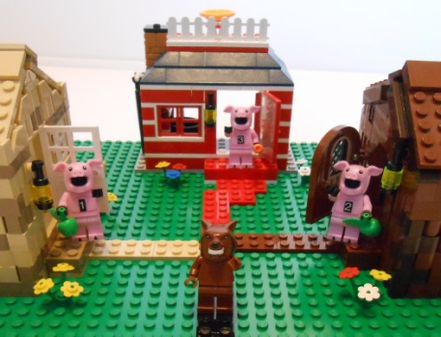
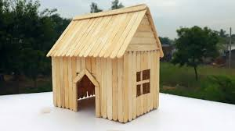
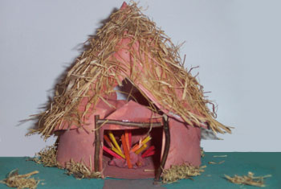
Mrs Smith and Miss Blair

