Year R Home Learning Menu – Week 5
Counting  Play Counting Caterpillar to practise counting to 10.  https://www.tvokids.com/preschool/games/caterpillar-count  For more of a challenge try  https://www.topmarks.co.uk/ordering-and-sequencing/caterpillar-ordering  (There are lots of options in this game. Most children will be happy using numbers to 20 to order or sequence. Some children will be confident with numbers to 100 and can count in tens or learn to! We do not cover decimals! )  Can you make a ‘Counting in tens’ numberline? | Reading  We are really missing hearing you all read! Can you make a video of yourself reading and send it to us on EyLog?  Practise your sounds every day using these digital flash cards  https://www.teachyourmonstertoread.com/digital-flashcards  (some children will know all of these, some will only know the single letter sounds, but could learn new ones!) | Spring  How many words can you think of that rhyme with spring? Make a list  Write down as many things about spring as you can. You can do this as a list or in sentences.
Spring Has Come  Watch Spring Has Come (link below).  Draw a picture of ‘Spring,’ see if you can include the animals that woke up from their winter sleep.  Can you write about the celebration? What did the animals do? What did they see? How were they feeling?  https://youtube.com/watch?v=38xwpe8NFOI  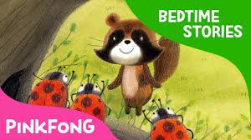 | The Very Hungry Caterpillar Yoga  Try a bit of Yoga and tell the story of The Very Hungry Caterpillar.  https://www.youtube.com/watch?v=xhWDiQRrC1Y | Nature Picture  When out on your daily walk, collect some natural objects like sticks, stones, leaves etc. Can you make a picture? Take a photo of it and send it to us on EyLog.  You could draw your picture and label it!  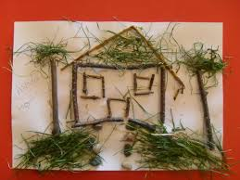
Try to complete as many of the activities on this menu as you can during the week. If you would like more, log on to Teach Your Monster to Read, Oxford Owls or use some of the websites provided in the original pack. Please remember to take photos of any of the activities and upload onto EyLog so we can see what you have been doing!

