Year 1 Maths Support Pack - Week 7
In this pack, you will find instructions on how to complete your Maths lessons for this week. We are learning about halves and quarters this week and you will need to watch some short videos to help you. Follow the links on your home learning menu, or on our class page on the website, to watch the videos. You can then complete the worksheets by printing them, or viewing them on the screen and writing the answers on your own paper.
Week 7 Lesson 1 – Find a half (Lesson 4 on the website)
Watch the short video that links with lesson 4 – Find a Half (Summer Term - Week 1 (w/c 20 April) Then complete the tasks below. When completing the tasks please feel free to use objects to help your child, if they need it. If your child finds this straight forward then get them to use objects to prove their answers and mark their own work.
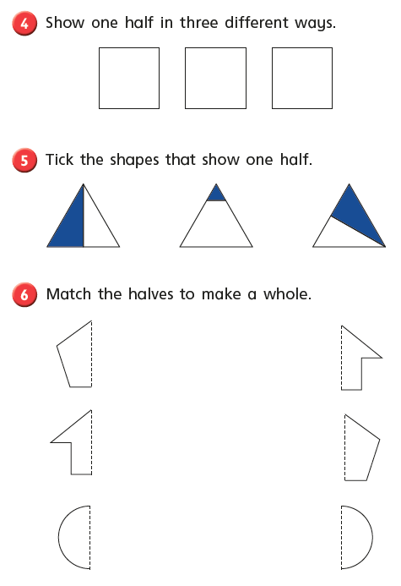
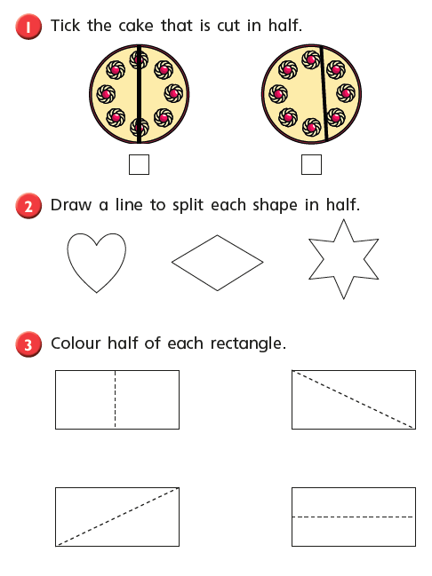
Lesson 2 – Find a half 2
Watch the short video that links with lesson 1 – Find a Half (2) (Summer Term - Week 2 (w/c 27 April) Then complete the tasks below. When completing the tasks please feel free to use objects to help your child, if they need it. If your child finds this straight forward then get them to use objects to prove their answers and mark their own work.
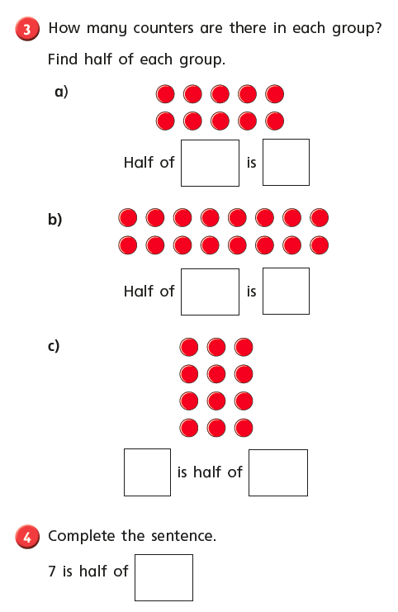
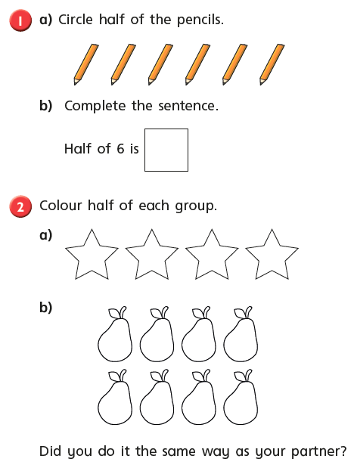
Challenge:
Use objects to complete the questions.
- Circle half of the apples.

- Find the fractions of amounts.
- Half of 4 = b) Half of 10 = c) $\frac{1}{2}$ of 12 = d) $\frac{1}{2}$ of 6 =

- Which is bigger?
$\frac{1}{2 }$ of 16 or $\frac{1}{2}$ of 18.

Draw a picture to show your working.

- Look at Sam’s counters.
His answer is 4.
Complete the number sentence.

of = 4

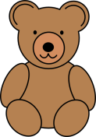
- Jenny is sorting her teddy bears.
She gives $\frac{1}{2}$ of them to her sister.
How many does she have left?

Lesson 3 – Find a quarter (1&2)
Watch the short video that links with Lesson 3 – Make Equal groups (sharing) then complete the tasks below. When completing the tasks please feel free to use objects to help your child, if they need it.
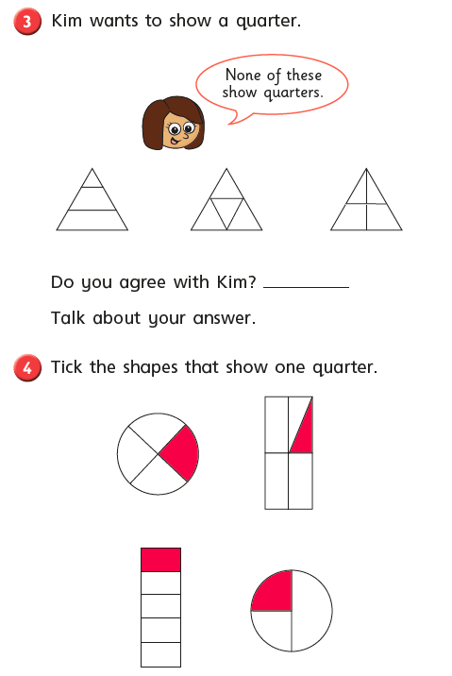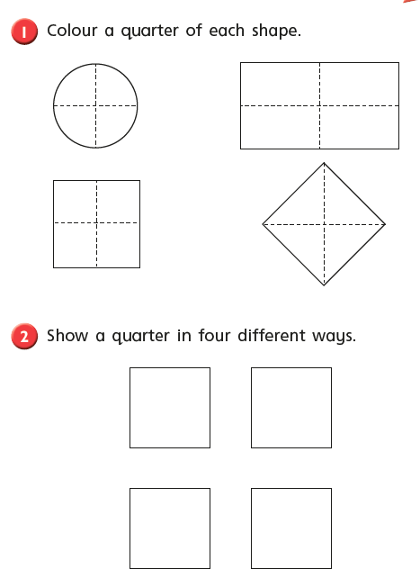

Video 2 on quarters (Lesson 3 Find a Quarter(2))
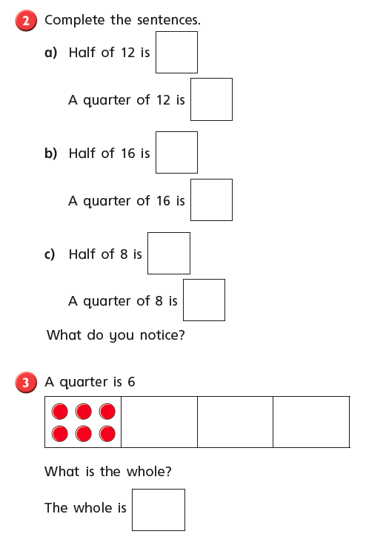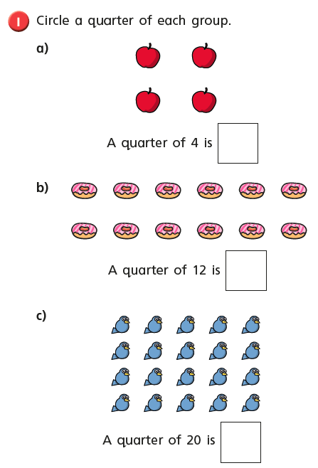

Problem Solving Challenge tasks:
