Year 2 English Support Pack – Week 7
This week we are continuing to use the story The Pirates Next Door by Johnny Duddle as a focus for our English work. You can still hear the story read by Miss Stratton on the VLE or the website.
Lesson 1 – Expanded Noun Phrases
For this task, we are going to recap expanded noun phrases. If you remember, these are when we add extra detail to a simple noun phrase, usually by adding adjectives to describe. For example,
the butterfly the beautiful, blue butterfly
Watch the short BBC Bitesize clip to refresh your memory https://www.bbc.co.uk/bitesize/topics/zwwp8mn/articles/z3nfw6f
First, how many different adjectives can you think of to describe each of these pirate nouns? Write them down.
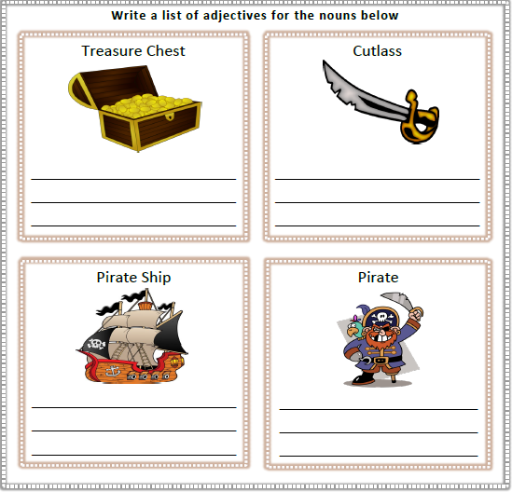
Now, can you use these adjectives and nouns to write sentences that include expanded noun phrases?
Example: The scruffy pirates fire loud cannons.
__________________________________________________________________________________________________________________________________________________________________________________________________________________________________________________________________________________________________________________
Lesson 2 – Design your own pirate
Imagine that you could design your own pirate for a new pirate story. What would they look like? What would they wear? Would they be a nice pirate or a mean pirate?
For this task you need to draw your new pirate and then label your picture to show as many different features as you can. Make sure you use expanded noun phrases to describe, when you label the picture. Have a look at my example below to help you.

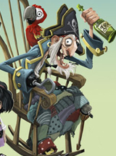
A thin, brown wooden leg
A smart navy blue jacket with gold trim and shiny gold buttons
A long, white, scraggly beard with a black bow tied to the end
A scruffy, red parrot called Squawk
A crooked creepy smile, filled with rotten, yellow teeth
A sharp, silver hook
A black pirate hat with a large skull and cross-bones
Grandpa
My Pirate

Lesson 3 – Character Description

Now that you have planned your own pirate, can you write a description of them? Try to include all the information from your picture and don’t forget to use expanded noun phrases to help describe. Have a look at the example below to help you.

Grandpa is a scruffy looking pirate who won’t set foot on dry land because the last time he did, the King chopped off his hand! He sits all day long in his creaky, wooden rocking chair on the ship with his scruffy, red parrot called Squawk.
Grandpa has a large bulgy nose and two huge beady eyes that seem to pop out of his head when he looks at you. He has a crooked, creepy smile filled with rotten, yellow teeth. What stinky breath he must have! Yuck! Growing out of his chin is a long, white scraggly beard with a black bow tied to the end.
Grandpa wears a smart navy blue jacket with gold trim and shiny gold buttons. He also has a black pirate hat with a large skull and cross-bones that sits on top of his head. Instead of his right hand, he has a sharp, silver hook that he uses to scare people away! Watch out, you wouldn’t want to come across this scurvy seadog!
Checklist of things to try and include in your pirate description:
- Expanded noun phrases
- Conjunctions (and, but, or, when, if, that, because)
- Punctuation (full stops, exclamation marks, commas)
- Capital letters – to start sentences and for names
______________________________________________________________________________________________________________________________________________________________________________________________________________________________________________________________________________________________________________________________________________________________________________________________________________________________________________________________________________________________________________________________________________________________________________________________________________________________________________________________________________________________________________________________________________________________________________________________________________________________________________________________________________________________________________________________________

Extension task – Character Inference
Listen to Miss Stratton reading ‘The Pirate’s Next Door’ again. Think carefully about each of the townspeople and how they are feeling.

Circle the best word to describe how each of these townspeople feel and explain why they feel that way.
I think Miss Divine feels…
thrilled disgusted scared
Why?
__________________________________________________________________________________________

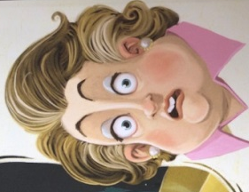
I think Mrs Plumb feels…
frightened happy sad

Why?
__________________________________________________________________________________________

I think Mrs Bevan feels…
pleased worried fed-up

Why?
__________________________________________________________________________________________

