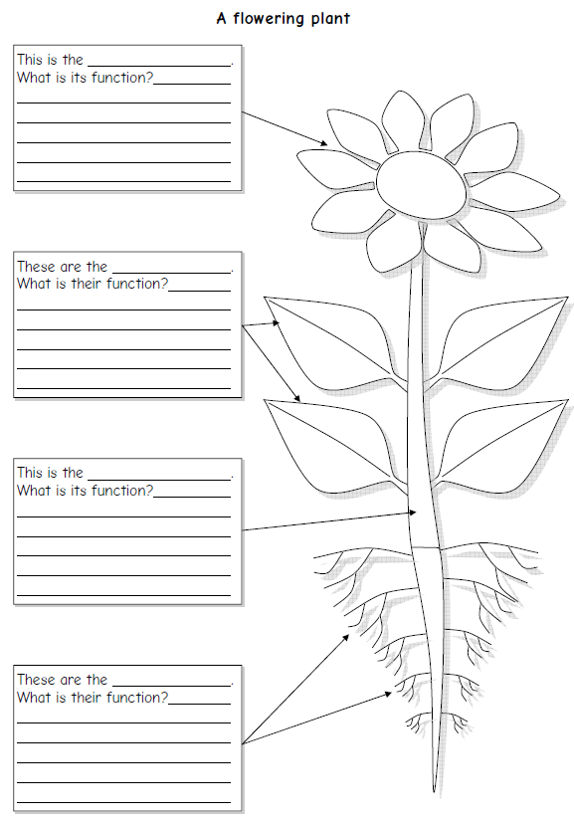**Science – Parts of a plant and their function**