Home Learning Easter
YR Tower Hill – Sears and Pisa Class
 | Monday | Tuesday | Wednesday | Thursday | Friday
Reading | Read a book on Oxford Owl. | Play washing line rhyming.  If you type washing line rhyme in google it is the first game that comes up.  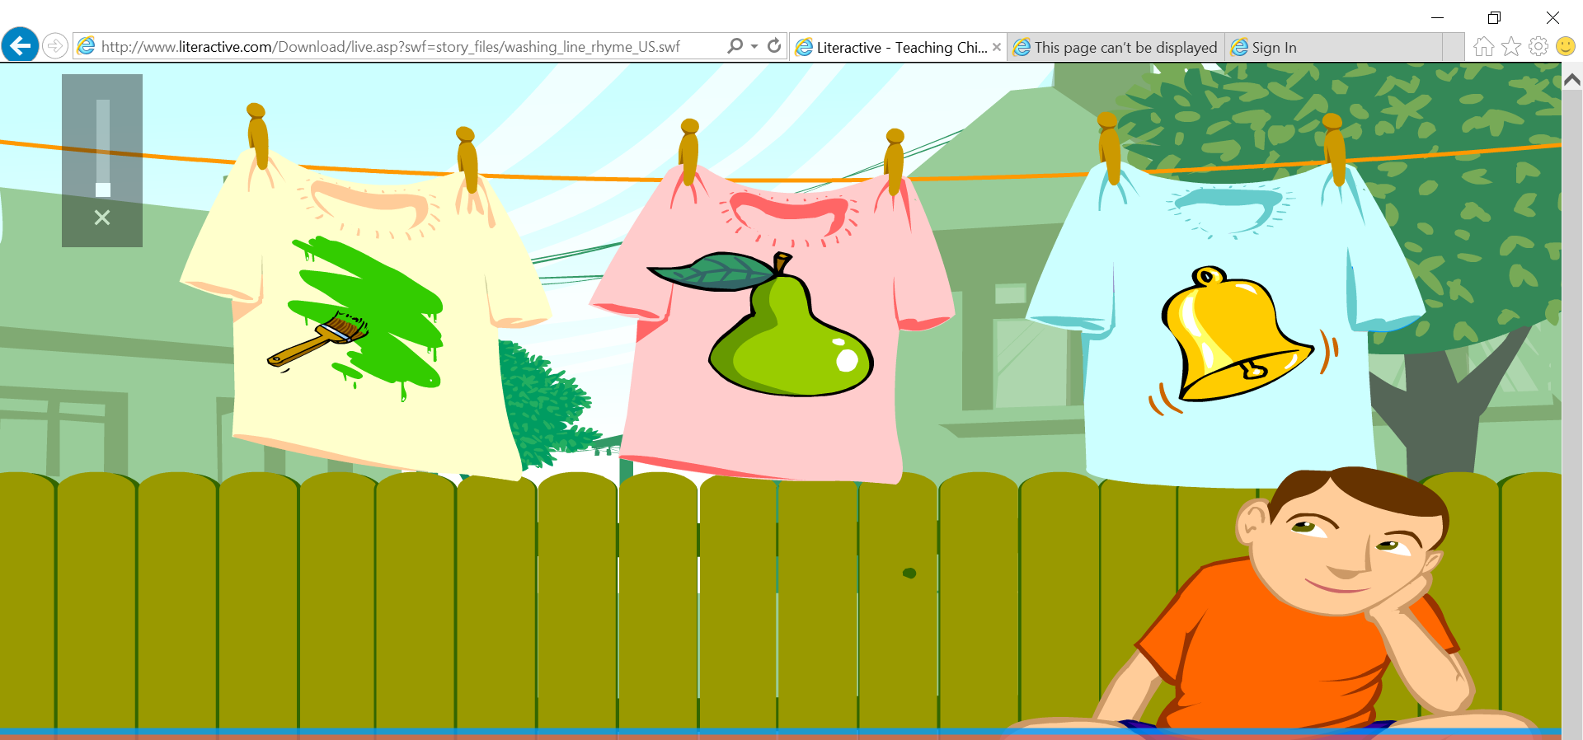 | Make some tricky words with two of each word cut them out and play snap with them.  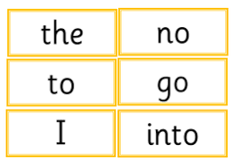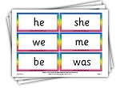 | Put on your favourite programme with the subtitles and pause it. Can you read some of the words or say some of the sounds you can see. | Ask a grown up to write red words to, my, the, I, was and she and hide them around the house or garden. Can you find them and read them.
Writing | Look at the Spring powerpoint (on the website)  Can you write some sentences about spring using your phonics to sound out the words.  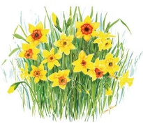  In spring…. | Write a message to your teacher for your grown up to upload on Eylog. | Draw a picture of something you did today and write a sentence about it.  e.g. Today I played with my… | Research rabbits and write some facts about them.  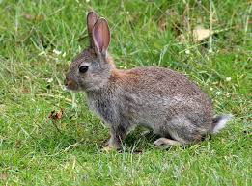 | Research a picture of daffodils and draw them. Can you write down what they need to grow using your phonic sounds.  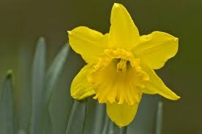
Maths | Gather some of your toys and order them from biggest to smallest.  Can you then draw a picture of them in order | 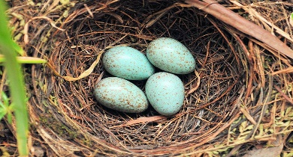  Draw 3 birds nests draw 3 eggs in each of your nests. How many eggs are there altogether. Repeat with different amounts of nests and eggs. | Ask members of your family to lie on the floor can you count how many footsteps long they are and record this. Who was the most footsteps? who was the least? | How old are you can you write the number 4 times if you are 4 5 times if you are 5. What is 1 more than your age what is one less?  Can you write how old members of your family are and write one more and one less? | https://www.topmarks.co.uk/learning-to-count/paint-the-squares  can you paint the squares as you count as say the numbers out loud.  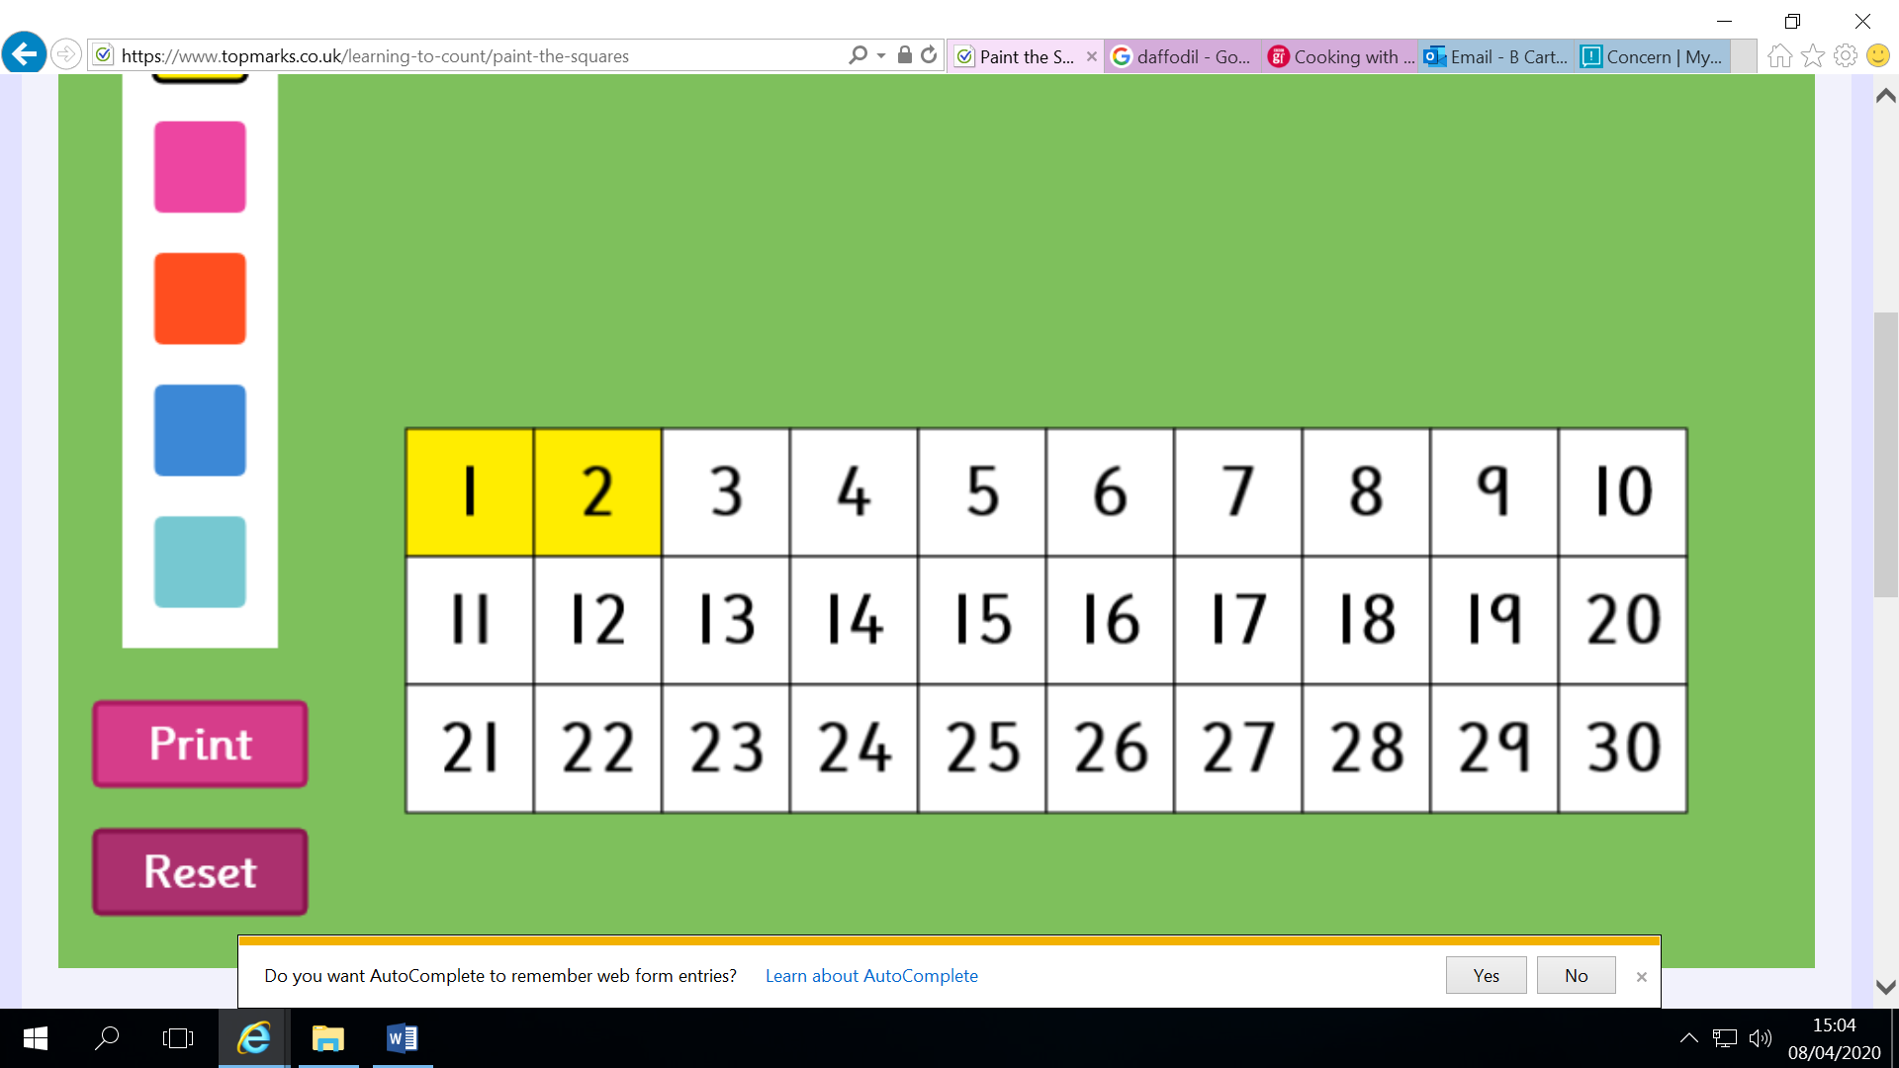
Other | Make a handprint bunny | Make some chocolate cornflake nest cakes. (you can also use rice crispies or shredded wheat.  https://www.bbcgoodfood.com/recipes/cooking-kids-chocolate-cornflake-cakes-0 | Watch the sleeping bunnies video and see if you can sing along and copy the actions. | Make a yoghurt pot telephone.  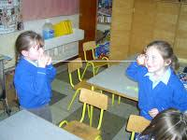  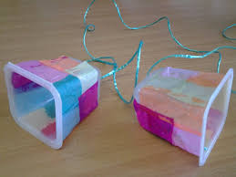 | Watch the Jack Heartman Bunny song in the tune to B-I-N-G-O  Can you sing it?  https://www.google.com/url?sa=t&rct=j&q=&esrc=s&source=web&cd=1&cad=rja&uact=8&ved=2ahUKEwjY2rTmgdnoAhUtQkEAHXEGAygQwqsBMAB6BAgIEAQ&url=https%3A%2F%2Fwww.youtube.com%2Fwatch%3Fv%3DEIVoIaqd0nc&usg=AOvVaw3O33-PF4RtPS9wvf-bqkmL

