Year 2 Maths Support Pack – Week 8
In this pack, you will find instructions on how to complete your Maths lessons for this week. We are learning about measuring length this week and you will need to watch some short videos to help you. Follow the links on your home learning menu to watch the videos. You can then complete the worksheets by printing them, or viewing them on the screen and writing the answers on your own paper.

Lesson 1 – Measuring Length in cm
First watch the White Rose Maths video to introduce how to measure in centimetres (cm) using a ruler. Pause the video at the indicated points to complete the questions below using either; a ruler you have at home, the printed ruler in your pack or the link provided to access the online ruler - https://www.ginifab.com/feeds/cm_to_inch/actual_size_ruler.html

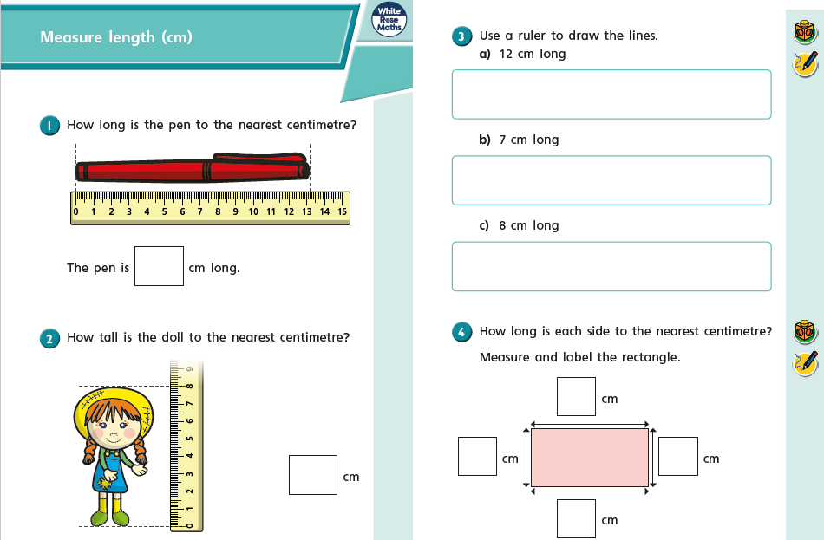

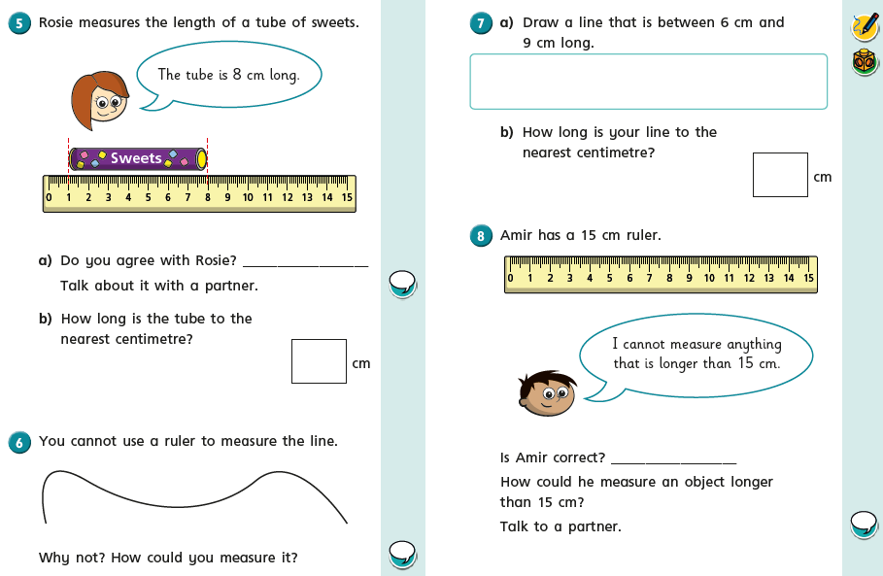

Lesson 2 – Comparing lengths
First watch the White Rose Maths video to help you understand how to compare lengths using the < > and = symbols. Pause the video at the indicated points to complete the questions below to show your understanding of how to compare lengths using centimetres (cm) and metres (m).

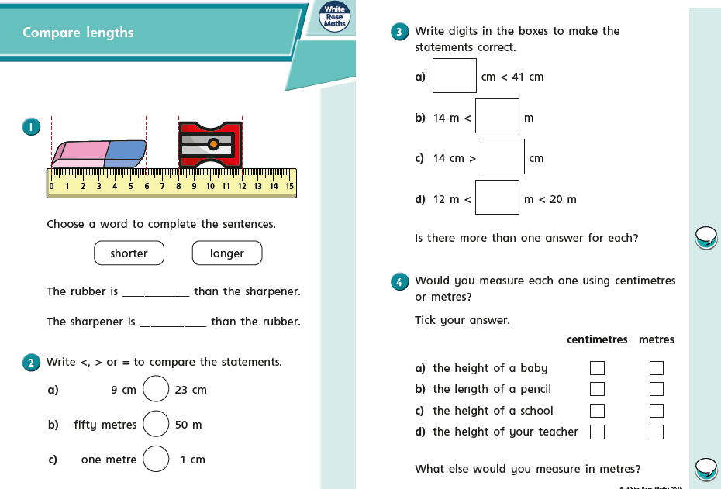

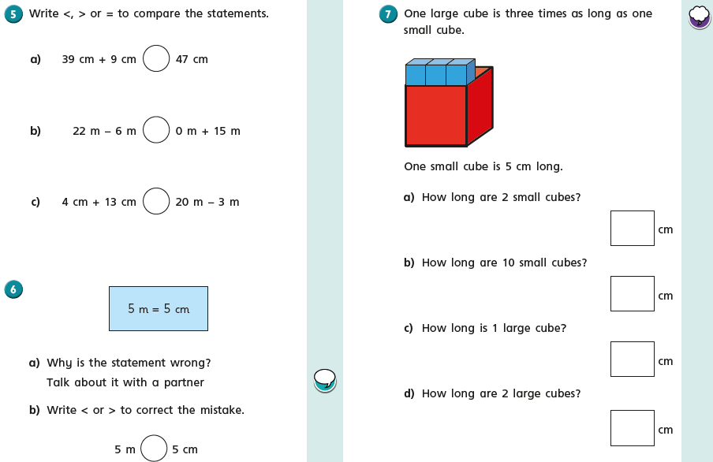

Lesson 3 – Ordering Lengths
First watch the White Rose Maths video to help you understand how to order lengths using the vocabulary ‘shortest, longest and tallest’. Pause the video at the indicated points to complete the questions below to show your understanding.

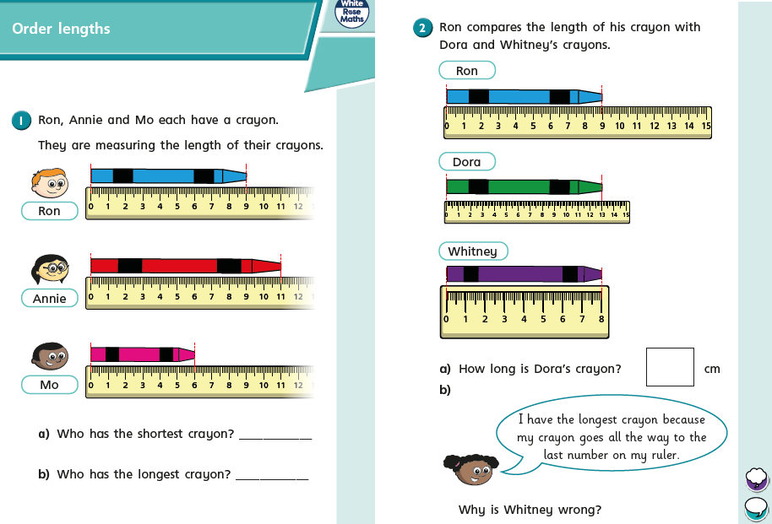

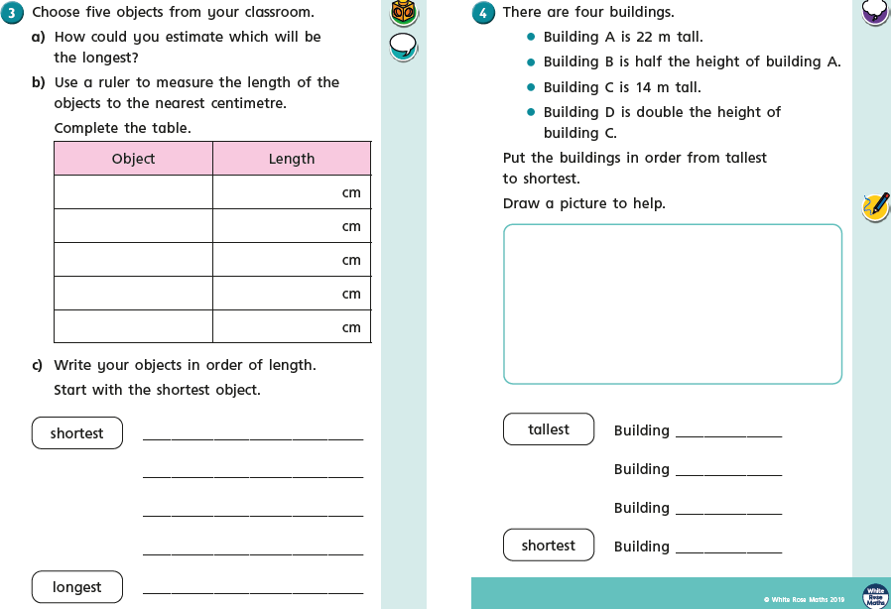
home

Chilli Challenges!
