Year 5/6 Home Learning Pack- Week 15

Activity 1- Maths Escape Room
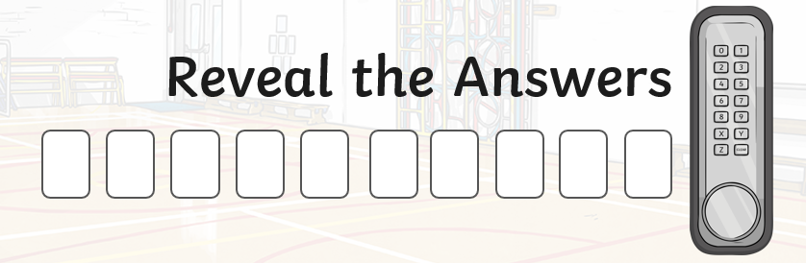

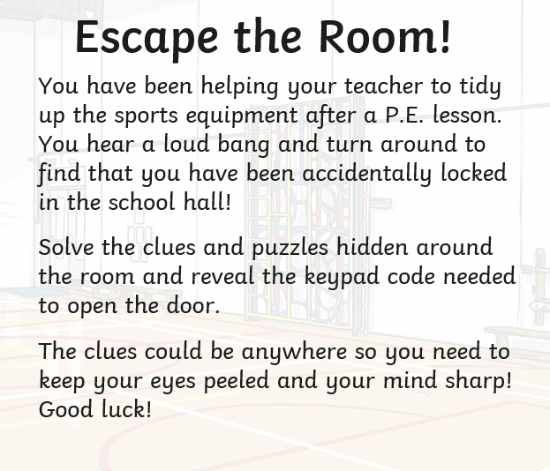

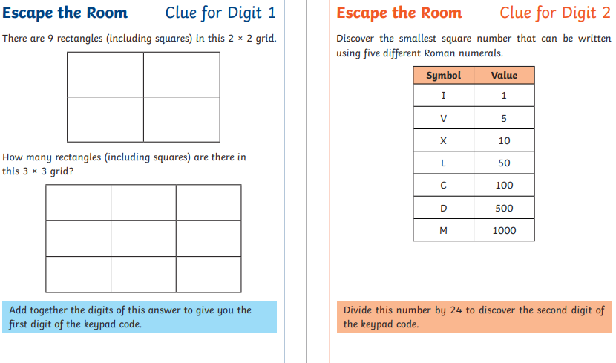
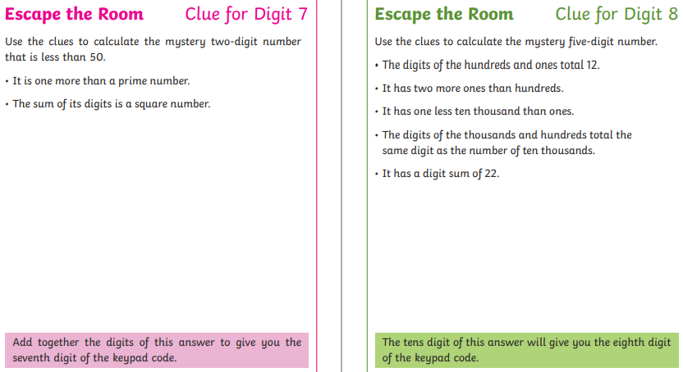
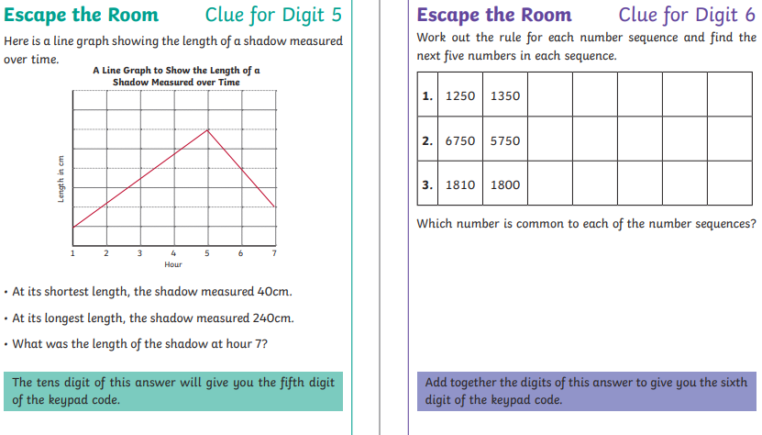
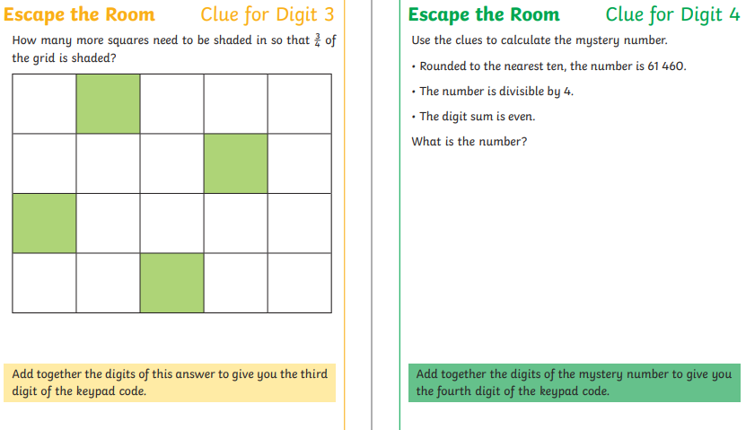
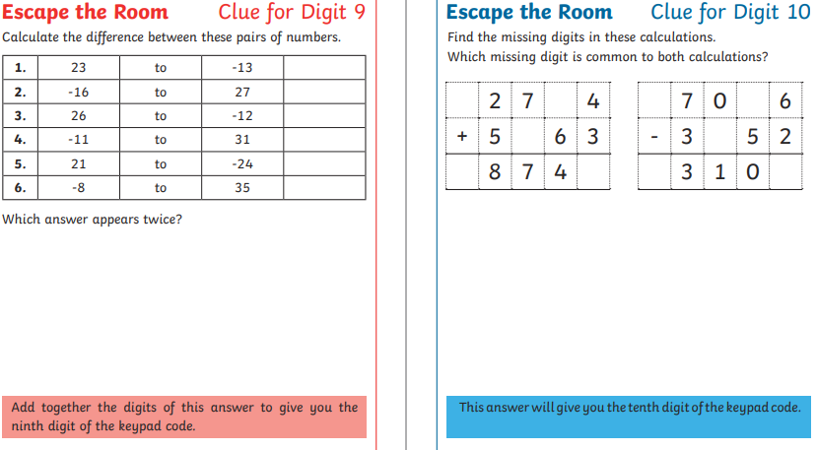
Activity 2- Mindfulness Colouring
Make your favourite snack/drink and take some quiet time to complete this colouring.
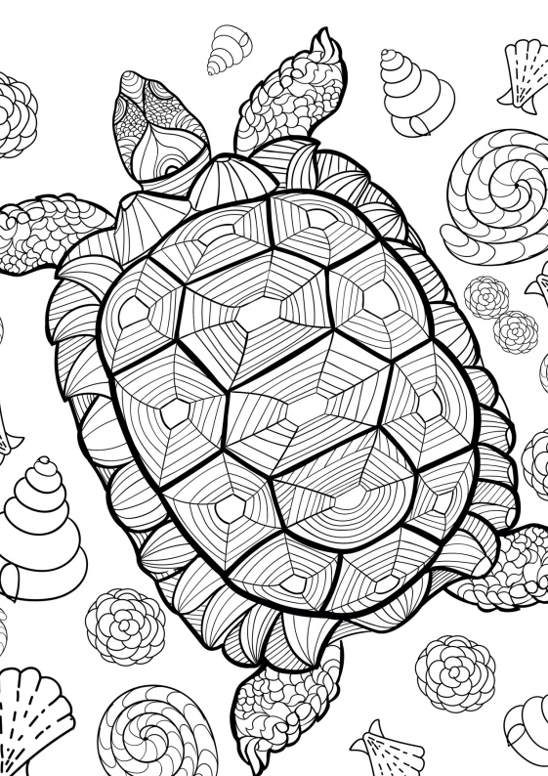
Activity 3- Comic Strip
Create a comic strip for how you would like your first day of your next school year to go. Use the template to draw in if you would like to.
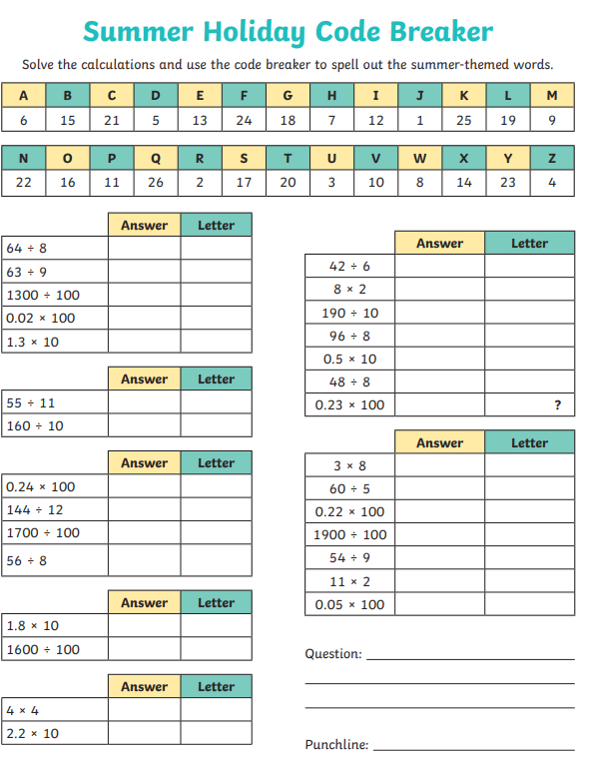
Activity 4- Code breaker

Activity 5- Acrostic Poem
Create an acrostic poem about this year, it could be about moving up into a new school/year group, home schooling, coming back to school, NHS key workers etc.

Activity 6- Sudoku Puzzles
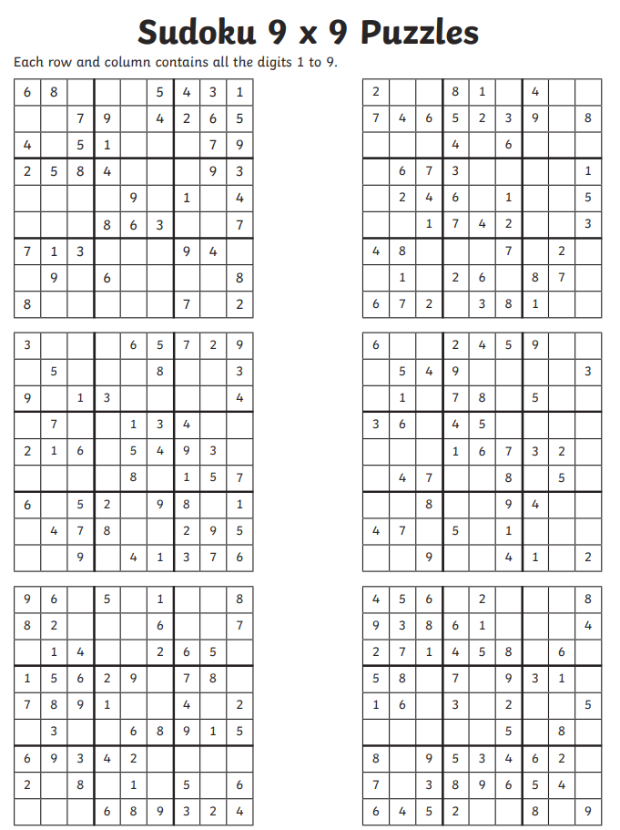
Each grid must be filled in. Every column and row all contain the numbers 1-9 but cannot appear more than once.
Activity 7- School/Class Mascot
Create a mascot for your new class or school. You need to make sure that the mascot represents key things about the school. Make it colourful and eye catching! Draw it in the box below.
E.g. Maybe for Tower Hill, you could create a mascot that is a fox with a jumper with values all over it.

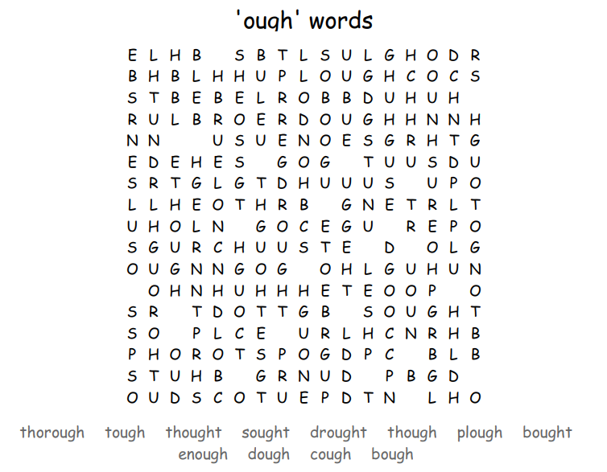
Activity 8- Word searches

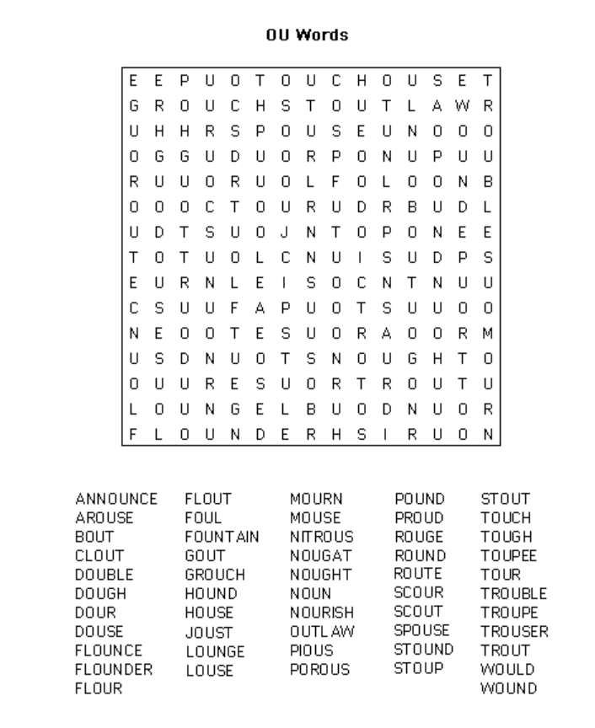

Activity 9- Riddles
- What has four fingers and one thumb but isn’t alive?
- If an electric train is travelling north and there is a strong easterly wind, what direction with the steam be blowing?
- If I dig a hole that is 4.7m wide and 8.9m deep, how much dirt is in the hole?
- What gets wetter when it dries?
- What starts with a T, end with a T and has T in it?
- The more you have of it, the less you see. What is it?
- Two in a corner, 1 in a room, 0 in a house, but 1 in a shelter. What am I?
- I have streets but no pavement, I have cities but no buildings, I have forests but no trees, and I have rivers yet no water. What am I?

