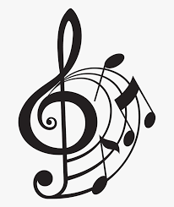
Instrumental lessons

Do you want to learn more about musical instruments? Are you interested in learning to play a instrument? Watch the short videos below to learn more!

1. Woodwind:

https://youtu.be/LPeVid5GCn0

2. Brass:

https://youtu.be/xBFhalUXenk

3. Strings:

https://youtu.be/w0euXFcNp3A

4. Piano/keyboard:

https://youtu.be/Oe4nLEYJwjQ

5. Percussion:

https://youtu.be/FdFe8jp6aHo

6. Guitar:

https://youtu.be/-xLa3dutztk

7. Voice:

https://youtu.be/9gkXlC9CiOk

