Literacy Support Documents: Lesson 1
Prepositions are usually short words, normally placed directly in front of nouns to string a sentence together. In this task we will be looking at prepositions that describe a position. Go through the ‘Where is Teddy’ prepositions PowerPoint. Can you now complete the below activity. You need to add in a preposition to describe where Jack is hiding from the Giant.
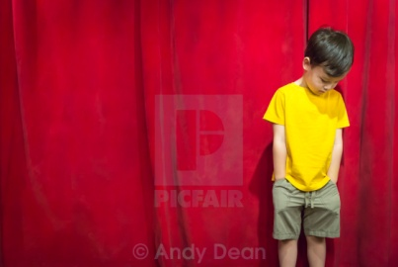
Jack hid ________ of the curtain.
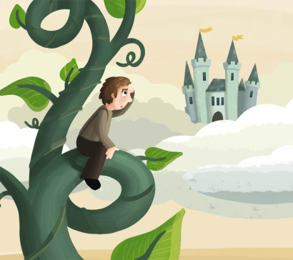
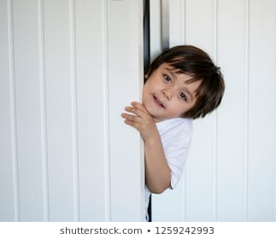
Jack hid ________ the beanstalk.

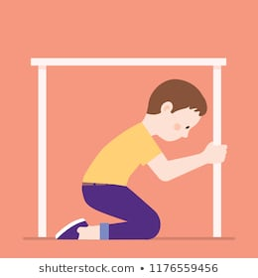
Jack hid _________ the door.

Jack hid _________ the table.
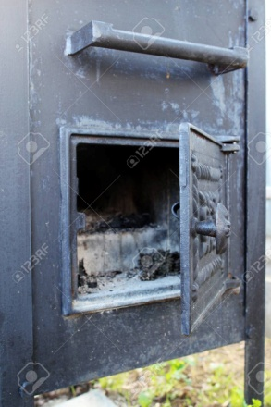

Jack hid ______ the oven.

Fancy a challenge? Complete the preposition game within you support pack. Here are the rules…
Children must roll a dice and move across the board, making a sentence that includes any preposition they land on. For example, they could land on 'between' and say 'in my class, I sit between Emily and Jake'. Along the way, they must try and avoid the penalty squares that will send them backwards.
The first person to reach the end of the board wins.
Literacy Support Document: Lesson 2
Using your story map created last week to help you, can you re-write the story of Jack and the Beanstalk. Try to include all the following: (this is your checklist)
-Capital letters and full stops
-The correct spelling of the Year One challenge spelling words-these can be found on the school website
-Prepositions
-An un- word, you may want to look back at your work from last week
-Story language, for example ‘Once upon a time’
-Have a go at joined up handwriting
Fancy a challenge? Can you include some speech in your story using speech marks?
I have included an example of the start to my story, you may want to continue writing from where I ended, or you might want to start your own
Once upon a time there was a little boy names Jack. Jack and his Mummy were poor. One day Jack’s Mummy said to him,
“Go and sell our cow.”
So Jack took the cow to the market. A man bought the cow from Jack but instead of paying with money he gave Jack some magic beans! Jack’s mummy was very unhappy when he returned with magic beans and no money.
_________________________________________________________________________________________________________________________________________________________________________________________________________________________________________________________________________________________________________________________________________________________________________________________________________________________________________________________________________________________________________________________________________________________________________________________________________________________________________________________________________________________________________________________________________________________________________________________________________________________________________________________________________________________________________________________________________________________________________________________________________________________________________________________________________________________________________________

Literacy Support Document: Lesson 3
Editing
Miss Ramsier and Mrs Stroe decided to write a letter to you all last night, but we were a little tired and I think we made some silly mistakes! I wonder if you could read our letter and make any corrections needed. Make sure to look out for missing capital letters, full stops, silly phonic choices and spellings! Silly us!
To Yair One,
Wee both miss yoo all so much It woz so nice seeing sum of your smilin faces on zoom last week. wee hope you haf been enjoyin the sunshine n ar staying safe. mrs Stroe had her berfday last week onn VE day Shee is 18 again!
missin yoo lots and lots year wun
Love from Miss ramsier an mrs Stroe
xxxx
Can you know have a go at editing your story, I would suggest doing this in a different colour pen like we do at school. Remember to refer back to the checklist I gave for your story in the previous lesson.

