Year 2 Maths Support Pack – Week 6
In this pack, you will find instructions on how to complete your Maths lessons for this week. We are learning about position and direction this week and you will need to watch some short videos to help you. Follow the links on your home learning menu to watch the videos. You can then complete the worksheets by printing them, or viewing them on the screen and writing the answers on your own paper.
Lesson 1 – Describing position
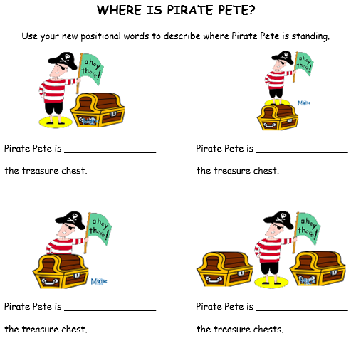
First, complete the short starter quiz to check what you already know. Then watch the video to learn about describing position. Finally, complete this task to check your understanding.
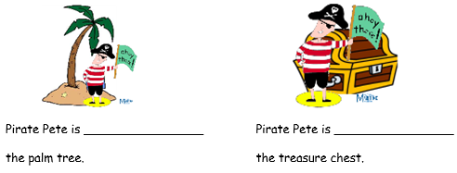
Lesson 2 – Giving directions
First, complete the short starter quiz to check what you already know. Then watch the video to learn about giving directions. Finally, complete this task to check your understanding.
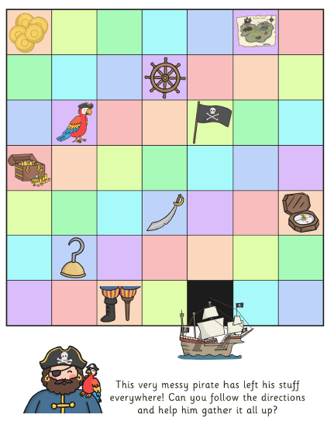

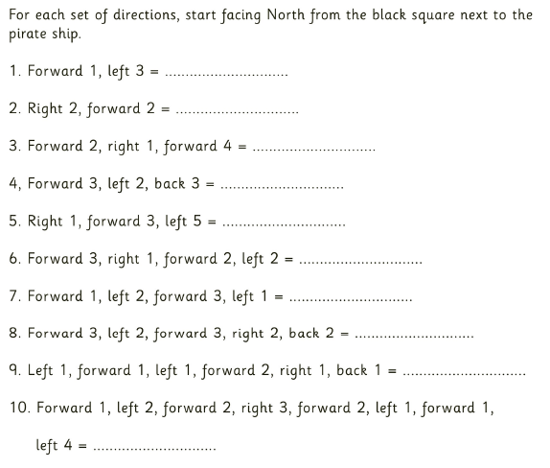

Challenge – Can you write some directions to get back to the pirate ship?
Lesson 3 – Language of rotation
First, complete the short starter quiz to check what you already know. Then watch the video to learn about rotations. Finally, complete this task to check your understanding.
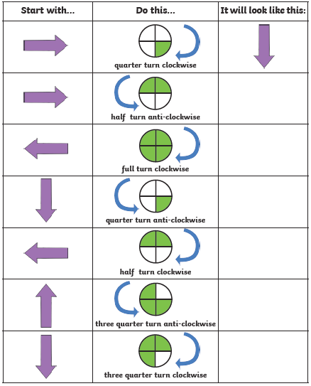

Challenge
If you are feeling confident, you can now try this next map with a new set of directions!

For each set of directions, start facing North from the black square next to the pirate ship.

1. Forward 3, one quarter turn anti-clockwise, forward 4 = ………………………………

2. One quarter turn clockwise, forward 1, one quarter turn anti-clockwise, forward 6 = ……………………………

3. Forward 3, one quarter turn anti-clockwise, forward 2, one quarter turn anti-clockwise, forward 3 = ……………………………

4. Forward 3, three quarter turn clockwise, forward 3, one quarter turn clockwise, forward 1 = ………………………………

5. One quarter turn anti-clockwise, forward 3, three quarter turn anti-clockwise, forward 6, one quarter turn anti-clockwise, forward 1 = ……………………

