Year 2 Maths Support Pack – Week 9
In this pack, you will find instructions on how to complete your Maths lessons for this week. We are learning about addition and subtraction this week and you will need to watch some short videos to help you. Follow the links on your home learning menu to watch the videos. You can then complete the worksheets by printing them, or viewing them on the screen and writing the answers on your own paper.

Lesson 1 – Part-Whole relationships and fact families
First watch the two videos on BBC Bitesize to refresh your understanding of part-whole models and fact families. Then complete the questions below to show your understanding of the relationship between three numbers.
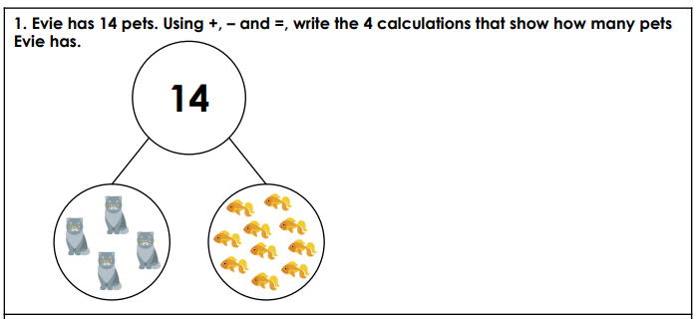

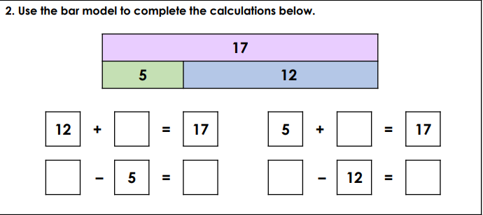

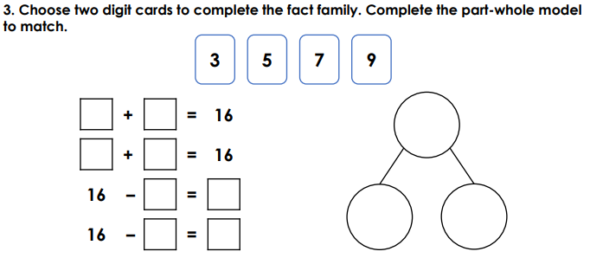

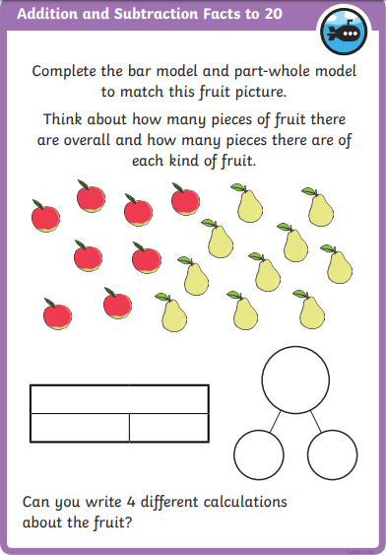
Challenges!

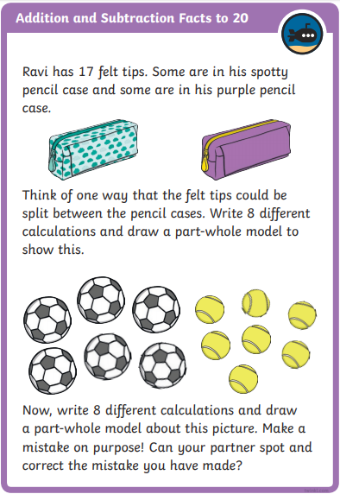

Lesson 2 – Comparing number sentences
First watch the video to refresh your understanding of the greater than (>), less than (<) and equal to (=) symbols and how to use them when comparing two number sentences. Then have a go at the questions underneath to show your understanding.
< > =
Less than Greater than Equal to
7 + 5 4 + 6 | 8 + 4 6 + 2
3 + 9 5 + 8 | 12 + 4 11 + 7
18 + 9 21 + 7 | 23 + 8 17 + 9
25 + 7 24 + 8 | 33 + 7 30 + 10
14 – 3 17 - 6 | 19 – 5 20 – 7
26 – 7 28 - 5 | 30 – 5 20 + 5

Challenge! – Follow the link to play the comparing number sentences game. https://kids.classroomsecrets.co.uk/resource/year-2-compare-number-sentences-game/
Lesson 3 – Number facts
First watch the two videos to understand the relationship between addition and subtraction. If you know an addition number sentence, you also know a subtraction number sentence.
Can you complete four number sentences to show the related number facts to 20?
11
14
20

9
20
6
20
17
3
___ + ___ = ___
___ + ___ = ___
___ - ___ = ___
___ - ___ = ___

___ + ___ = ___
___ + ___ = ___
___ - ___ = ___
___ - ___ = ___

___ + ___ = ___
___ + ___ = ___
___ - ___ = ___
___ - ___ = ___
20
____
1
15
____
20
____
8
20
___ + ___ = ___
___ + ___ = ___
___ - ___ = ___
___ - ___ = ___

___ + ___ = ___
___ + ___ = ___
___ - ___ = ___
___ - ___ = ___

___ + ___ = ___
___ + ___ = ___
___ - ___ = ___
___ - ___ = ___

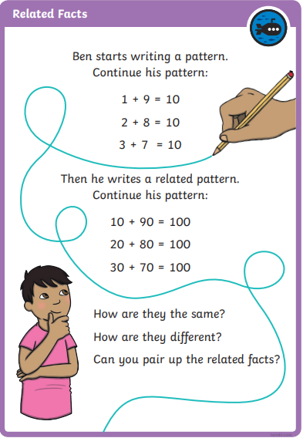
Challenge!

