Year 2 English Support Pack – Week 11
Lesson 1 – Imperative verbs
Read through the Powerpoint presentation to learn about what an imperative verb is. Then have a go at completing the activities.

Circle all the words that could be used as imperative verbs:
mix | cut | under | put | running
happy | no | hot | sprinkle | sad
talking | turn | squeeze | sun | pour

Now can you complete these commands, by adding an appropriate imperative verb?
__________________ down on your chair!
__________________ the cheese on top of your pasta.
__________________ out your shapes and stick them down.
__________________ the water down the sink.
__________________ your coat away in the cupboard. __________________ the door when you come in.
__________________ the milk and flour together.
__________________ off the light when you go to bed.

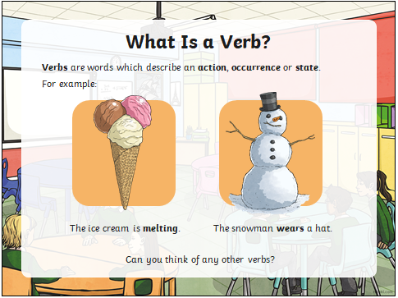
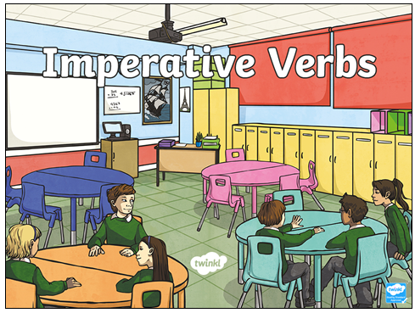
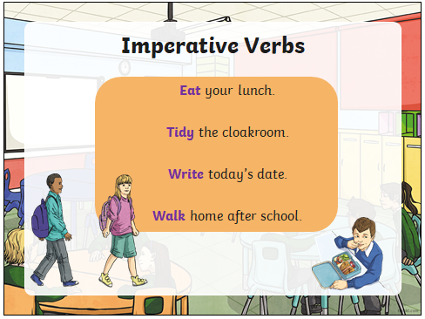
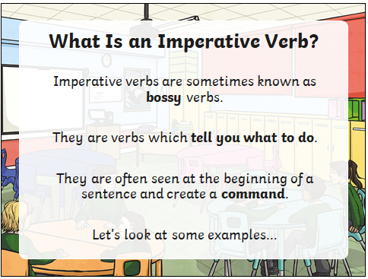
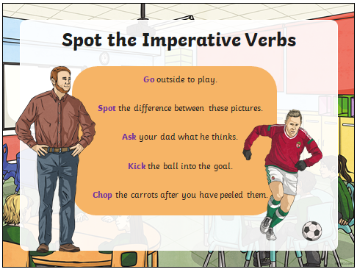
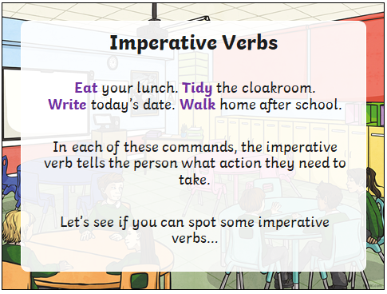
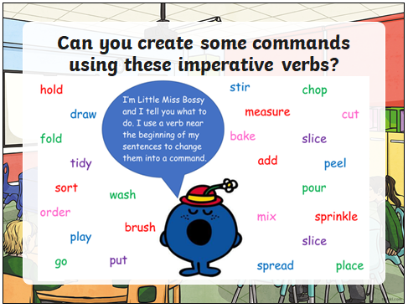
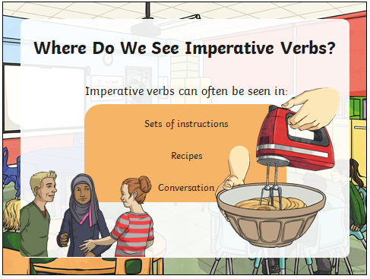
Lesson 2 – Features of instructions

This week we are going to have a go at writing a set of instructions. Instructions tell us how to do something and are often used for recipes, building things and playing games. Have a look at the example set of instructions on how to make a globe. The key features of the instructions are labelled on the sides. Make sure you are really clear on the key features and what a set of instructions should look like. Can you spot any imperative verbs?

Next, you will see a set of instructions for brushing your teeth but they are all jumbled up! Can you either cut out and re-order the instructions or re-write them in the correct order?
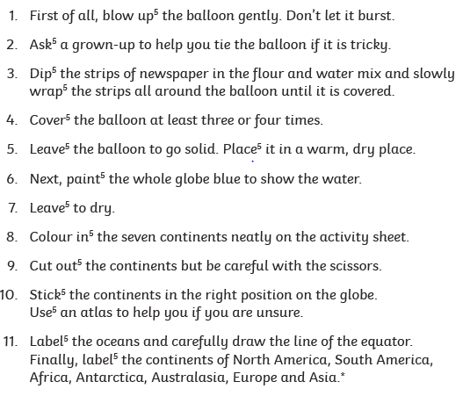
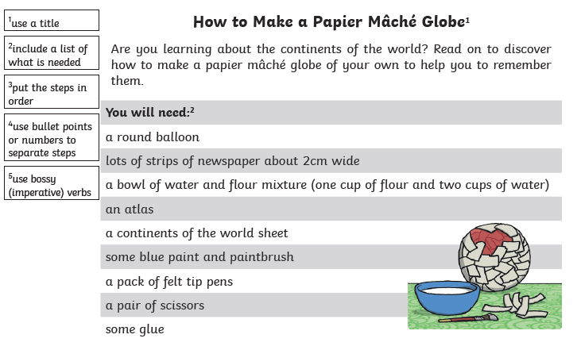

Finally dry your mouth completely with the towel.
Rinse your whole mouth with clean water.
A tube of toothpaste
A toothbrush
Water
A towel
Hold the toothbrush under the tap to rinse.
Keep brushing carefully for two minutes, moving the brush in circular motions.
How to clean your teeth
Brush the toothpaste all over your teeth.
What you do:
Turn on the tap and wet the toothbrush.
What you need:
Squeeze a small amount of toothpaste onto the brush.

Lesson 3 – Writing a set of instructions
PLEASE NOTE – In order to complete this lesson, you must have completed your Design & Technology task first.

Now that you have designed and made your own lighthouse sandwich, can you write a set of instructions to teach someone how to make your sandwich?
Remember, instructions must be really clear and must be written in the correct order so that they are easy for someone to follow.
There is a writing template on the next page to help you. Use the checklist below to make sure you include all of the key features.

Key features checklist

- Title
- A list of what is needed (equipment and ingredients)
- Imperative verbs
- Numbers to order each instruction
- Instructions written in order

_________________________________________________________________________________________________________________________________________________________________________________________________________________________________________________________________________________________________________________________________________________________________________________________________________________________________________________________________________________________________________________________________________________________________________________________________________________________________________________________________________________________________________________________________________________________________________________________________________________________________________________________________________________________________________________________________________________________________________________________________________________________________________________________________________________________________________
You will need:
_____________________________________________________________________________________________________________________________________________________________________________________________________________________________________________________________________________________________________________________________________

_________________________________________________________________

