Year 4 Home Learning 11.5.20-15.5.20
Topic Support Document
You have 3 topic tasks this week looking at areas of learning we would have covered during the end of Spring Term and during the Summer Term. Use the information below to help you, but as always, if you need further support, please do email/message or class teacher.
Topic 1: Design and Technology
Following our HMS Victory unit, design and annotate a boat which you can make with recycled materials. Think carefully about how it will float and what materials will be suitable for water. Start collecting your recycled materials, to help you make your boat next week.
Things to consider when design your boat and to annotate:
- What shape will it be? Will this make it go fast or slow?
- What is the purpose of your boat?
- What recycled materials are you going to use? Which part of your boat will they be?
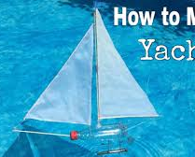
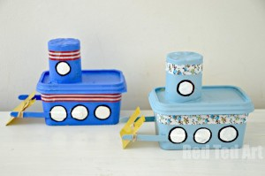
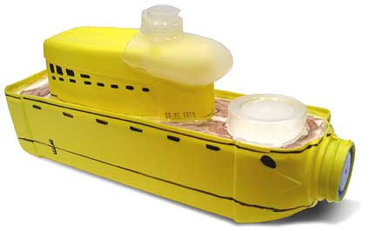
Use the following images below to support your design.

CHALLENGE: Research and explain how the surface area of an object effects whether it floats or sinks.

Topic 2 – Science (Electricity)
Research the different symbols and their meanings, which represent the different components that can be used in an electrical circuit. Create a resource or document to show the symbols you have researched. For example a light bulb would look like this:
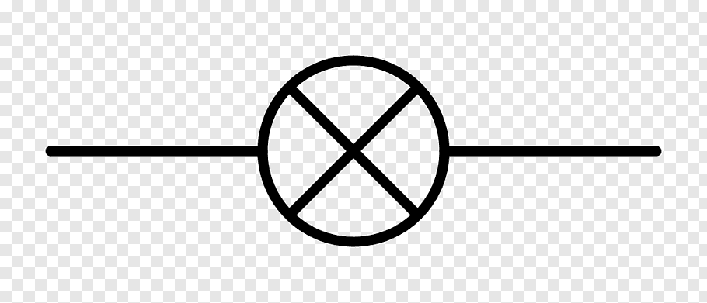

Topic 3 – French
Research and list 10 sports or hobbies in French. You can use Google or a Frech dictionary, if you have one, to find the translations. Use the table provided to record your information, an example has been completed for you.
Sport/Hobby | French Translation
Swimming | La natation

CHALLENGE: Choose one of the sports or hobbies you found in French and write it in the sentence ‘I like…’ or ‘I play…’ in French.

