Year 2 Maths Support Pack – Week 12

Lesson 1 – Sharing and the ÷ symbol
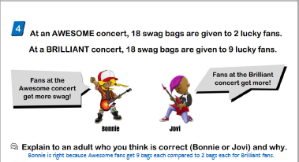
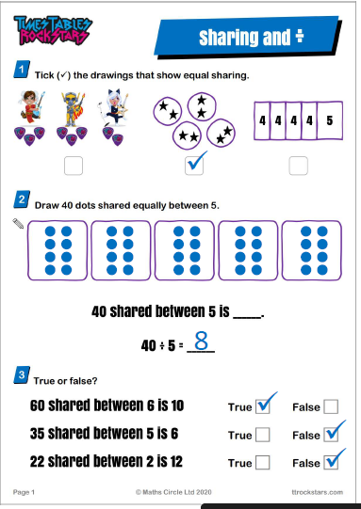
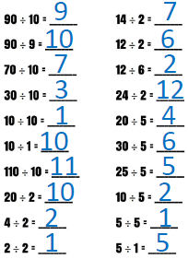
Lesson 2 – Grouping and the ÷ symbol

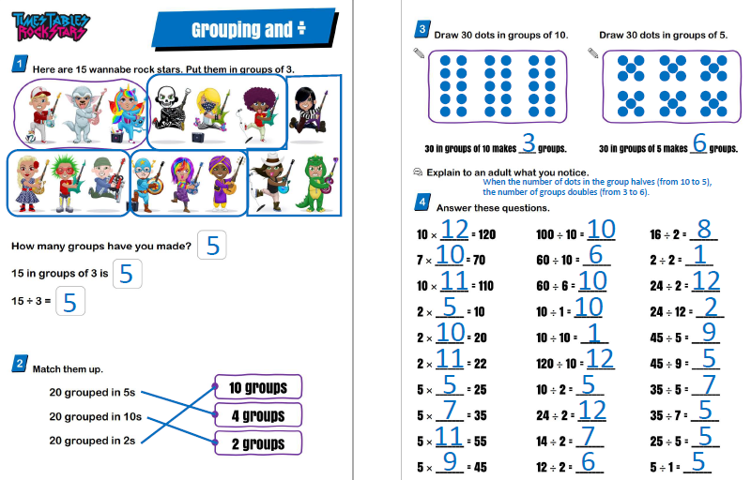

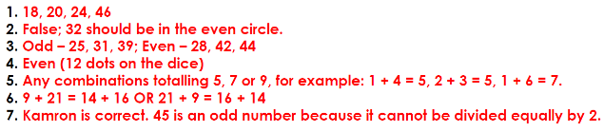
Lesson 3 – Odd and Even numbers

