Year R Home Learning Menu – 13.7.20
Try to complete as many of the activities on this menu as you can during the week. If you would like more, log on to Teach Your Monster to Read, Oxford Owls or use some of the websites provided in the original pack. Please remember to take photos of any of the activities anng upload onto EyLog so we can see what you have been doing!
Draw with Rob  Follow the instructions in the video to learn how to draw Sonic the Hedgehog.  https://www.youtube.com/watch?v=fj12BZE5FKw | Snakes and ladders  Use the sheet and enjoy a game of Snakes and Ladders.  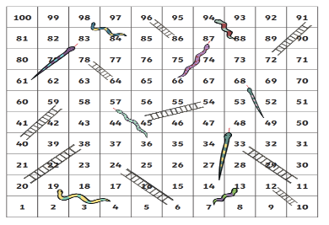 | Rainbow Bubbles  Use the instructions in your pack to create rainbow bubbles.  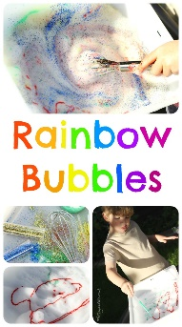
Bubble Snake  Use the instructions in the pack to create a Bubble Snake. | Guided Dance  Copy the dance moves to the Banana, Banana, Meatball song.  https://www.youtube.com/watch?v=BQ9q4U2P3ig | Hide and Seek  Play a game of hide and seek. When you are counting, whilst other people hide, try counting slowly to 10 or 20. Does this give the others enough time to hide? How could you give the others more or less time?

