**Literacy Lesson 1**

Read the below information and then have a go at writing verbs in the past tense.

Step 1: What is a verb? A verb is an action word

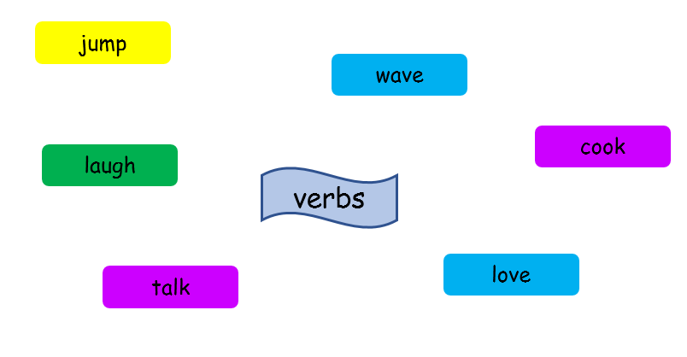

Step 2: What is the past? The past means something has already happened. It might be yesterday, last week or 2 years ago. It is not happening now, it happened in the past. It is already finished and over.

Step 3:

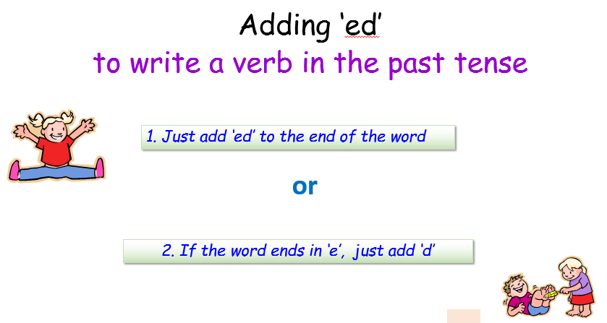

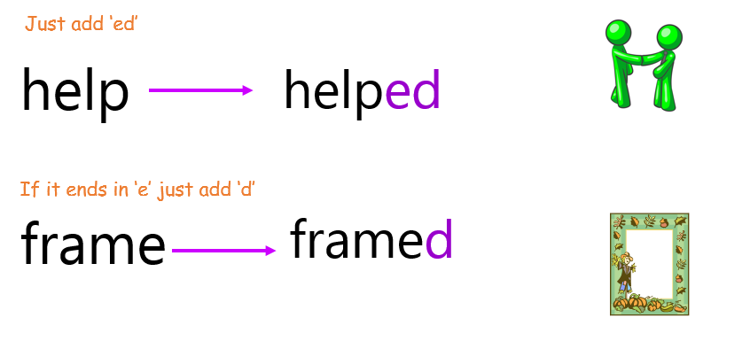

Step 4: Watch this fun YouTube video below to help you

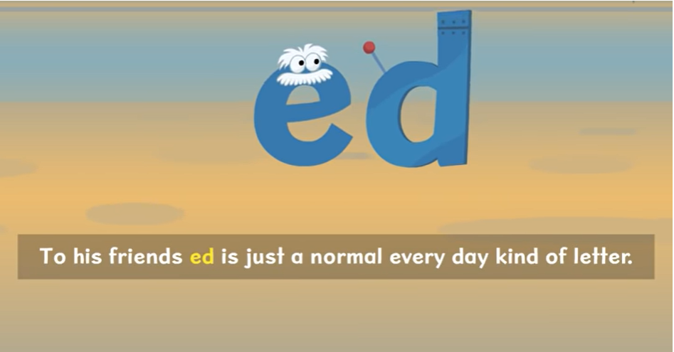

<https://www.youtube.com/watch?v=jxl28KQOHy4>

Now have a go at changing these verbs into past tense

|  |  |  |  |
| --- | --- | --- | --- |
| jump |  |  | j0232431 |
| call |  |  | C:\Users\Dave\AppData\Local\Microsoft\Windows\Temporary Internet Files\Content.IE5\U3Y6V555\MC900232650[1].wmf |
| laugh |  |  | j0232983 |
| wave |  |  | C:\Users\Dave\AppData\Local\Microsoft\Windows\Temporary Internet Files\Content.IE5\UG3MU0XR\MC900232063[1].wmf |
| cycle |  |  | C:\Users\Dave\AppData\Local\Microsoft\Windows\Temporary Internet Files\Content.IE5\KAJHB6X5\MC900318754[1].wmf |
| ask |  |  | http://www.creativeeducation.co.uk/blog/wp-content/uploads/2010/12/hands-up-color.gif |
| bake |  |  | C:\Users\Dave\AppData\Local\Microsoft\Windows\Temporary Internet Files\Content.IE5\KAJHB6X5\MC900292032[1].wmf |
| turn |  |  | j0212933 |

Challenge: Can you write a sentence using one of the above verbs in the past tense?

____________________________________________________________________________________________________________________________________________________________

**Literacy Lesson 2**

Watch the video ‘There’s a Stegosaurus on the Stairs’ on the following link: <https://www.youtube.com/watch?v=OXp4g6F6wj4>

After watching the video complete the following fact file:

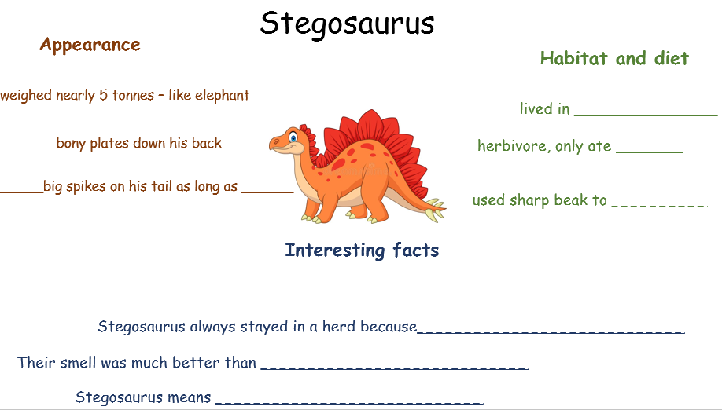

Literacy Lesson 3

**Can you create an information text on a Stegosaurus**

Remember:

An information text is full of facts and knowledge.

Look back at your notes on the stegosaurus from the previous session. You will need to write about a stegosauruses appearance, habitat, diet and give 2 interesting facts. You may want to use the WOW word mat below to help you.

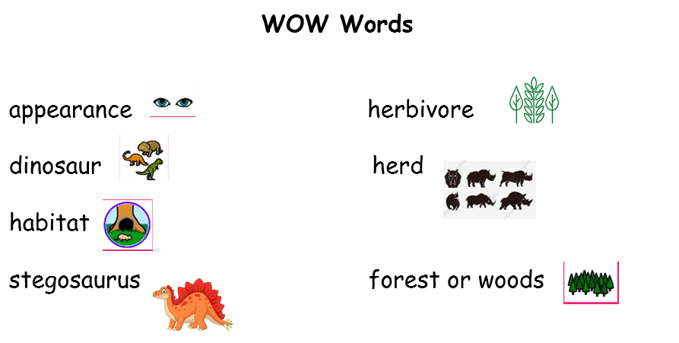

Here is the beginning of my information text to help you…

Stegosaurus

Stegosaurus was a large dinosaur. He lived about 150 million years ago!

Do you want to find out more about a stegosaurus? Then read on.

Appearance

Stegosaurus was a very large dinosaur. He weighed about 5 tonnes. That’s around the weight of an elephant.

**Stegosaurus Information Text**

**Written by _______________________________**

______________________________________________________________________________________________________________________________________________________________________________________________________________________________________________________________________________________________________________________________________________________________________________________________________________________________________________________________________________________________________________________________________________________________________________________________________________________________________________________________________

Extension: Read the following information on how to look after a dinosaur egg and then answer the questions

