Recommended Books – Year 4

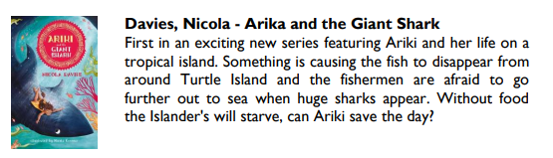
These are a selection of books which are aimed at children in Year 4 – we hope you enjoy them!
