Year R Home Learning Menu – Week 3
Calendar Maths  Can you teach your grown up the days of the week and Months of the year songs?  https://www.youtube.com/watch?v=HtQcnZ2JWsY  https://www.youtube.com/watch?v=5enDRrWyXaw  Discus what day it is and the date. You could even make your own Calendar!  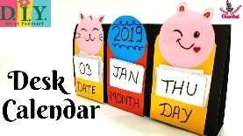 | Weather  Can you teach you grown up the ‘what’s the weather,’ song?  Whats the weather, whats the weather, whats the weather everyone?  Is it rainy? Is it cloudy? Is it snowy? Is there sun?  Discuss the weather and keep a tally of the weather for the week.  Challenge: At the end of the week can you write about what you found out? | Spring  What can you find out about spring? Use the clips below or have a look for signs in your garden or if you go out for a walk. Draw a picture, take a photo and try to write about what you have found out.  https://www.youtube.com/watch?v=TnSIFaer9XA  https://www.youtube.com/watch?v=s_fIEWViJyE  (An American book but some good information)
The Very Hungry Caterpillar  Watch or read (if you have a copy) the story of The Very Hungry Caterpillar. Can you draw your favourite part and write about it?  If you want a challenge, can you make your own book? The Very Hungry …  https://www.youtube.com/watch?v=75NQK-Sm1YY  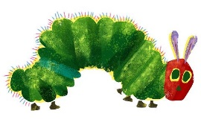 | Timer Challenge  How long can you hold this pose for? Time yourself each day to see if you can improve? | Host your own movie night!  Choose your favourite movie, design tickets and relax with a bag of popcorn!
Try to complete as many of the activities on this menu as you can during the week. If you would like more, log on to Teach Your Monster to Read, Oxford Owls or use some of the websites provided in the original pack. Please remember to take photos of any of the activities and upload onto EyLog so we can see what you have been doing!

