Year 4 Home Learning 18.5.20-22.5.20
Maths Support Document
Use the link provided to complete your Maths activities set. You will need to watch the video and then complete the activity afterwards. You will be focusing on Summer Term Week 1 and 2.
Lesson One: Compare Decimals (Summer Term Week 1 Lesson 3)
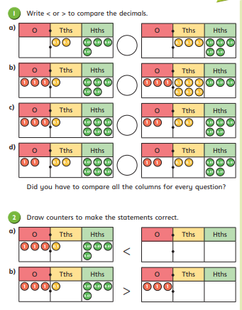
https://whiterosemaths.com/homelearning/year-4/

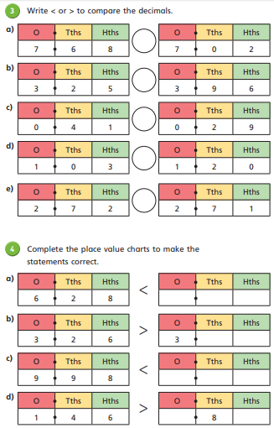

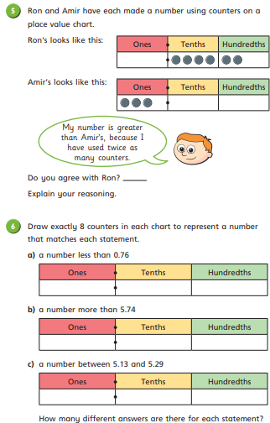

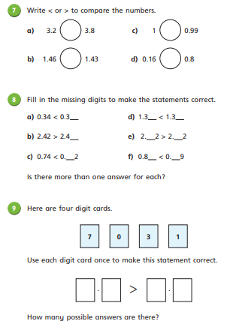

Lesson 2: Order Decimals (Summer Term Week 1 Lesson 4)
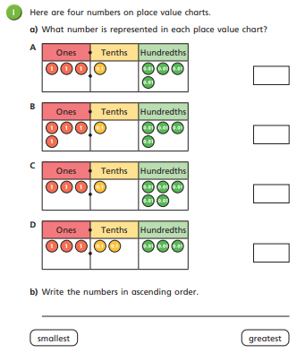
https://whiterosemaths.com/homelearning/year-4/

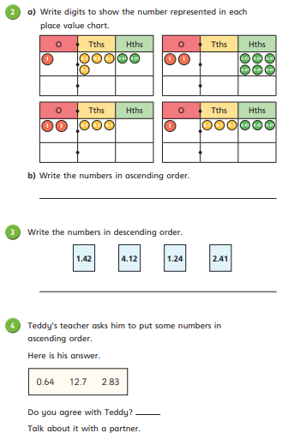

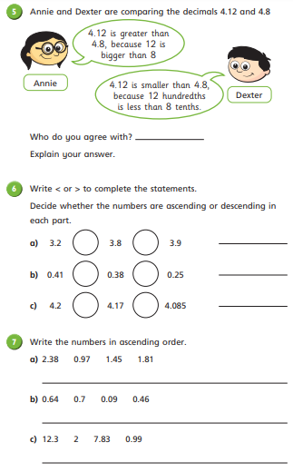

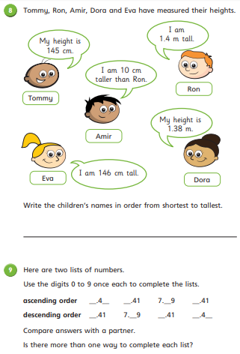

Lesson 3: Round Decimals (Summer Term Week 2 Lesson 1)
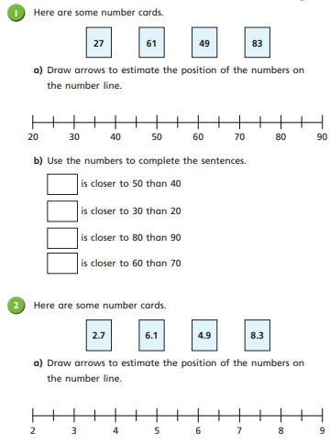
https://whiterosemaths.com/homelearning/year-4/

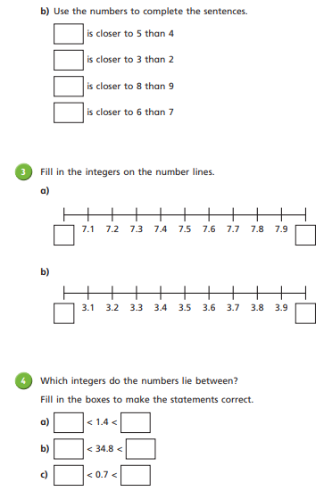

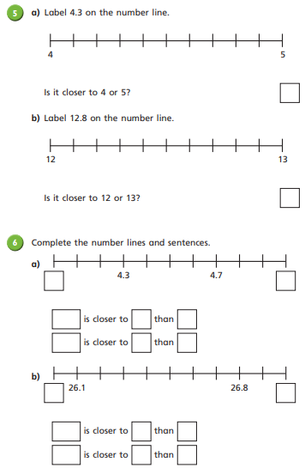

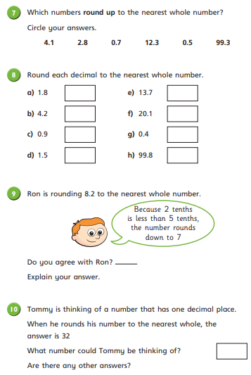

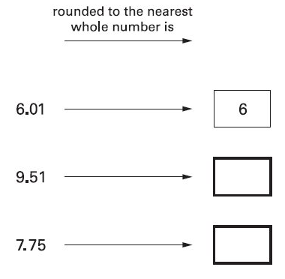
Extension/Challenge: Test Style Questions

