Year 2 Homework – Autumn 2
Choose at least one of the tasks to complete at home this half term. You can choose when to bring your homework back to school but this must be before we break up for Christmas. Be creative and have fun!
If you could have a super power what would it be? Would you be able to fly? Become invisible? See through buildings? Write about an adventure you might have. | Who is your hero? Bring in a picture of them and write a few sentences to explain why you chose them. | Read a newspaper or watch the news with a parent and see if you can spot any stories of people doing heroic things.
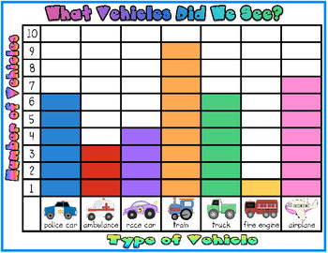  Ask your family and friends who their favourite superhero is and record your results in a tally chart and then create a block diagram. | Draw or make your own Remembrance poppy. | 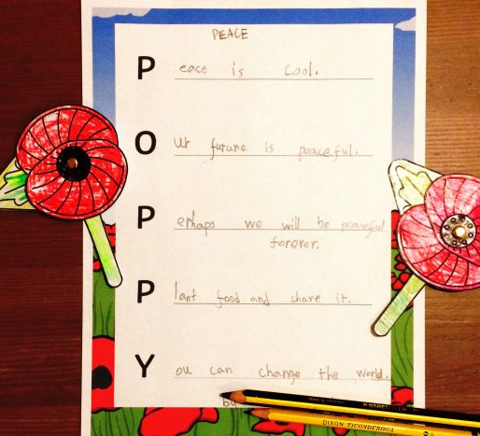  Write a Remembrance acrostic poem.
Don’t forget to try and read at home at least 3 times per week.

