Literacy Lesson 1
Listen to the story of ‘Rainbow Fish’ being read on the following link:
https://www.youtube.com/watch?v=BzZuS3ze-Ho. Complete the below book review

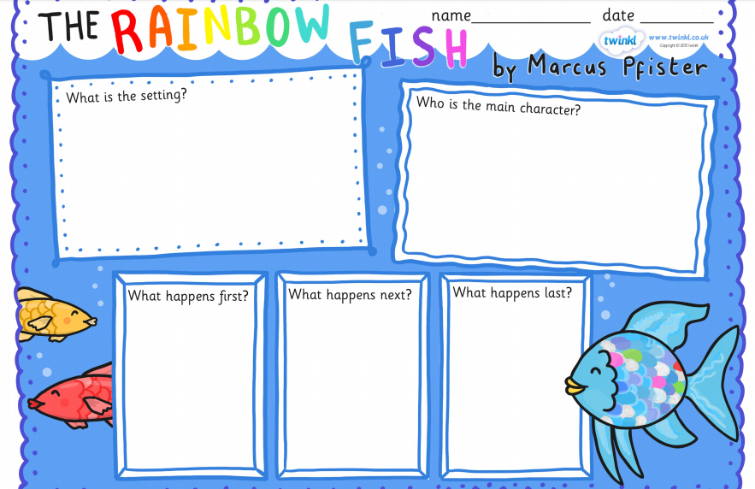
Literacy Lesson 2
Can you fix the Rainbow Fish sentences? Words are spelt incorrectly, and they are missing capital letters and full stops. Use the story to help you.
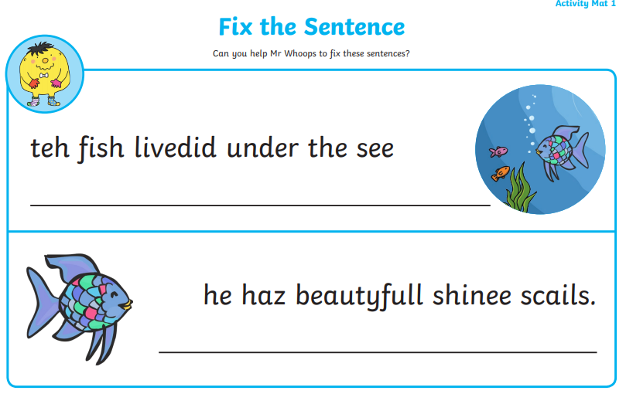
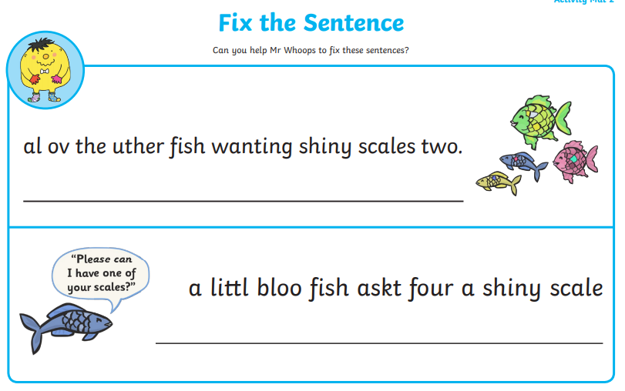
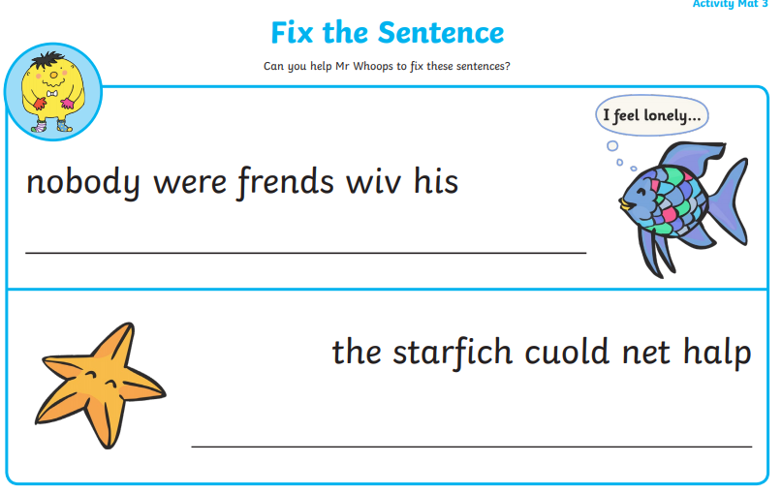

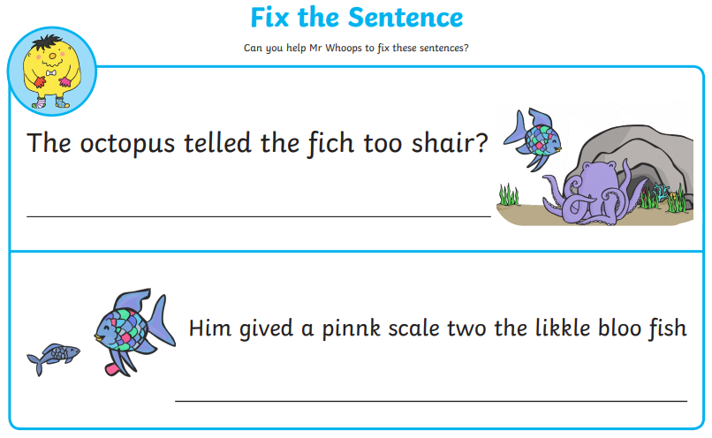
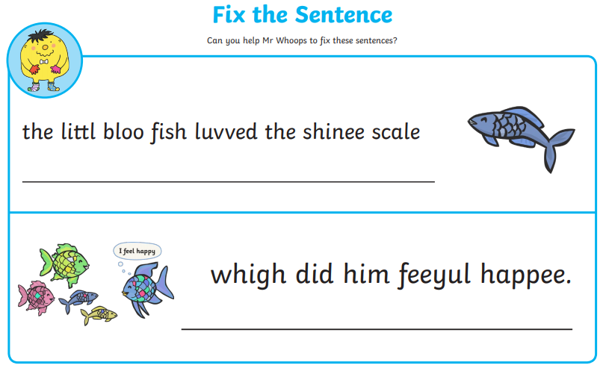

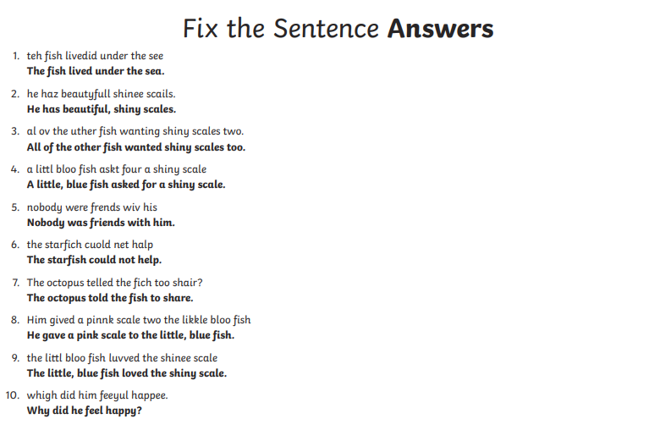

Literacy Lesson 3
The Rainbow Fish gave away his most prized possession, his scales. What is your most prized possession? Can you draw a picture of it and tell me why it is so special?

__________________________________________________________________________________________________________________________________________________________________________________________________________________________________________________________________________________________________________________

