Year 2 Maths Support Pack – Week 11
In this pack, you will find instructions on how to complete your Maths lessons for this week. We are continuing to learn about addition and subtraction. This week you will be applying your understanding of adding and subtraction to a range of problems, You can complete the worksheets by printing them, or viewing them on the screen and writing the answers on your own paper.

Lesson 1
Using your addition and subtraction learning from the last two weeks, can you have a go at solving the following problem? Remember to find all the different possibilities. Use the squares below to help you organise your thinking.
Hint! – finding the difference means you need to subtract.
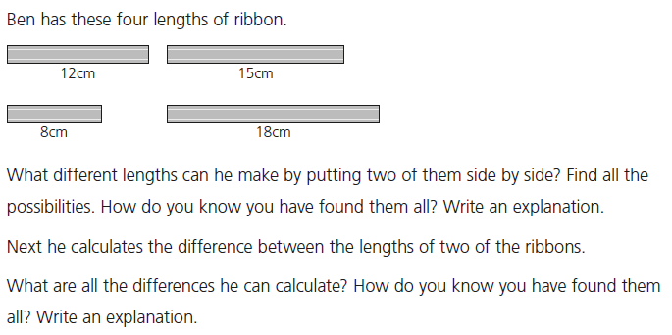

Lesson 2
Using the partitioning method from last week’s learning can you check the number sentences on each side of the ‘=’. Remember ‘=’ means ‘equal to’ and therefore needs to be balanced.

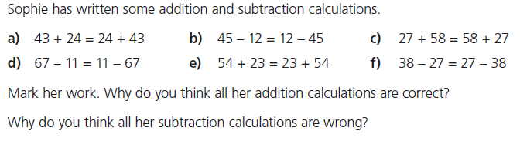

Lesson 3
Using the partitioning method from last week and your understanding of the relationship between addition and subtraction can you work out the starting numbers? Then can you apply the same understanding to work out Sophie and Ben’s numbers?
