Dear New Children and Parents of Tower Hill Primary School,

You are warmly invited to join us to celebrate the Queen’s Platinum Jubilee. We would love to see you for an afternoon of fun, games and entertainment!
Our celebration takes place on Thursday 26th May from 3.20pm onwards. Bring a blanket and enjoy the festivities on our school field.
We hope you can make it and look forward to seeing you there!
Barbeque
Bottle tombola
Nail painting and tattoos
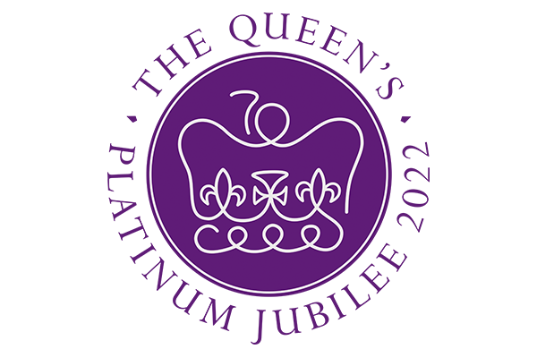
Strawberries and Cream
Face painting
Beat the Goalie
Candy Floss
Circus Skills with Juggling Jake
Sweet cones
Fruit cups

