Week 8 English Support Pack
In this pack, you will find all of the instructions, resources, and questions that you will need to complete your English lessons for this week. We are carrying on with our Summer text driver, Cogheart. This week, we will be recapping Chapter 1 looking deeper into the text. You can watch the video recording of Chapter 1 to remind yourself of the events so far.
Lesson 1 – SPAG/Guided Reading
This lesson we will be analysing page 20 and recapping the storyline of Chapter 1. Use different colours to find and highlight the following features in the text below (page 20):
- Simile
- Expanded noun phrase
- Parenthesis
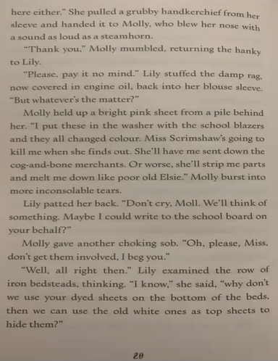
- Prepositions

Answer these questions below (refer to page 20):
The blue questions everyone can do.
The red questions are a bit trickier, but have a go!

Literal Questions
What did Lily stuff into her blouse sleeve?

What was the damp rag covered in?

What does Lily think she can do to help Molly?

How do you think Molly felt after she had accidentally died the sheets?

Inference Questions
Why do you think it was really loud when Molly blew her nose?

What colour do you think their school blazers might have been? Explain your answer…

Do you think Molly has feelings?
Find evidence from the text to support your answer.

Who is Elsie?

Summarise, in no more than 4 sentences, the events of Chapter 1. Use the video to help remind you what has happened so far.
________________________________________________________________________________________________________________________________________________________________________________________________________________________________________________________________________________________________________________________________________________________________________________________________________________________________________________________________________________________________________________________________________

Lesson 2 - Planning
This lesson I would like you to plan what happens after Lily is locked away in the cold, dark bunker (at the end of Chapter 1).
Below is the last page from Chapter 1. Read through, or listen to the voice recording to remind yourselves how the chapter ends.
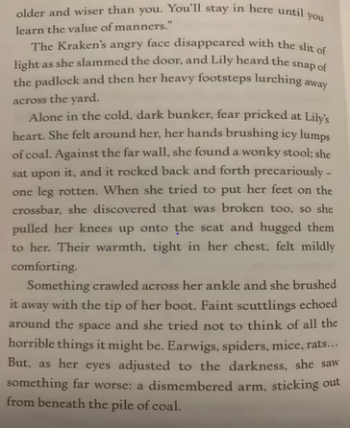

Think about what Lily might do next…
Could she:
- Call for help?
- Try and escape?
- Be stuck in there for another day?
- Meet someone new who appears out of the darkness?
- Discover a new world where the dead are alive?

Use these heading as a guide to carefully plan your writing. You will be using your plan to write what could happen to Lily next lesson.
My idea of what could happen next… ___________________________________________________________________________________________________________________________________________________________________________________________________
Expanded noun phrases | Similes | Metaphors
Fronted prepositional phrases | Alliteration | ISPACE
What Lily could hear… | What Lily could smell… | What Lily could touch…

Lesson 3 – Writing
This lesson we will be using our planning sheet from Lesson 2 to write about what happens next after Lily has been locked away in the cold dark bunker by Mrs McKracken. Remember you can tick off the features you use from your planning sheet. Try and write 2 to 3 detailed paragraphs.

I have written an example that includes features from the planning sheet. See if you can find examples of them! You can magpie ideas from this example if you need to. Let’s see what could happen next…
Example:
Gently, Lily closed her eyes; she could not imagine anything worse. The sound of all kinds of creatures, scuttling across the sharp, stony floor, grew louder and LOUDER. As quick as a cheetah to its prey, Lily shot up off of the cold, dusty floor and ran to the nearest crack of light she could see. Squinting through the tiny, fractured crack in the wall, all Lily could think about was to try and find her way out of there.
The prison seemed impossible to escape. Beneath the stench of rotting bodies, Lily crawled across the room searching for the sharpest stone she could find. Her plan was to chip away at the peeking crack in the wall until she could squeeze though and escape the steel walls of the prison. On her hands and knees, Lily felt every painful crawl, until she came across a very sharp stone. Jumping to her feet, Lily ran back to the ray of hope. Chip, chip chip… Was this finally her ticket to freedom?

Extension Task
Illustrate your writing from Lesson 3, thinking about what you will draw and how closely it relates to what you have written. It would be lovely to help bring your ideas to life!

