Literacy: Lesson 1
Wanted Poster
In Giant village all the Giants are very cross that Jack broke in and stole from Mr Giant and Mrs Giantess! They want to find Jack and get him to return what he stole! Can you create a wanted poster to put up in Giant village?
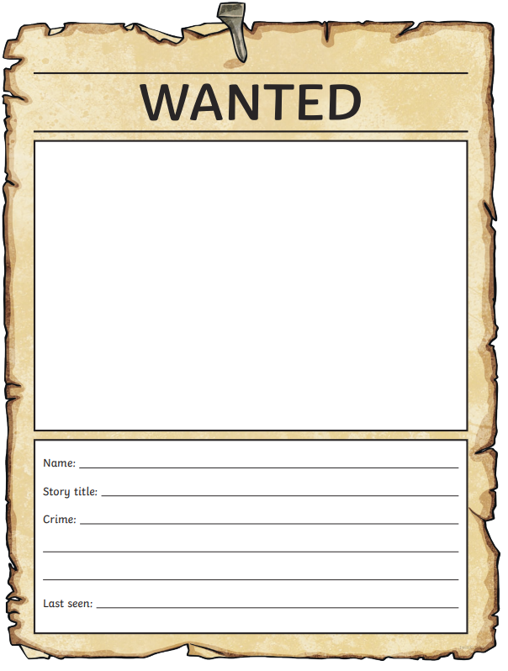
Challenge: Do you think it was right that Jack stole from the Giant? Explain your answer to someone in your house.

Literacy Lesson 2
Unscramble the letters that the naughty wizard has muddles up to work out each word related to Jack and the Beanstalk. For a real challenge, cover up the word list before you begin!
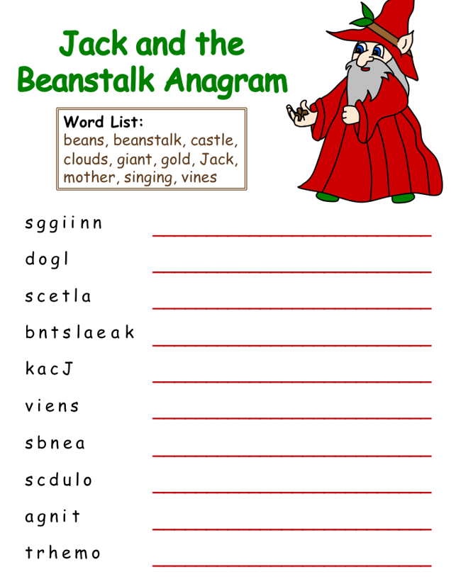
Literacy: Lesson 3
Reading Comprehension
Have a go at reading the story of ‘The Three Billie Goats Gruff’, you may want to ask a grown up to help you, and then answer the comprehension questions.
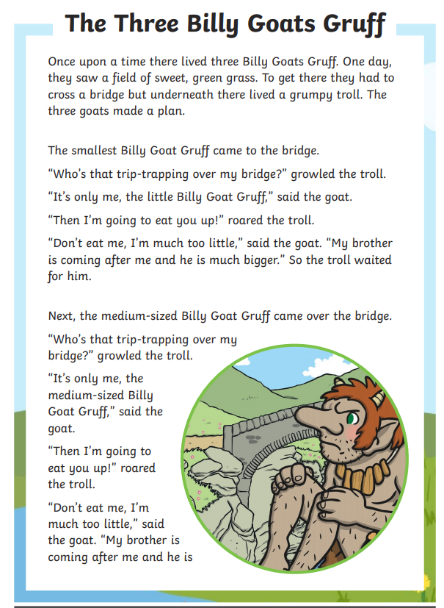
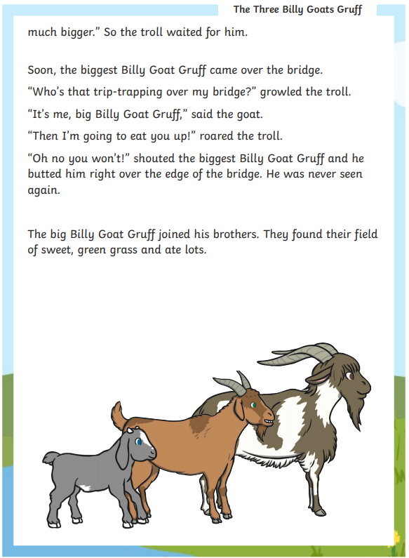
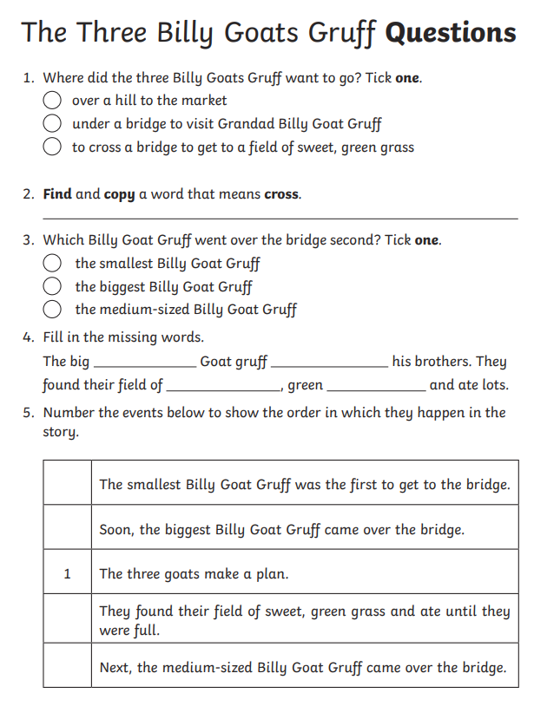
Challenge Question:
