Year 4 Parents Evening Information - October 2021
In this booklet, you will find various pieces information which you can use to support your child from home.

Times Table Information: We would be extremely grateful if you particularly supported your child in times tables, as they will be expected to sit a Government test at the end of the academic year.
Here are some websites that you can go on to help practise your times tables:
TTRockstars: https://ttrockstars.com/ Please try to complete this at least 3 times a week. They will need to use the ‘Garage’ option, as this is tailored to their specific areas of need.
Hit The Button: https://www.topmarks.co.uk/maths-games/hit-the-button You can use this link to practise individual times tables you struggle with.
MTC URBrainy: https://urbrainy.com/mtc/test This is a model of the test Year 4 will be taking at the end of the academic year. Please try and do this 2 times a week. At the end, after selecting ‘See My Results’ and then print. It will give you a few links to practise the weakest times tables.
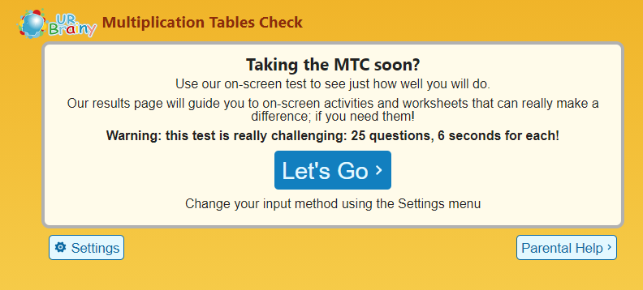

Reading: Here are some questions you can ask while reading at home. These will help comprehension skills.
Can your child find evidence directly from the story to answer your questions?
The answer is right there in the text.
- What did……… do?
- Who did……… do it to
- How many……… were/are there?
- Who are………?
- Can you tell me what this word/bit means?
- What kind of ……… is that?

Can your child think and search for the answer?
The answers are found in different parts of the story and they might have to apply prior knowledge or personal experience to an answer.
- How do you make/do……?
- What happened when……… did………?
- What happened to………?
- What do you think might happen next OR what happened before?
- How many times…
- What examples can you find?
- Where did this happen?
- Where was…… when this was happening?
Can your child answer questions without referring to the story?
The answer is not in the story, it is your child’s opinion and thoughts.
- Have you ever…
- If you could…
- If you were going to…
- In your opinion…
- Do you agree with………? Why?
- Do you know anyone who………?
- How do you feel about……?

Spellings: These are the spellings Year 4 are expected to know by the end of the academic year. They will be tested throughout the year.
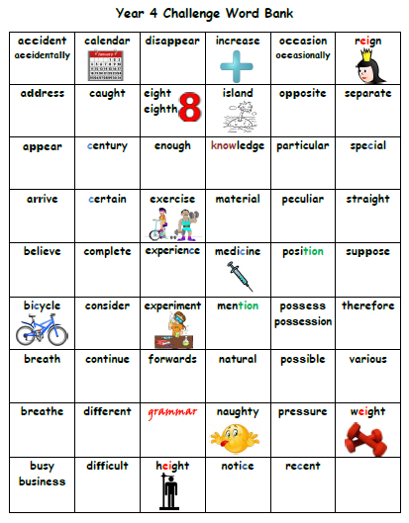

Here is a copy of the Year 3 Spellings, for them to revise throughout the year, so they do not forget. Additionally, these were not fully covered, due to COVID.
